Title: Register into Account

Actor(s): User, Database, API

Purpose: To register user into the system so they can access the application.

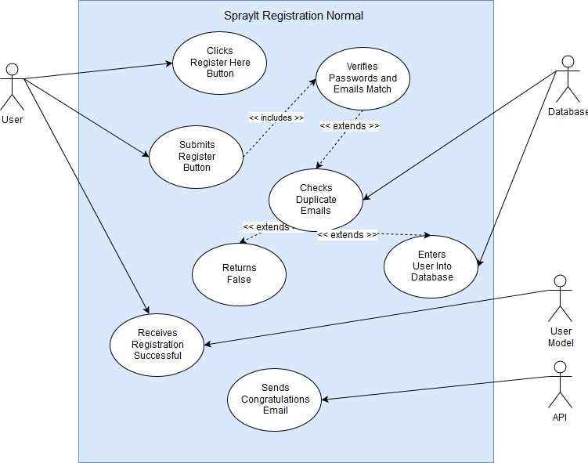

|  |  |
| --- | --- |
| **Normal Scenario** |  |
| Pre-condition(s): | User is on login screen but doesn’t have an account. User clicks the Register Here link. |
| Procedure: | Click Register Here Button |
|  | Enter first name, last name, email, confirm email, password, confirm password |
|  | Click Register Button |
|  | Application confirms emails and passwords match |
|  | Application confirms no other instance in database of email address |
|  |  |
| Post-condition(s): | User is registered |
|  | User receives registration success message |
|  | User receives congratulations message |
|  | User is sent to Login Page |

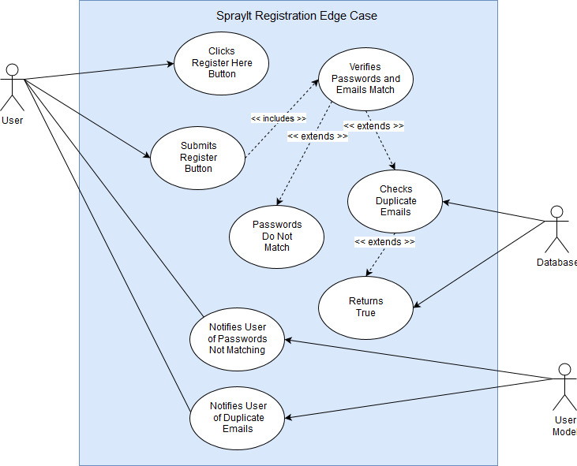

|  |  |
| --- | --- |
| **Scenario 1** |  |
| Pre-condition(s): | User is on login screen and thinks they don’t have an account. User clicks the Register Here link. |
| Procedure: | Click Register Here Button |
|  | Enter first name, last name, email, confirm email, password, confirm password |
|  | Click Register Button |
|  | Application confirms emails and passwords match |
|  | Application confirms finds another instance of email in database |
|  | Application notifies User of duplicate emails |
|  |  |
| Post-condition(s): | User is not registered |
|  | User is sent back to Register Page |
|  |  |
|  |  |
| **Scenario 2** |  |
| Pre-condition(s): | User is on login screen but doesn’t have an account. User clicks the Register Here link. |
| Procedure: | Click Register Here Button |
|  | Enter first name, last name, email, confirm email, password, confirm password |
|  | Click Register Button |
|  | Application confirms emails |
|  | Application cannot confirm passwords match |
|  | Application notifies User of passwords not matching |
|  |  |
| Post-condition(s): | User is not registered |
|  | User is sent back to Register Page |
|  |  |