CS 008 Introduction to World Wide Web Design
Adrian Pascual, Bill Matraw, Mike Fritz
Assignment Four
Food For Thought
Version <1.0>

Table Of Contents

Time Log 4
Software Requirements Specifications 5
Introduction 5
Purpose 5
Definitions, acronyms, and abbreviations 5
Overall Description 5
Storyboard 5
Assignment Requirements 6
Specific Requirements 7

Time Log
Estimated time to complete assignment => |  | 10 Hours
Date | Time Spent  (in hours) |  | Description |  | Author
5/1/14 | 2 |  | Took photos of food and finished reviews |  | Adrian Pascual
5/2/14 | 3 |  | Finished reviews and started CSS, worked on the nav bar, |  | Mike Fritz
5/4/14 | 2.5 |  | Finished the storyboard and contact-us.php |  | Adrian Pascual
4/4/14 | 2.5 |  | Finished bill.php and comments.php |  | Bill Matraw
 | 11 |  | <=Total Time Spent

Software Requirements Specifications

Introduction

Purpose
The purpose of this site is to inform the general public about the food offered at three dining halls, Cook, Northside, and the Grundle. We wanted to let people know which unlimited dining hall had the best pizza, specialty, and dessert. We also wanted to provide a forum for people to discuss our reviews, as evidenced by our comments page. Finally, our followers can fill out our form to let us know their opinions.

Definitions, acronyms, and abbreviations
HTML – Hypertext markup language
CSS – Cascading Style Sheets
W3 Validation – refers to both Html and CSS validation tool provided by the W3c.org. the html validator is located at:
http://validator.w3.org/
with the CSS validator located at:
http://jigsaw.w3.org/css-validator/

Overall Description
This website should be used to look up food reviews from three great critics, Adrian Pascual, Bill Matraw, and Mike Fritz. We will provide quality reviews with a rainbow rating system, with zero rainbows being the worst and five being the best. There will also be a contact us page which will allow people to recommend diners and anything to do next.

Storyboard
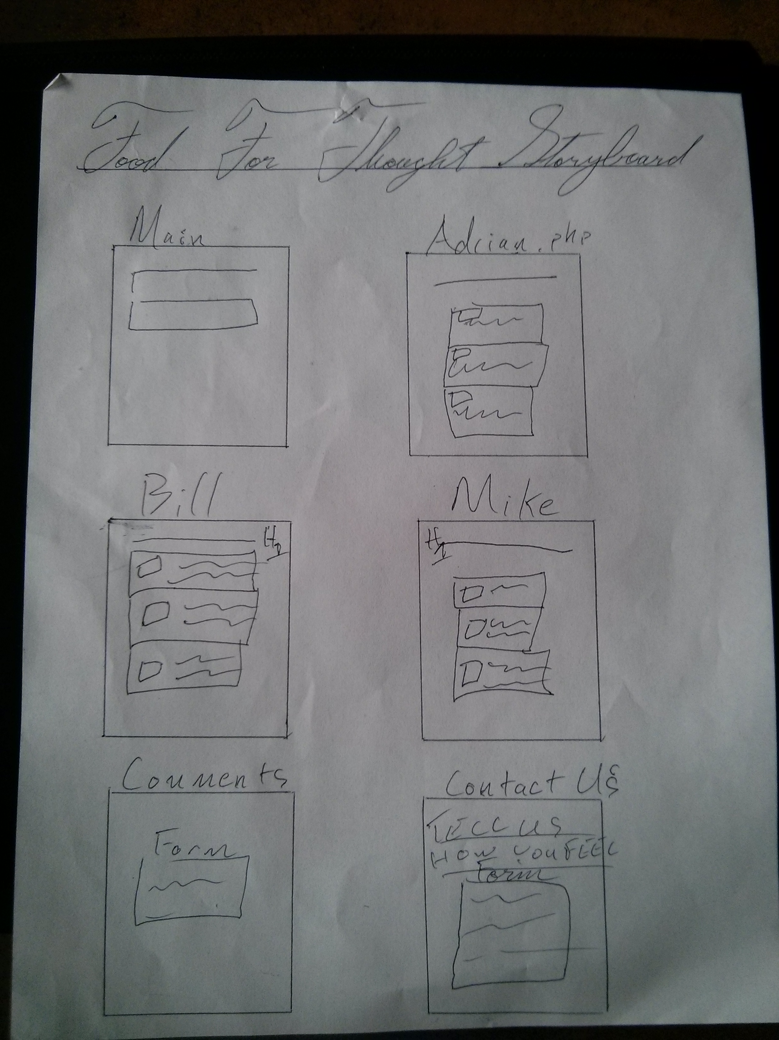

Assignment Requirements
- Create a design specification for this project, being sure to include everything on all previous design specs:

  - cover page
  - time log
  - table of contents
  - Introduction
  - Purpose
  - Scope
  - Definitions, acronyms, and abbreviations
  - Overview
  - Overall Description
  - Story Board
  - Specific requirements

- Create a complete and functional web site incorporating the concepts learned in this class. You will of course need to have:

  - style sheet
  - form
    - one text box for a users email address.
    - one additional text box.
    - one list box.
    - two check boxes.
    - two radio buttons.
    - Submit and ReSet command buttons.
    - Field sets and legends as needed
    - data should be validated for not missing, valid format etc as needed with both html and php
    - form should email the person who filled it out
    - form data should be saved to a file on the uvm share
  - One page should open a data file and display the information in some way. (it could be a file of image names or it could be data related to your research etc.
  - Minimum of six pages.

Specific Requirements
- This website will have food reviews, images of said food, a comment section, and a contact us page. There will also be
- Background color: #E09D31

