**Report on Computational Intelligence course of**

**Particle Swarm Optimization（PSO）**

Class: 1804 Student ID: 201894090 Name: Changrui Zuo

**Abstract：Another problem of this problem is to find the best solution through particle swarm optimization. Due to the limited time, only the maximum value was found this time. I think this method is simpler and more effective than GA.**

1. Code description

1.1 Overview

Librandom, numpy and matplotlib of Python3.7 are used. Due to time constraints, this code is just a basic example without classes in the PSO algorithm.

PSO is initialized as a set of random particles (random solutions). Then iteratively find the optimal solution. In each iteration, the particle updates itself by tracking two “extreme values”. The first is the optimal solution p_best found by the particle itself. The other extreme value is the optimal solution currently found by the entire population, namely the global extreme value g_best.

Here is the formula:

Speed formula:

$$vi+1​=w*vi​+c1​*rand1​*(pbesti​-xi​)+c2​*rand2​*(gbesti​-xi​)$$

Position formula:

$$x_{i}=x_{i}+v_{i+1}$$

In this code, w = 0.6, c1 = 2, c2 = 2.

1.2 Initialize

Population scale is set as pop_size, the number of target equation is set as variable_num, the parameter dec_min_val and dec_max_val are for minimum variable value and maximum variable value. The variable pop_x stands for position. And the variable pop_v stands for speed. The variable p_best is for the best solution so far.

def init_population(pop_size, variable_num, dec_min_val, dec_max_val, pop_x, pop_v, p_best):  
 for i in range(pop_size):  
 for j in range(variable_num):  
 pop_x[i][j] = random.uniform(dec_min_val[j], dec_max_val[j])  
 pop_v[i][j] = random.uniform(0, 1)  
 p_best[i] = pop_x[i]

**Code 1.1 Initialize particles**

* 1. Fitness

Because only the maximum solution is required at this time, the objective function can be regarded as a fitness function.

def fitness(s):  
 x1 = s[0]  
 x2 = s[1]  
 x3 = s[2]  
 y = 2 * x1 ** 2 - 3 * x2 ** 2 - 4 * x1 + 5 * x2 + x3  
 return y

**Code 1.2 Fitness function**

* 1. Save the best value of each term

Find the best value in the group and save it as g_best.

for i in range(pop_size):  
 fit = fitness(p_best[i])  
 if fit > temp:  
 g_best = p_best[i]  
 temp = fit

**Code 1.3 Judgement and save**

* 1. Process in term

Update the speed and position of each individual, then judge them if they are out of range. In the end, renew the value of p_best and g_best.

for i in range(max_gen):  
 for j in range(pop_size):  
 # update individual  
 pop_v[j] = w * pop_v[j] + c1 * random.uniform(0, 1) * (p_best[j] - pop_x[j]) + \  
 c2 * random.uniform(0, 1) * (g_best - pop_x[j])  
 pop_x[j] = pop_x[j] + pop_v[j]  
 for k in range(variable_num): # limit range  
 if pop_x[j][k] < dec_min_val[k]:  
 pop_x[j][k] = dec_min_val[k]  
 if pop_x[j][k] > dec_max_val[k]:  
 pop_x[j][k] = dec_max_val[k]  
 # Update p_best and g_best  
 if fitness(pop_x[j]) > fitness(p_best[j]):  
 p_best[j] = pop_x[j]  
 if fitness(pop_x[j]) > fitness(g_best):  
 g_best = pop_x[j]  
 result.append(fitness(g_best))  
 print("Generation %d: %.4f" % (i, fitness(g_best)))

**Code 1.4 Term process**

* 1. Visualization

Draw the graph of all process and the best value found.

# Visualization  
plt.figure(1)  
plt.title("Figure")  
plt.xlabel("count", size=14)  
plt.ylabel("value", size=14)  
plt.plot(result, color='b', linewidth=2)  
plt.show()

**Code 1.4 Term process**

1. Result

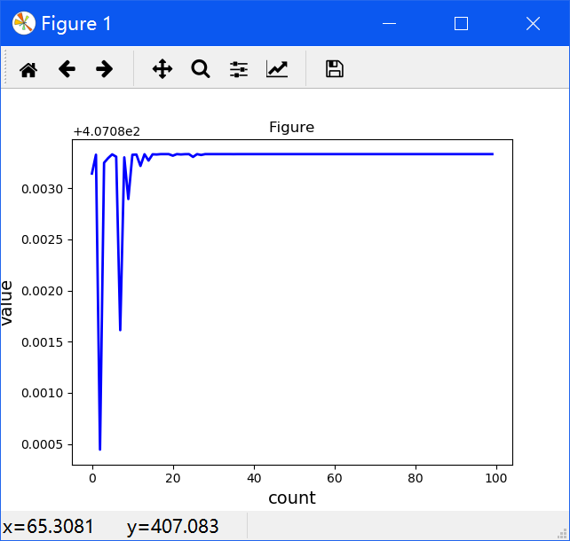

**Figure 2.1 Graph**

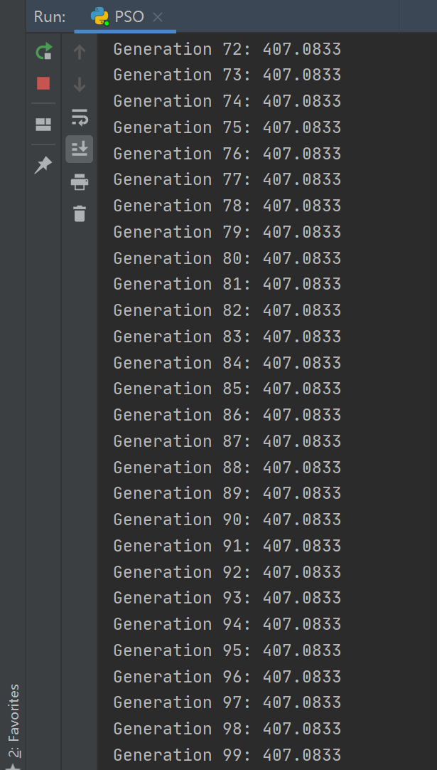

**Figure 2.2 Max**