**Project 1**

**Chapter 1: Introduction**

This project uses two different algorithms to compute X^N for some positive integer N.. Then, we analyze the complexities of the two algorithms by measuring and comparing the performances of Algorithm 1 and the iterative and recursive implementations of Algorithm 2 for X=1.0001 and N = 1000, 5000, 10000, 20000, 40000, 60000, 80000, 100000.

**Chapter 2: Algorithm Specification**

**Algorithm 1 : use N−1 multiplications.(Let’s call it iterativepow1)**

Here I use a loop to calculate.

**Algorithm 2 works in the following way: if N is even, X^N=X^(N/2)×X ^(N/2);**

**and if N is odd, X ^N=X ^(N−1)/2×X ^(N−1)/2×X.**

I implement algorithm 2 in a recursive version and an iterative version.

1. **The recursive version of algorithm 2(Let’s call it recursivepow)**

When exponent=0, return 1 as the exit of recursion. Otherwise, make the latter base square of the previous base to halve the times that we need to multiply.

1. **The iterative version of algorithm 2(Let’s call it iterativepow2)**

I use a loop. The loop number i means the times left to multiply, so i starts from 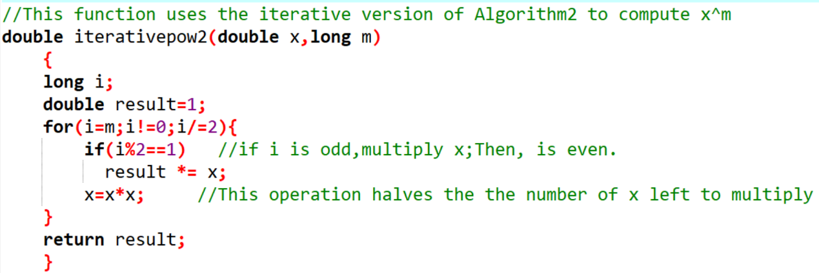the exponent m. Every time we finish the operarion in a loop,i=i/2.

**Chapter 3: Testing Results**

|  |  |  |  |  |  |  |  |  |  |
| --- | --- | --- | --- | --- | --- | --- | --- | --- | --- |
|  | N | 1000 | 5000 | 10000 | 20000 | 40000 | 60000 | 80000 | 100000 |
| Algorithm1 | Iterations(K) | 2086 | 1707 | 1200 | 493 | 4 | 149 | 85 | 40 |
| Ticks | 16 | 15 | 15 | 15 | 15 | 16 | 15 | 16 |
| Total Time(sec) | 0.016 | 0.015 | 0.015 | 0.015 | 0.015 | 0.016 | 0.015 | 0.016 |
| Duration(sec) | 0.0000076702 | 0.0000087873 | 0.0000125000 | 0.0000304280 | 0.00375 | 0.0001073826 | 0.0001764706 | 0.0004 |
| Algorithm2  (iterative  Version) | Iterations(K) | 168014 | 2626974 | 164597 | 188258 | 1669371 | 200323 | 348212 | 21124 |
| Ticks | 14 | 15 | 15 | 15 | 16 | 15 | 16 | 15 |
| Total Time(sec) | 0.014 | 0.015 | 0.015 | 0.015 | 0.016 | 0.015 | 0.016 | 0.015 |
| Duration(sec) | 0.0000000833 | 0.0000000057 | 0.0000000911 | 0.0000000797 | 0.0000000096 | 0.00000000749 | 0.0000000459 | 0.0000007101 |
| Algorithm2  (recursive  Version) | Iterations(K) | 127349 | 50207 | 333404 | 25496 | 10528 | 495370 | 148485 | 78183 |
| Ticks | 16 | 10 | 15 | 16 | 14 | 25 | 16 | 14 |
| Total Time(sec) | 0.016 | 0.01 | 0.015 | 0.016 | 0.014 | 0.025 | 0.016 | 0.014 |
| Duration(sec) | 0.00001256 | 0.00001992 | 0.0000000450 | 0.0000006275 | 0.0000013298 | 0.0000000505 | 0.0000001078 | 0.0000001791 |

**Chapter 4: Analysis and Comments**

1. **Theoretically analyze the time complexity of the three methods**

**Compute X^N:**

1. Algorithm 1

the loop will always circulate for n times, so the time complexity is O(n).

1. Algorithm 2(recursive version)

Every time we make m/2 until m=0,then we get out of the recursion.

So the time complexity is log(n).

1. Algorithm 2(iterative version)

O(logn), just similar with 2)

1. **Some conclusions we practically get from our test data in Chapter 3**
2. We can see that As a whole, algorithm 2 runs more quickly than algorithm 1,no matter the recursive version or the iterative version. What’s more, as N grows larger, the gap between the two algorithms becomes larger.
3. In terms of algorithm 2, Iterative version runs more quickly than recursive version. I think maybe it’s because recursion version has a process of backtracking, consuming some time. But the gap isn’t very big, and when N = 100000,I even see that recursive version runs more quickly.
4. **Some comments and confusion**

I think as a whole I finish the project perfectly and try my best to use as little code as possible to reach the goal.

But I find that the time don’t grow very regularly as the time complexity shows, for example, time complexity of algorithm 1 is O(n),but the time it consumes isn’t linear. This confuses me a lot.

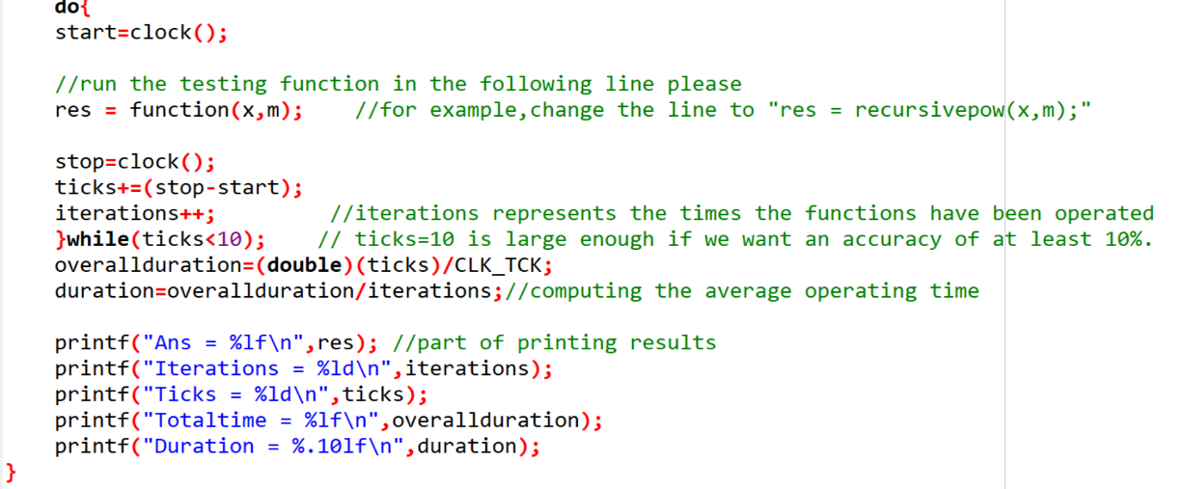**Chapter 5: Appendix**: **Here are part of my Source Code (in C)**

**Chapter 6:Declaration**

I hereby declare that all the work done in this project titled"XXX" is of my independent effort