Fundamentals of Data Structures

Laboratory Project 1

**Performance**

**Measurement(POW)**

# Date: 2023-10-07

**Author:陈硕**

**Number:3220106406**

**Chapter 1: Introduction**

This project uses two different algorithms to compute X^N for some positive integer N.. Then, we analyze the complexities of the two algorithms by measuring and comparing the performances of Algorithm 1 and the iterative and recursive implementations of Algorithm 2 for X=1.0001 and N = 1000, 5000, 10000, 20000, 40000, 60000, 80000, 100000.

**Chapter 2: Algorithm Specification**

**Algorithm 1 : use N−1 multiplications.(Let’s call it iterativepow1)**

Here I use a loop to calculate.

**Algorithm 2 works in the following way: if N is even, X^N=X^(N/2)×X ^(N/2);**

**and if N is odd, X ^N=X ^(N−1)/2×X ^(N−1)/2×X.**

I implement algorithm 2 in a recursive version and an iterative version.

1. **The recursive version of algorithm 2(Let’s call it recursivepow)**

When exponent=0, return 1 as the exit of recursion. Otherwise, make the latter base square of the previous base to halve the times that we need to multiply.

1. **The iterative version of algorithm 2(Let’s call it iterativepow2)**

I use a loop. The loop number i means the times left to multiply, so i starts from 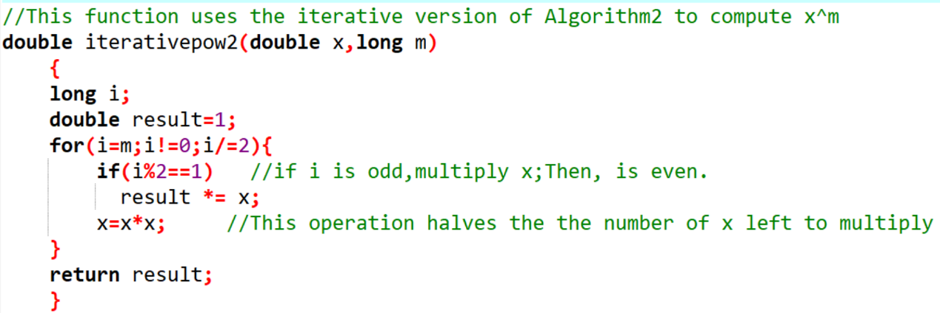the exponent m. Every time we finish the operarion in a loop,i=i/2.

**Chapter 3: Testing Results**

|  |  |  |  |  |  |  |  |  |  |
| --- | --- | --- | --- | --- | --- | --- | --- | --- | --- |
|  | N | 1000 | 5000 | 10000 | 20000 | 40000 | 60000 | 80000 | 100000 |
| Algorithm1 | Iterations(K) | 2086 | 1707 | 1200 | 493 | 4 | 149 | 85 | 40 |
| Ticks | 16 | 15 | 15 | 15 | 15 | 16 | 15 | 16 |
| Total Time(sec) | 0.016 | 0.015 | 0.015 | 0.015 | 0.015 | 0.016 | 0.015 | 0.016 |
| Duration(sec) | 0.0000076702 | 0.0000087873 | 0.0000125000 | 0.0000304280 | 0.00375 | 0.0001073826 | 0.0001764706 | 0.0004 |
| Algorithm2  (iterative  Version) | Iterations(K) | 168014 | 2626974 | 164597 | 188258 | 1669371 | 200323 | 348212 | 21124 |
| Ticks | 14 | 15 | 15 | 15 | 16 | 15 | 16 | 15 |
| Total Time(sec) | 0.014 | 0.015 | 0.015 | 0.015 | 0.016 | 0.015 | 0.016 | 0.015 |
| Duration(sec) | 0.0000000833 | 0.0000000057 | 0.0000000911 | 0.0000000797 | 0.0000000096 | 0.00000000749 | 0.0000000459 | 0.0000007101 |
| Algorithm2  (recursive  Version) | Iterations(K) | 127349 | 50207 | 333404 | 25496 | 10528 | 495370 | 148485 | 78183 |
| Ticks | 16 | 10 | 15 | 16 | 14 | 25 | 16 | 14 |
| Total Time(sec) | 0.016 | 0.01 | 0.015 | 0.016 | 0.014 | 0.025 | 0.016 | 0.014 |
| Duration(sec) | 0.00001256 | 0.00001992 | 0.0000000450 | 0.0000006275 | 0.0000013298 | 0.0000000505 | 0.0000001078 | 0.0000001791 |

**Chapter 4: Analysis and Comments**

1. **Theoretically analyze the time and space complexity of the three methods**

**Compute X^N:**

1. Algorithm 1

the loop will always circulate for n times, so the time complexity is O(n).

the space complexity is O(1)

1. Algorithm 2(recursive version)

Every time we make m/2 until m=0,then we get out of the recursion.

So the time complexity is log(n).

The space complexity is O(n)

1. Algorithm 2(iterative version)

O(logn), just similar with 2)

the space complexity is O(1)

1. **Some conclusions we practically get from our test data in Chapter 3**
2. We can see that As a whole, algorithm 2 runs more quickly than algorithm 1,no matter the recursive version or the iterative version. What’s more, as N grows larger, the gap between the two algorithms becomes larger.
3. In terms of algorithm 2, Iterative version runs more quickly than recursive version. I think maybe it’s because recursion version has a process of backtracking, consuming some time. But the gap isn’t very big, and when N = 100000,I even see that recursive version runs more quickly.
4. **Some comments and confusion**

I think as a whole I finish the project perfectly and try my best to use as little code as possible to reach the goal.

But I find that the time don’t grow very regularly as the time complexity shows, for example, time complexity of algorithm 1 is O(n),but the time it consumes isn’t linear. This confuses me a lot.

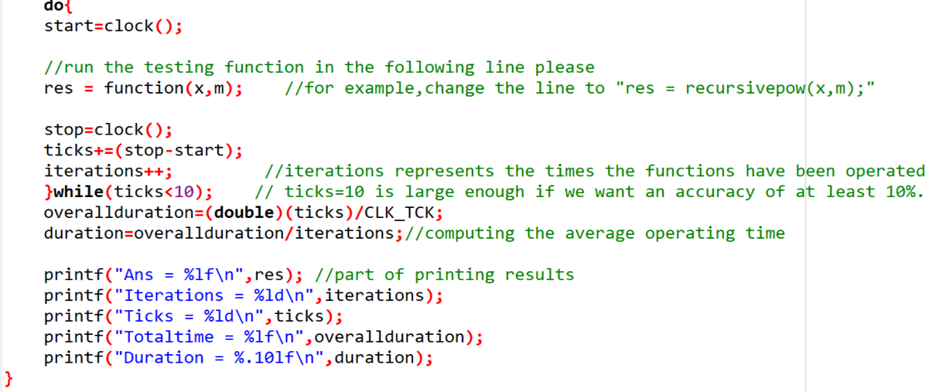**Chapter 5: Appendix**: **Here are part of my Source Code (in C)**

**Chapter 6:Declaration**

I hereby declare that all the work done in this project titled"陈硕" is of my independent effort