MP 1 Documentation
Bernadette Misa
2013 – 05551
CS 131 WFX
April 5, 2018

Heat Transfer - Cubic Interpolations

Given the data of Temperature (Celsius) and Water Depth (m):

Table 1: Summer temperature vs depth for Platte Lake
z (m) | 0 | 2.3 | 4.9 | 9.1 | 13.7 | 18.3 | 22.9 | 27.2
T ( ◦ C ) | 22.8 | 22.8 | 22.8 | 20.6 | 13.9 | 11.7 | 11.1 | 11.1

temp_vs_depth = np.array([[0.0, 2.3, 4.9, 9.1, 13.7, 18.3, 22.9, 27.2], [22.8, 22.8, 22.8, 20.6, 13.9, 11.7, 11.1, 11.1]])

1. Curve Fitting
***********************************************************************************

1.1 Performing least squares regression to a cubic polynomial using the data in
Table 1.

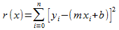
The least squares regression model is the formula below:

Below is the generalized matrix form of the least squares regression model:

Equation 1: Ac = y

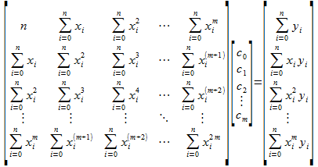

In solving 1.1, the least_squares_cubic_poly function returns lsm_final which is the matrix A in equation 1.

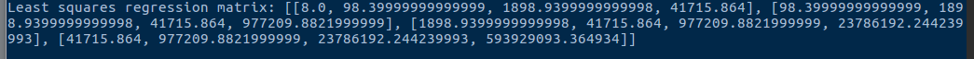

In 1.2, equation 1 is solved using Cholesky LDLt decomposition on A which is represented by calling the LDLt(A_matrix, b) function. Below are the corresponding L, D and LT matrices. The LDLt(A_matrix, b) returns the a0 -a3 coefficients that are asked to be solved.

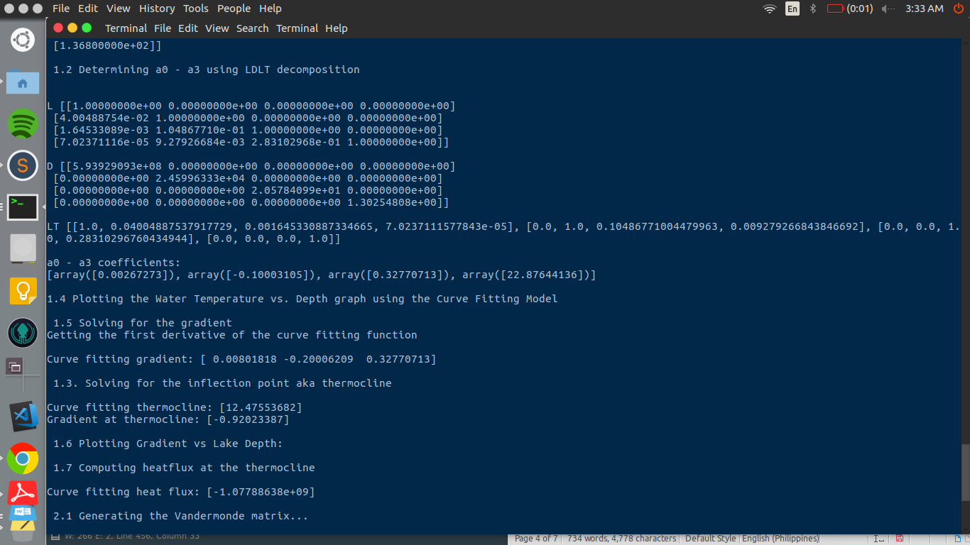

In 1.3, the inflection point (also known as the thermocline) is being asked to solve for.

To be able to get the thermocline, the second derivative of the temperature with respect to the water depth should be equal to 0 as described by the equation below.
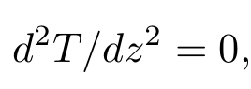

This is done by first getting the first derivative of the curve_fitting_model by using the polyder() function, a function that uses the Horner’s method. The resulting function will be equivalent to the gradient (curve_fitting_gradient) which is also asked to be solved in 1.5.

After being able to get the curve_fitting_gradient, it is differentiated again using the polyder() function, to be able to get the thermocline. The thermocline is computed using the roots() function and has the highest absolute value when evaluated into the curve_fitting_gradient.

The curve_fitting_thermocline = 12.476

The gradient at the thermocline = -0.92023387

1.4 Plotting the Temperature vs Water Depth

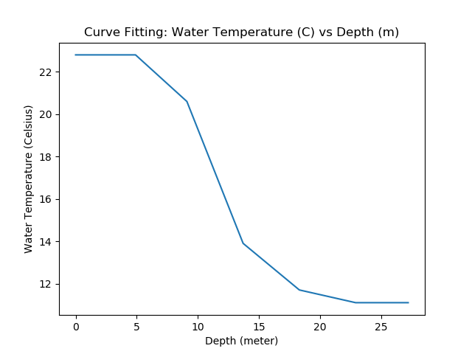

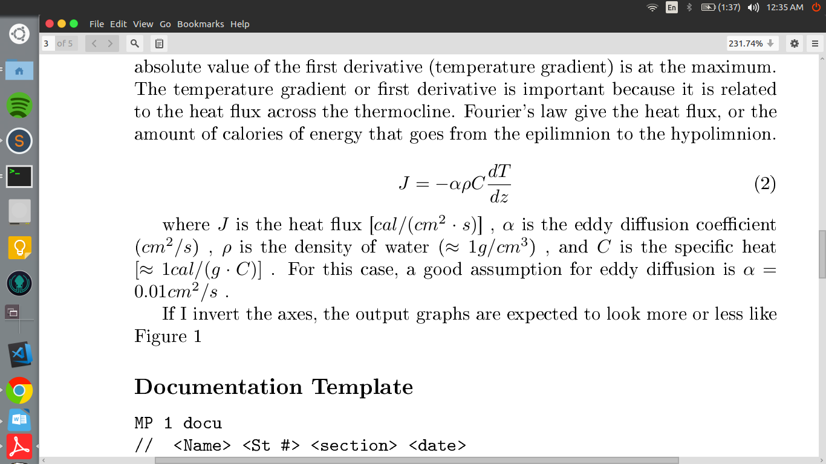

1.6 Plot the Gradient vs Lake Depth (m)

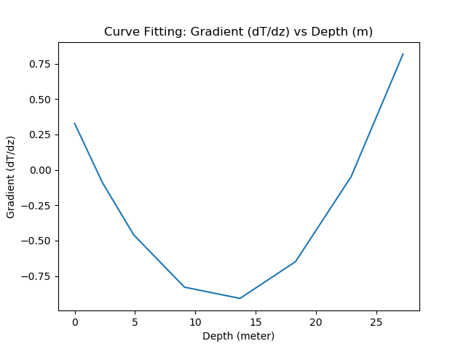

1.7 Computing for the heat flux at the thermocline

The heat flux is given by the equation below as stated in the MP hint.

However, we are being asked to determine the heat flux across the thermocline in terms of calories per square centimeter per day using Fourier's Law.

The get_heat_flux(point) function computes for the heat flux at the certain parameter point. In this case, the point is the thermocline. Necessary conversion are also made to the units to be able to return the correct units which is heat flux in terms of calories per square centimeter per day.

Heat flux = -1.07788638e+09

2. Monomial Basis
***********************************************************************************

2.1 Construct Vandermonde Matrix

The Vandermonde matrix is defined below:

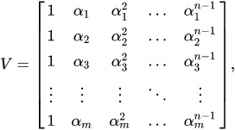

The generate_Vandermonde_matrix() generates the corresponding Vandermonde matrix for the given water temperature data.

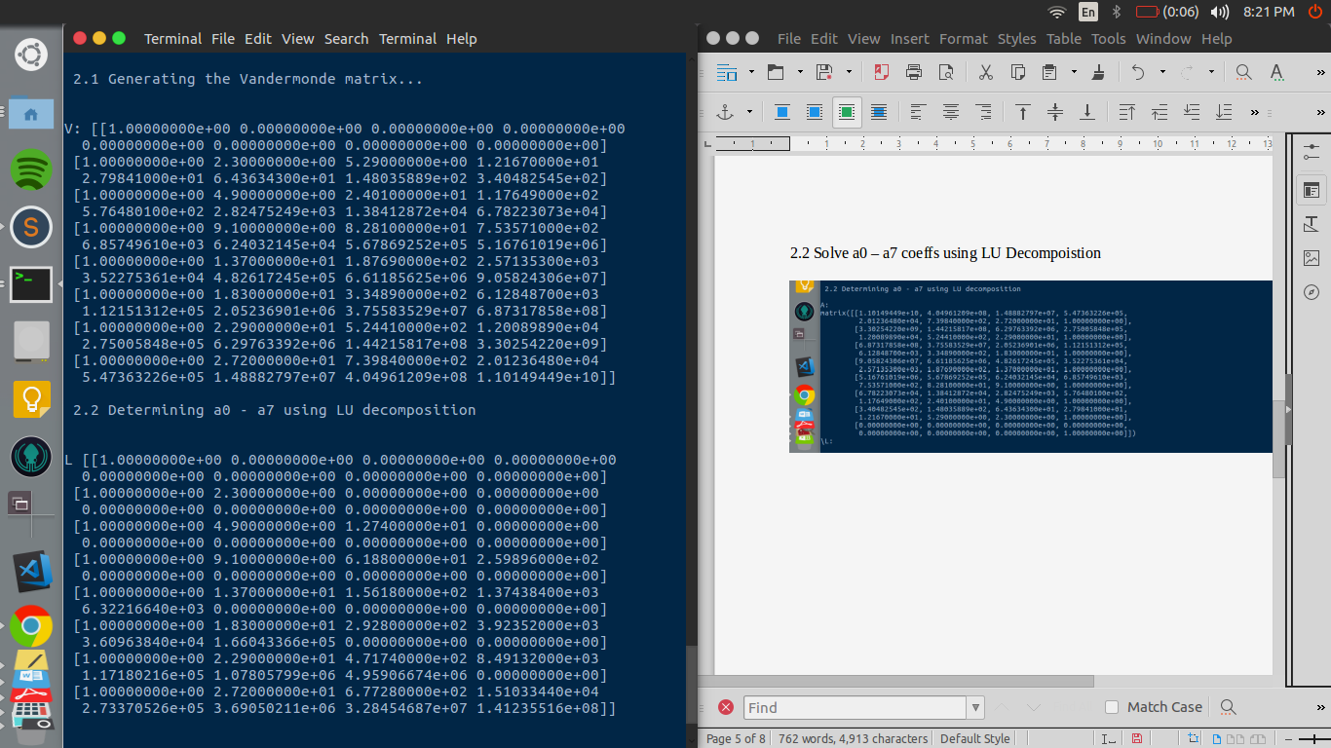

2.2 Solve a0 – a7 coeffs using LU Decompoistion

Eq. 2: Ax = b

The coefficients a0 – a7 is solved using the LU_decomp(A_matrix, b) function where the Vandermonde matrix V is th A matrix in equation 2. This returns the monomial_poly_fcn array which contains the a0 – a7 coefficients.

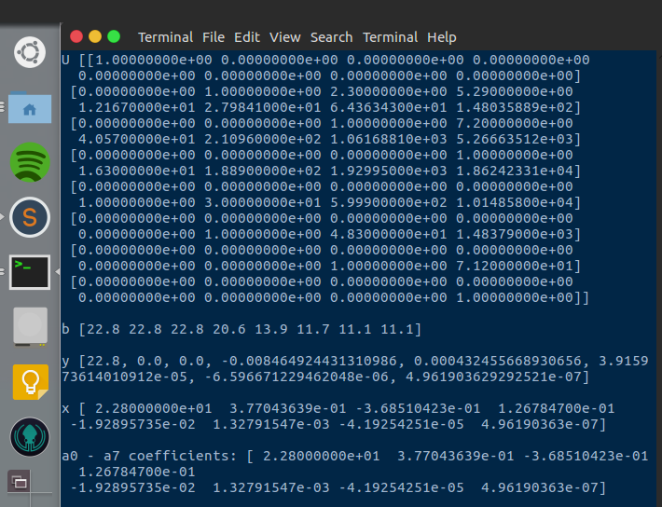

Just like in the previous number, in 2.3 we are also asked to find the inflection point aka the thermocline. To be able to get the thermocline, the second derivative of the temperature with respect to the water depth should be equal to 0.

This is done by first getting the first derivative of the monomial_poly_fcn by using the poly_der() function, a function that also uses the Horner’s method. The resulting function will be equivalent to the gradient (monomial_gradient) which is also asked to be solved in 2.5.

After being able to get the monomial_gradient, it is differentiated again using the poly_der() function, to be able to get the thermocline. The thermocline is computed using the get_inflection_point() function and has the highest absolute value when evaluated into the monomial_gradient.

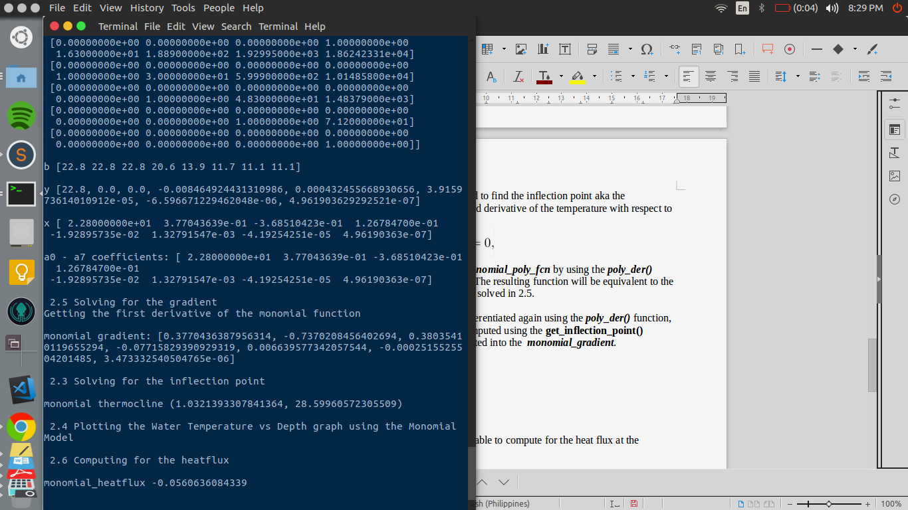

2.4 Plot temperature vs Water Depth

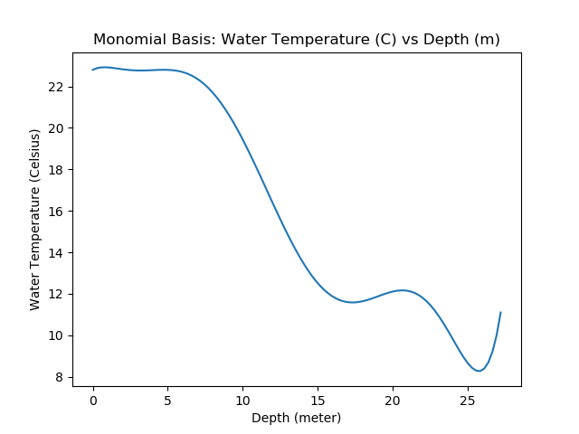

2.6 Compute Heatflux
The get_heat_flux(point) function is called again to be able to compute for the heat flux at the thermocline.

Heat flux = -0.0500636084339

2.7 Plot gradient vs lake depth

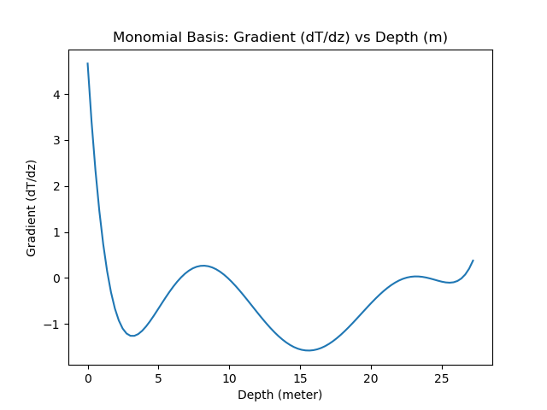

3. Piecewise Cubic Polynomial Interpolation
***********************************************************************************

3.1 Use polynomial cubic splines
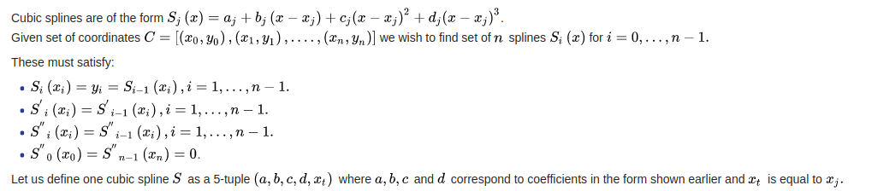

(Retrieved from Birkhoff; de Boor (1965). "Piecewise polynomial interpolation and approximation". In Garabedian, H. L. Proc. General Motors Symposium of 1964. New York and Amsterdam: Elsevier. pp. 164–190.)

To be able to solve for the cubic splines, the cubic_splines_wiki(temp_vs_depth) function

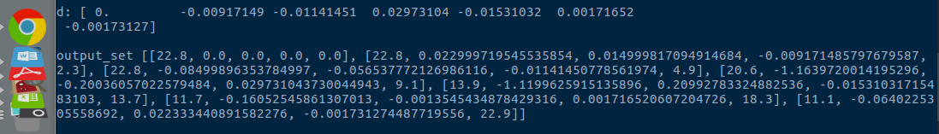

3.2 Determine depth of thermocline

3.3 Solve for the gradient
Thermocline is at the max slope

3.4 Compute Heat flux

3.5 Plot temperature vs Water Depth

3.6 Plot gradient vs lake depth

