1) First Come – First Serve (FCFS) Scheduling

All incoming requests are assigned at the end of the queue and the number that is next in the queue will be served the next. This algorithm does not give the best results. In the above case, it went from 2255 to 2055 to 1175 and so on. From 2255 to 2055 it moved 200 tracks and likewise, if you add up the total number of tracks then you will get the total number of tracks it had to go through before finishing the entire queue of requests. For this case, it had a total head movement of 13279 tracks as calculated in the table below.

2255
2055 | 200
1175 | 880
2304 | 1129
2700 | 396
513 | 2187
1680 | 1167
256 | 1424
1401 | 1145
4922 | 3521
3692 | 1230
Total | 13279

2) Shortest Seek Time First (SSTF) Scheduling

| ( 2255 - 2304 )| + | ( 2304 -2055 )| + | ( 2055 - 1680 )| +| ( 1680 - 1401 )|
+ | ( 1401 - 1175 )| + | ( 1175 - 513 )| + | ( 513 - 256 )| + | ( 256 - 2700 )|
+ | ( 2700 - 3692 )| + | ( 3692 - 4922 )|
= 6763

Order of cylinders visited:
2255, 2304, 2055, 1680, 1401, 1175, 513, 256, 2700, 3692, 4922

3) SCAN Algorithm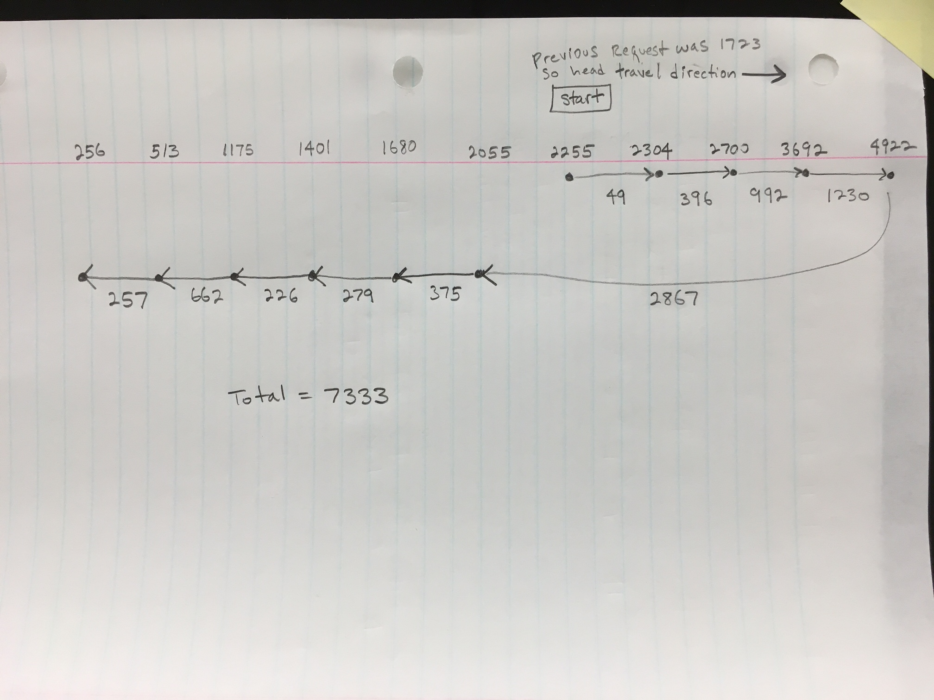

4) LOOK Algorithm

5) C-SCAN Algorithm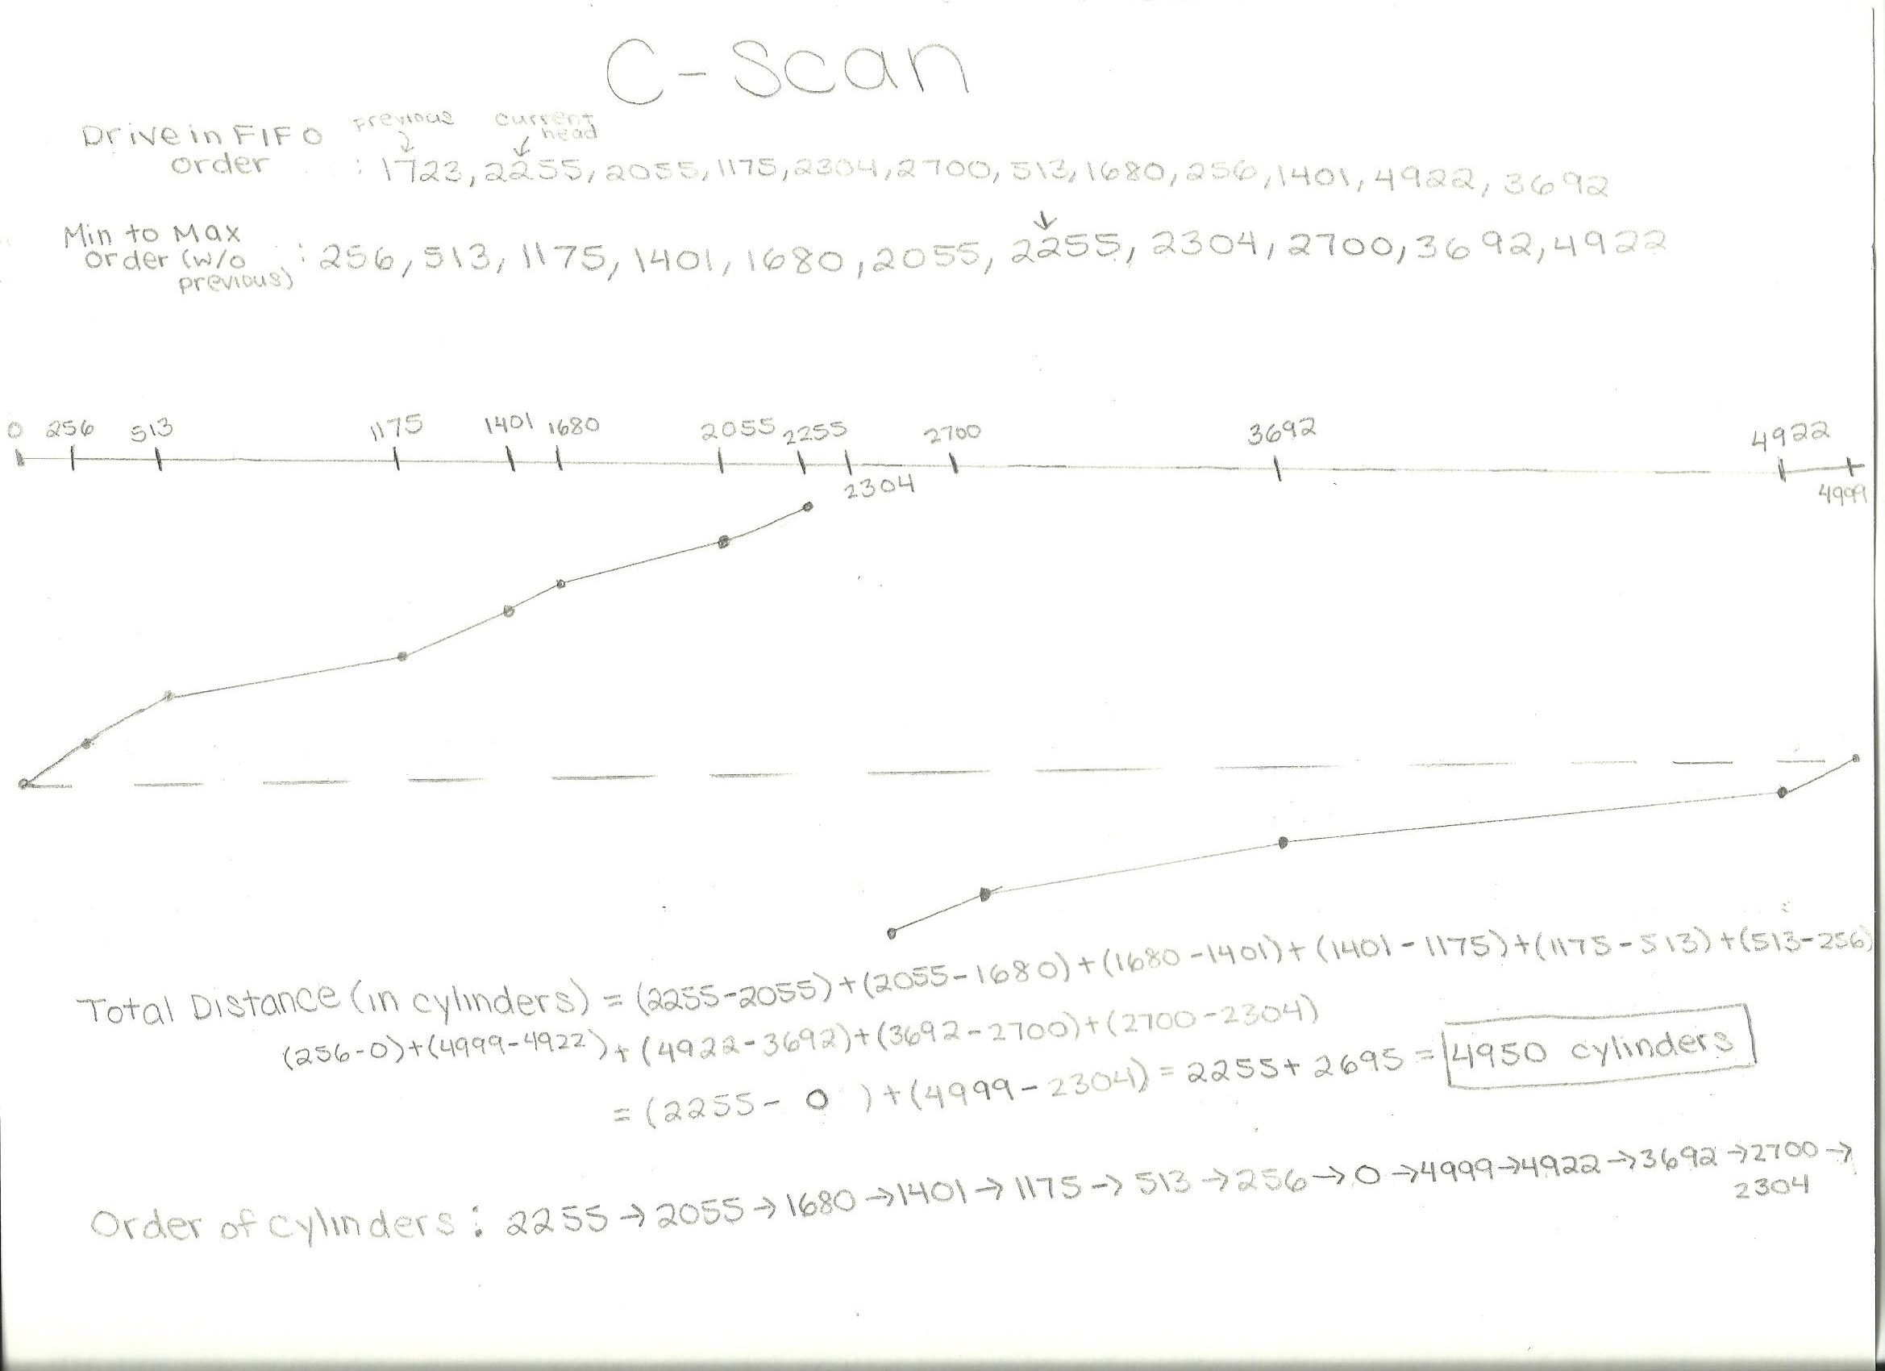

6) C-LOOK Algorithm