EventHub Requirements Specification
1.0 Product Overview
EventHub is a web application that provides a place for members to organize and explore local events that interest them. An event on EventHub can be anything from a pickup football game to a nationally touring concert coming to your town. More specifically, EventHub empowers users to manage a personal account that includes creating and deleting events, following other members, and the ability to RSVP to events. EventHub also provides robust mechanisms which give users the ability to discover events around them. These mechanisms include an “event feed” view where all upcoming events can be seen. Also users have the ability to search events based on various parameters including date, type, and location. Finally users have the ability to follow other users' event creation. All of these features are provided via a reliable and robust back-end that provides enterprise-level reliability without compromising in flexibility. The software that runs EventHub has been battle tested in production environments for years on the largest of scales. Through all the powerful features that EventHub provides, the software breaks down the existing barriers that are in place for people to find events and meaningful experiences around them. No longer will a person be disappointed when they find out about a concert only after it happened or be frustrated when they did no hear about a pickup basketball game happening with some friends she hasn't been able to catch up with in a long time. No matter what the event though the key mission of EventHub remains the same: Help people find exciting, meaningful, and interesting things to do wherever they may find themselves.
2.0 Information Description
2.1 – User Interface
See User Manaul section of software configuration.
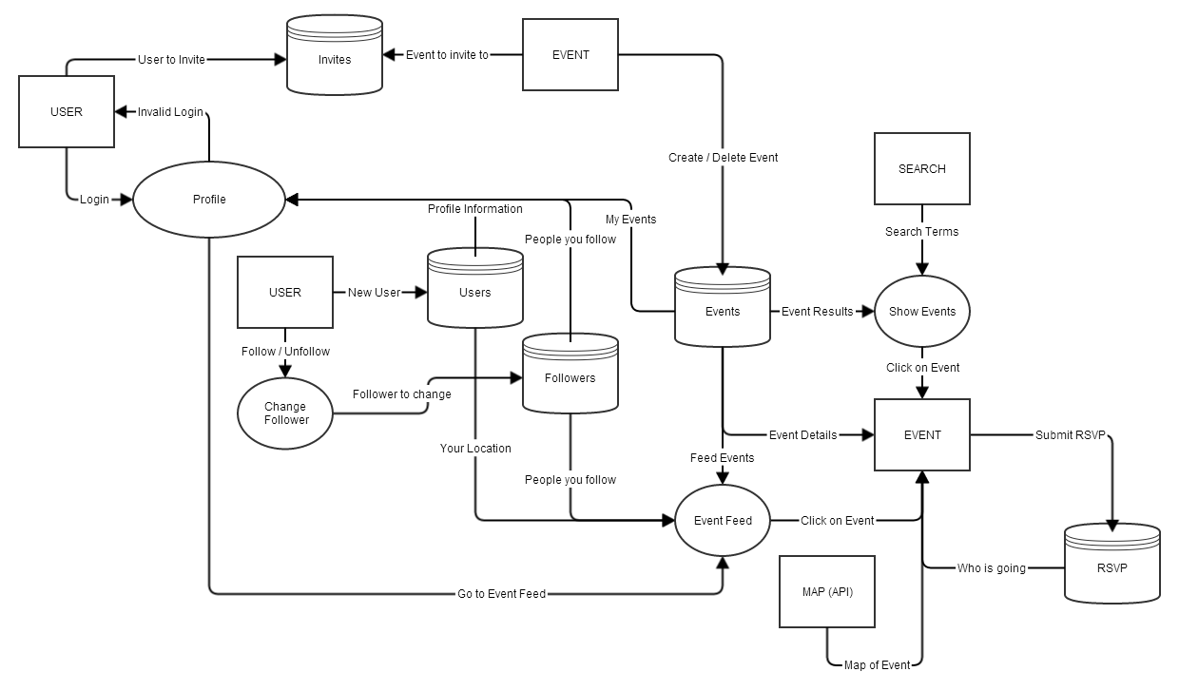
2.2 – High Level Data Flow Diagram
3.0 Functional Descriptions
3.1 New User
3.1.1 Description:
EventHub enables users to sign-up with a unique account that stores various information unique to that user. To sign up, a user must input his or her profile information into a registration form and click submit. The information entered by a user is error checked to ensure that it meets the minimum requirements of each input. The new user is prompted to correct errors, if any. Once the information entered in the form is valid, then the new user is entered into EventHub's user database. All users are stored in the user database. Once a new user is registered, the user is able to access her or her profile as well as EventHub's other features.
3.1.2 IC Cards:
3.1.3 Design Constraints:
A new user is limited to providing only the information that is required in the registration form. A new user may provide a name, email, picture, and a short bit about themselves. New users can only sign up with a valid email address.
3.2 Follow Other User
3.2.1 Description:
People can follow other users on Eventhub. The following mechanism allows users to track which events other users create or RSVP to. Once a user has registered with a personal account, the user is able to log in and navigate to other users’ profiles. The user can then simply click the “follow” button on other user's profile to follow them. Both users are then notified. When a user follows another user, that relationship is stored in the followers database.
3.2.2 IC Cards:
3.2.3 Design Constraints:
Users need an account to follow other users. Users cannot block other users from following them. However, users can only view other users that are interested in the same events as themselves (there is no user search at this time).
3.3 Event Creation
3.3.1 Description:
Users may create events on EventHub. Anyone with a valid EventHub account may create an event. To create an event, provide the necessary information (name, location, and type) and submit this form. After standard error checking, all events are submitted and stored in the events database. Once an event is created, the standard EventHub functionality associated with events is enabled. Users can perform EventHub’s standard event functions, such as search, RSVP, invite, and deletion for the created event. The original event creator serves as the sole administrator for the event.
3.3.2 IC Cards:
3.3.3 Design Constraints:
Only EventHub users with a valid account can create events. Users can only create valid events. For example, a valid event must specify a time, place, and event type before it is created. Multiple users cannot create the same event. Users cannot transfer control of an event to other users. Event creators have no control upon who can view their event within the EventHub site.
3.4 Event Deletion
3.4.1 Description:
An event creator can delete events. Users can delete events in the “My Events” section in their profile. Users can delete events that they have created and have administrator privileges for by simply clicking “Delete Event”. Once confirmed, an event is deleted. Once an event is deleted, it is irrevocably lost. And it is fully removed from the events database. This means that it will no longer be accessible from any feature within the rest of EventHub. For example, users can not search and find a deleted event and the event no longer can be seen on any user’s feed.
3.4.2 IC Cards:
3.4.3 Design Constraints:
Only user that made an event can delete it. Users cannot delete events that have already occurred. Similarly, users cannot delete events once the event is in progress.
3.5 Event Search
3.5.1 Description:
Users are given the ability to search events. To search an event, a user must go to EventHub’s search page and enter specific search terms. Users may filter searches by location, event type, and date. After a user submits a search, a list of the most relevant events is provided. To find these results, EventHub queries the event database and selects the most relevant event data, based upon our industry gold standard search algorithm. Once a user selects an event to inspect, he is taken to an event page which displays the event's information.
3.5.2 IC Cards:
3.5.3 Design Constraints:
Only EventHub users may search events. Search is limited by the provided search filters.
3.6 RSVP to an Event
3.6.1 Description:
Users may RSVP to an event. EventHub users can RSVP to an event by finding an event’s page and clicking the “RSVP” button. Users can RSVP to events they find via search, see on their feed, or are invited to. When a user RSVP’s to an event, this relationship is stored in the RSVP database. Users can see who is RSVP’d to an event via viewing the event details, or looking at their feed of followed users. Users can RSVP to a limitless number of events. In fact, it is encouraged.
3.6.2 IC Cards:
3.6.3 Design Constraints:
Only registered EventHub users may RSVP to an event. There is no functionality to deny users from RSVP’ing to an event.
3.7 View Event Feed
3.7.1 Description:
Users can view their event feed. To view an event feed, a user must navigate to his or her profile where the event feed will be listed. The event feed provides a real time display of events that are relevant to the user. Users see events flow across their event feed that their followers RSVP’d to, or that they RSVP’d to. The event feed serves as both a reminder and a notification of events that are of interest to the user. Event data from the event database, followers database, and RSVP database fuels the event feed.
3.7.2 IC Cards:
3.7.3 Design Constraints:
Users can only see events on their event feed which they are directly connected with. For example, the feed only shows events that their followers and those they followed, along with pending event invites. Other events, like nearby events, that the user has no connection with will not display on a user’s event feed.
3.8 Invite User to Event
3.8.1 Description:
Users can invite other users to an event. To invite another user to an event, a user can do one of two things. First, a user may navigate to another user’s profile, click “invite, and specify which event. Second, a user may invite multiple users to the same event by going to an event’s page and clicking “invite users”. Once a user is invited to an event, the relationship is stored in the invites database. When a user is invited to an event, a user is able to RSVP for that event.
3.8.2 IC Cards:
3.8.3 Design Constraints:
Users can only invite other users to events which they either RSVP’d for or created. Users can only invite other registered users to an event.
3.9 Event Map
3.9.1 Description:
Users may view EventHub’s event map. The event map uses the Google Maps API to display pins of event locations. Users will enjoy the same functionality as Google Maps. Users can view events on the map and click on each event to either learn a little bit about that event or navigate to the event’s EventHub page. The event map uses an outside API for its functionality.
3.9.2 IC Cards:
3.9.3 Design Constraints:
The event map is limited in functionality by the Google Maps API. EventHub will not be providing additional features that are not offered by the Google API.

