EventHub Object Oriented Analysis
- System Overview
EventHub is a complex system that empowers its users to create events and view events that are most important to them. The system that makes this possible involves interaction between different classes and functions in a unique way. EventHub consists of four primary classes that are pivotal to the functionality of the system. These classes are Users, Events, Profiles, and Invitations. This document explains the interaction between these classes and how they are incorporated into the entire EventHub system.
- The Class Model
2.1 The Classes
User(ID, Password, First_Name, Last_name)
Event(Event_ID, Event_Name, Event_Type, Event_Location, Event_Time, Event_Creator)
Profile(ID, First_Name, Last_Name, Event_Feed, Followers, User_Picture)
Invitation(Event_ID, Inviter_ID, Invitee_ID)

2.2 The Class Diagram
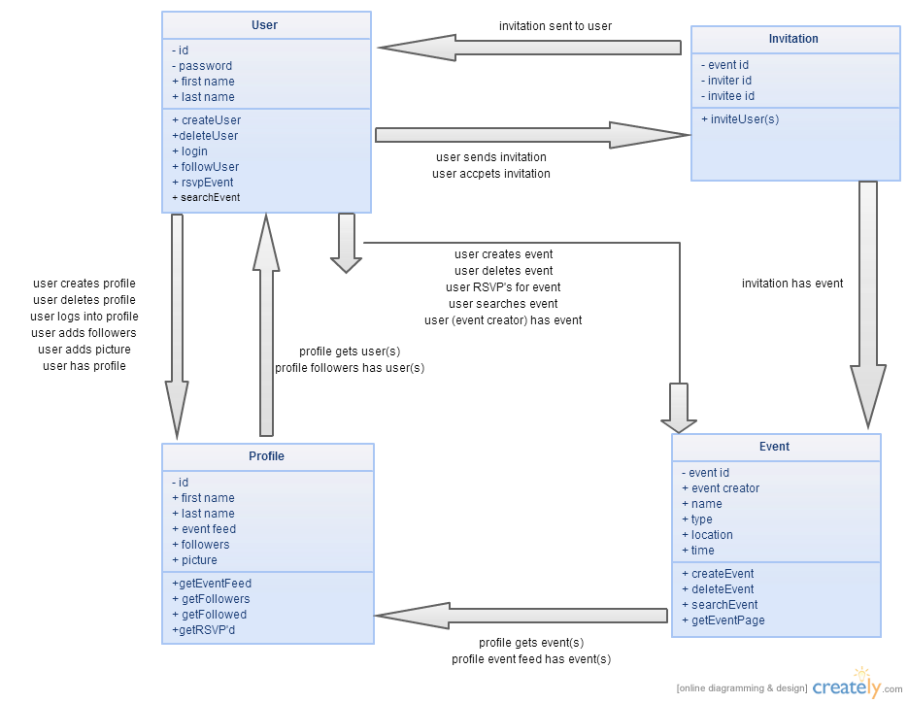
3.0 The Dynamic Model
EventHub contains two key scenarios that warrant explanation by the use of the dynamic model. Both creating an event as well as invited a user to an event are described below through the user of both a step by step scenario description as well as a state diagram.
  - Scenarios
    - User creates an event
- User logs into EventHub
- User makes a request to create and event
- User completes event form
- User submits event to database
- Event is added to user’s profile
    - Invite user to event
- User logs into EventHub
- User navigates to event page
- User makes a request to invite others to the event
- Other users which this user follows are listed
- User selects user to invite
- Invitation is created
- Invitation is added to invited user’s profile
  - State Diagrams
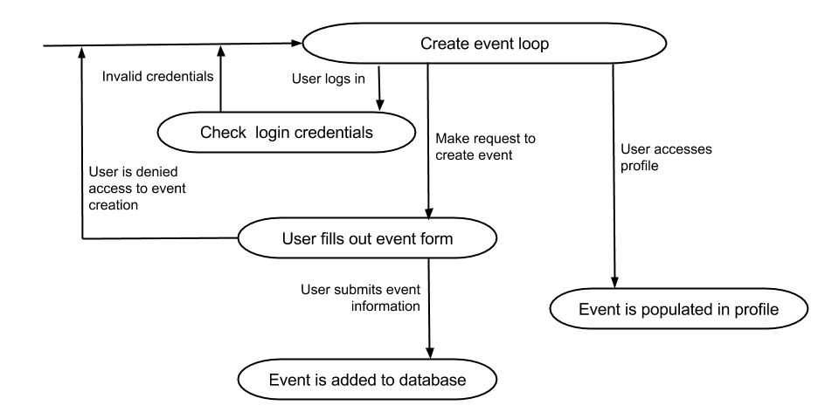
    - User creates an event

    - Invite user to event
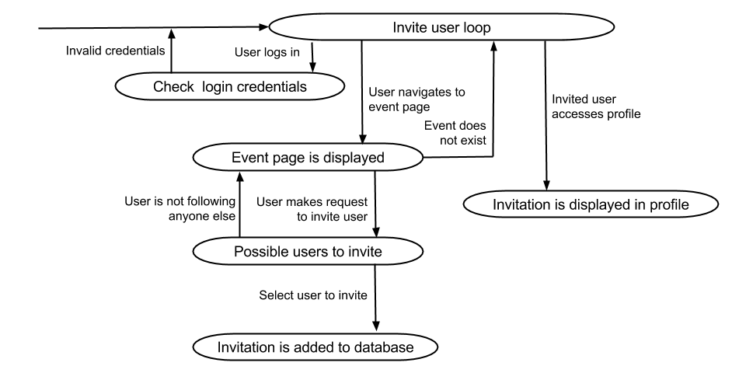
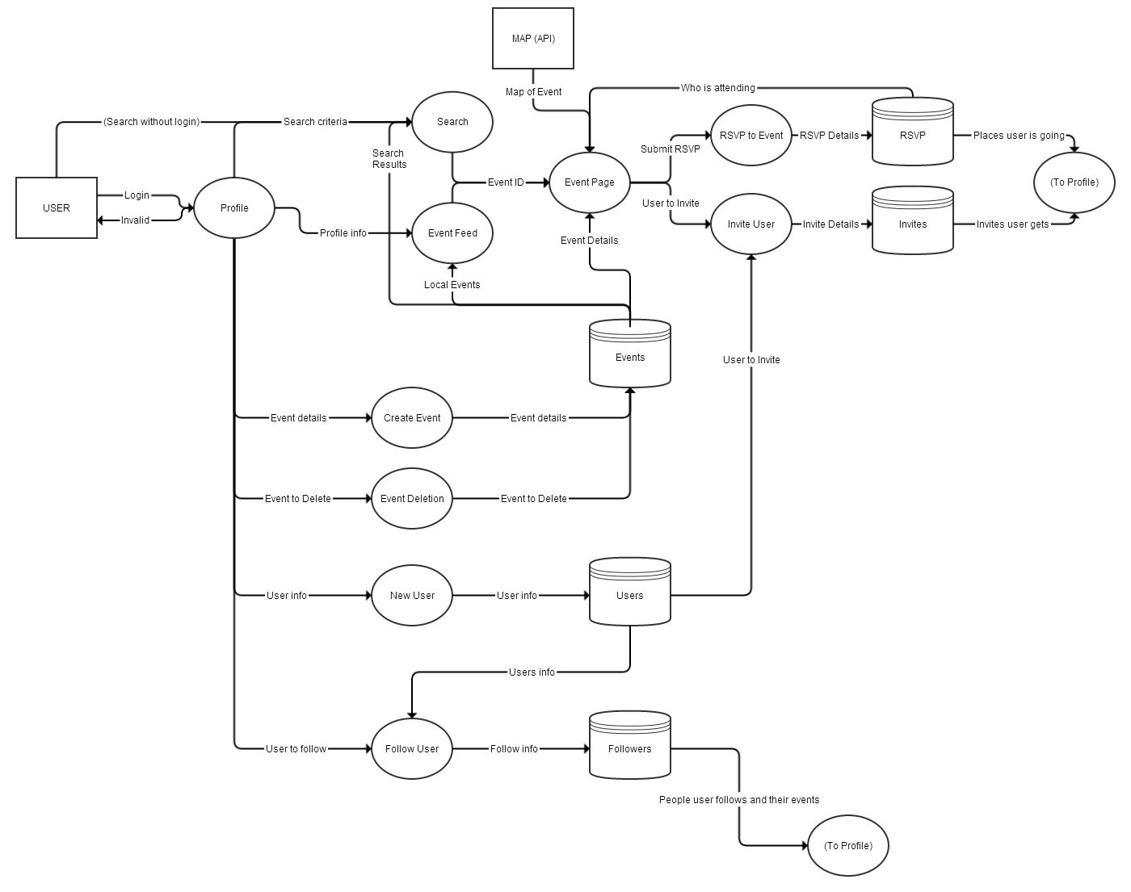
- The Functional Model

