SJSU Bookhub

Team 15

Project Design

ENTITIES

----------------------------------------------------------------------------------------------------------

Conversation list - It is the entity that will store the conversations a user has with other users of the site.

Conversation - This contains the messages between two users.

Messages - The individual messages that a user sends.

Users - The people that are signed up to use this service.

Uploaded files - They are the files that are uploaded by the user to accompany their book listing(for quality assurance).

Department - This contains all the courses within each specific department.

Courses - The courses available within SJSU.

Listing - A user-made post of a book for sale for certain course(s).

ATTRIBUTES

----------------------------------------------------------------------------------------------------------

Users:

- email: PRIMARY KEY this is the email that user uses to create an account on our site

- profile picture: This is the user's profile picture. The website creates a default profile picture

for new accounts.

- password: This is part of the login credentials for the user to access their account.

- username: This is an optional field. If there is none specified, it will default to their email.

Conversations:

- user2: PRIMARY KEY This is going to be using the primary key of one of the second users participating

in the conversation.

Message:

-date: PRIMARY KEY This is the date/time at which the message is sent

-sender: PRIMARY KEY This is the one of the user who sent the message

-content: This is the actual text of message that the user wants to send

Uploaded Files:

-filename: PRIMARY KEY This is the name of the file that the user wants to upload and it needs to have a unique name

Listing:

-title: PRIMARY KEY This is going to be the title of the lsiting and the title can not be same for two listings.

-price: the price of the book in the listing. This will be required.

Courses:

-name: PRIMARY KEY This is the name of the course and two courses cannot have same name

Department:

-name: PRIMARY KEY This is the name of the department and two departments cannot have same name

DEPENDENCIES

----------------------------------------------------------------------------------------------------------

- Finding the listing depends on the department and course that is associated with the listing.

- The presence of conversations depends on the presence of messages.

- Uploaded files depend on the Users because without the users uploading there will be no files on out

database

RELATIONSHIPS

----------------------------------------------------------------------------------------------------------

has - this relation refers to the conversation list that users have with many users

Talks To - refers to the conversations between two users when they send messages to each other

Lists - refers to the listings that a user can create

Listing - refers to the department and course that the listing belongs to

upload - refers to the files uploaded by users

forms - messages create conversations. It is a many to 1 relationship.

CONSTRAINTS

----------------------------------------------------------------------------------------------------------

-password: must be at least 8 characters long

-email: must contain @sjsu.edu

-username: must be at least 3 character long and maximum 12 characters long

-filename: must be a string

-price: must only contain integers

-profile picture: It must have appropriate file type extension. It will also has to be reference by a name

since storing it in the database is no best practice.

-For conversations between two users, only those two users will have access to the conversation.

SHOW ISA, MULTI-WAY RELATIONSHP, WEAK ENTITY SETS, ETC THAT APPLIES TO YOUR DESIGN

----------------------------------------------------------------------------------------------------------

- multi-way relationship: There is a multiway relatiionship between department, course and listing. A listing

can only exist if there is a department, course and a listing post associated with it.

- Role in a Relationsip: There is a role of User1 and User2 in the Talks to relation because two users need to be messaging each other in the conversation.

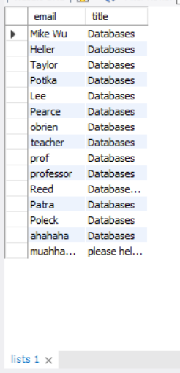Pictures of Tables:

List Table

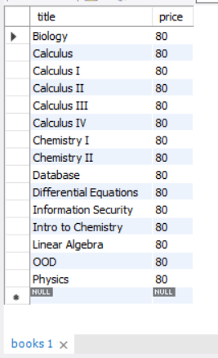

Books Table

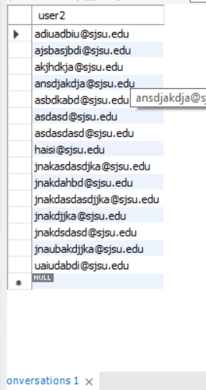Conversations Table

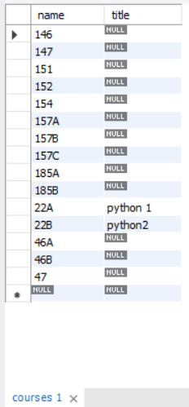

Courses Table

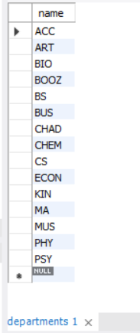Department Table

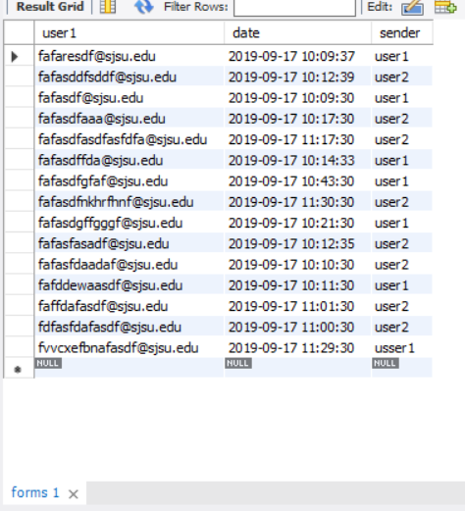

Forms Table

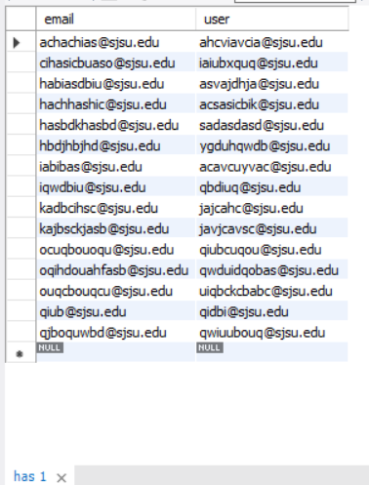

Has Table

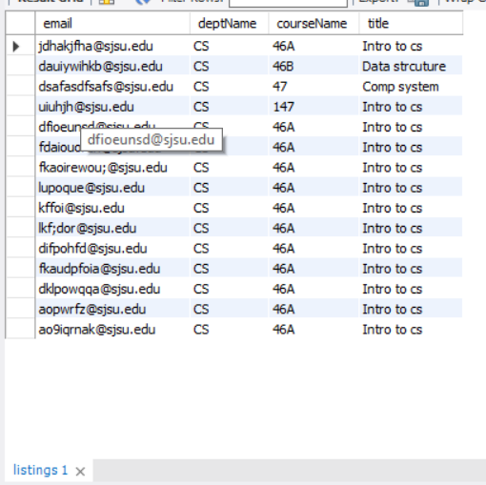

Listings Table

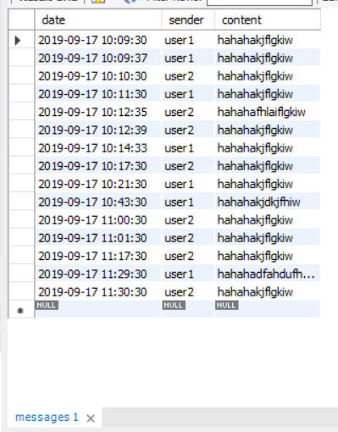

Messages Table

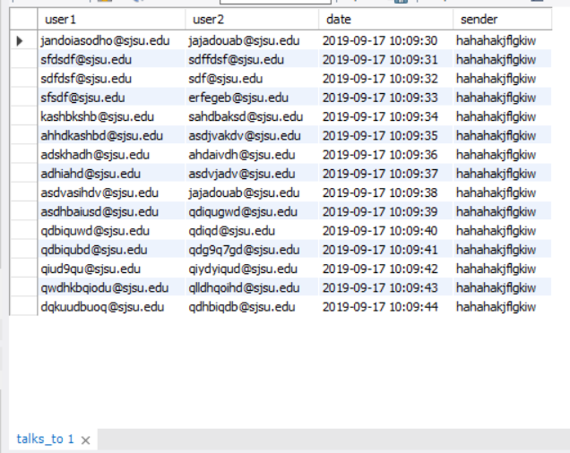

Talksto

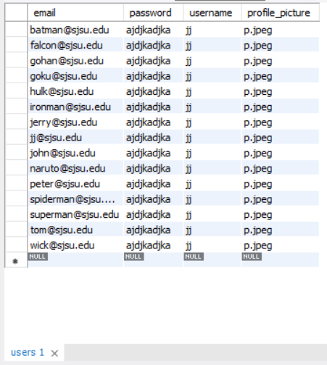

Users Table



Uploadedfiles Table

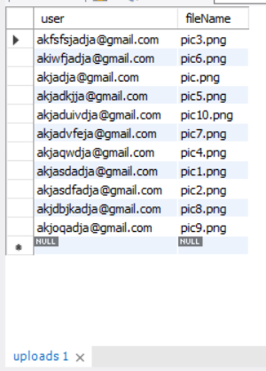

Uploades Tables