**Project Overview**

A web application that connects experts of various levels in various fields to mentees to build serious mentor/mentee relationships.

The Stakeholder are of the following:

**-People who are looking for career help**

**-People who are becoming hobbists**

In learning of any topic it is difficult for people to look up resources that provide a guided experience. Take students in college for example. Academic success centers exist, but there are time limits and location limits to these resources. Rotating availabilities of mentors makes it difficult to real serious mentor/mentee relationships, which help with learning tremendously. This web app cuts the delay from the time a problem arises and a solution found. It also changes the typical dynamic of guided learning into one that promotes well rounded success.

**- People who want to pay it forward of their technical skill**

**- People who want to share their niche expertise**

The process of someone with expertise to share their knowledge is quite stifled. There are many hoops that one must set up in order to connect with people who are interested to learn. There are also complications that arise due to flakey students or bad characters that leave a bad taste. A robust platform should free the experts to express to their best extent their knowledge, and provide a network of talent, both of experts and “experts-to-be” that can help hone their craft.

**- Developers**

We want to maintain a lively community and a source of income.

**System Environment**

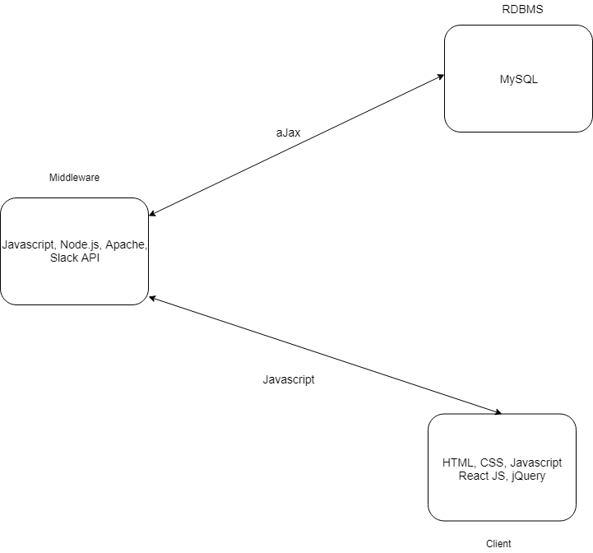

**Functional Requirements**

- Describe users and how users access system

Users log on to the system, and can choose to tag themselves as mentors or mentees for any topic. There will be a general front page of which a user can participate in discussions in all kinds of topics. They can access their dedicated chat platform for their particular mentors/mentees and group chats as well.

- Describe functionality/features, processes and I/O

Features:

Rating system:

Mentors/Mentees can write and read reviews left by others on the platform, this helps prospective mentors/mentees with decision making to see if that respective person would be a good fit for them. This feature is essential as it ensures users have a quality experience connecting with other users.

Tags system:

The tags system is designed to help the users in finding the skills they are looking for (reword), and these tags can be used to filter the mentors to only find the ones with those certain skills set.

Matching:

Mentors will have the ability to take mentees “under their wing”, establishing a concrete contact. Mentees can try to establish contact with mentors, but there is no guarantee that a mentor will accept to become a dedicated mentor to them.

Chat Messaging:

The chat messaging feature is the main way of communication among the mentors/mentees with each other. There will be two types of chat messaging channel, a public group one for everyone to ask questions and respond to others, and the other will be a private chat between the mentor and the respective mentee. There will also be other public chats available such as a mentees only chat based on geofencing where they can discuss topics or just hold some casual conversations, and mentors only chat for mentors to connect with each other and talk about things such as different ways of guiding the mentees.

Profile:

The profile will demonstrate a mentor’s/mentees’ interests in a particular field, location and relevant experience.  The page will include an avatar, description, rating and tags the particular user would like to be categorized under.

**Non-functional Issues**

Usability

- The prevalence of chat and message boards should make this system rather simple to operate.

Reliability & Performance & Scalability

- The scope of the project currently makes the system setup in a virtual 3-tier architecture. Depending on the success, we may port it onto a cloud hosting platform, thus increasing positive traits of all of the factors above.

Security

- Personal information that is acquired during sign up will be salted, hashed, and/or encrypted based on data type.