**CS 157A Project Proposal**

**Three-Tier Web Application**

**Bookie**



Cole McKinnon, Jonathan Van, Yu Xiu

Team 4

Advisor: Dr. Mike Wu

Sep. 05, 2019

**Project Overview**

According to the Bureau of Labor Statistics, the cost of attending college has increased by 63% between 2006 and 2016, while the cost of textbooks has increased by 88% from 2006 to 2016. [1] While some professors do not require textbooks for their courses, a good number of them require students to purchase untransferable one-time use textbooks with the online access code. There must be a way or method to reduce costs for students of all majors while they are at university.

We will be creating a system for San Jose State students to buy and sell used textbooks. Users will be able to buy and sell textbooks to other students using a JS web app. When a user has a book they no longer need, they can post it on the system. When a student wants to buy a book, they can search through the available postings by book title, author, or course. When the student buyer is interested in a listing, they can communicate with the seller through the app.

If a student wants to sell a textbook, they can do so by creating a new book posting. Creating a new posting will require sellers to fill in a title, author, price, and picture. The book title will be used when buyers are searching for books. Buyers will also be able to search for books based on the courses requiring them.

The backend will primarily be a MySQL database that will keep track of postings, namely the textbooks posted by sellers. The database will also be responsible for storing users, sales history, and messages between users. The various tables will be referenced with one another using IDs of the users, the listing ids, and the message ids. These will be accessed by taking user inputs from the front end/client and parsing it into a SQL like format to be used by NodeJS, after it established a connection to the database, to get the data we need to display.

The stakeholders for this application will be students who need the textbooks and want to save money, and students who have the textbooks and want to make money. This is important because once a semester ends for a student, they rarely use the textbooks anymore. And nowadays, textbooks are no longer inexpensive, so it is costly for students to buy a required text in order to pass the class. The application is vital as it will connect college students (preferably SJSU) who will pass off the books to one another in order to reduce the costs during their time at university.

This application is necessary since there exists no dedicated application to selling books or items between students. Current technologies are Craiglist and SJSU’s Sammy. However, the former is not affiliated with San Jose State University, therefore its integrity is questionable and the latter is inefficient for selling books as there is no optimal search function and is a primarily scrolling text-based application. The format that SJSU Sammy has is not ideal for creating, listing, presenting, and searching for sales posts.

The overall goal of our project is to reduce the costs of anything possible while at San Jose State University by connecting past students of courses with new students to courses for them to sell, buy or trade books with one another.

**System Environment**

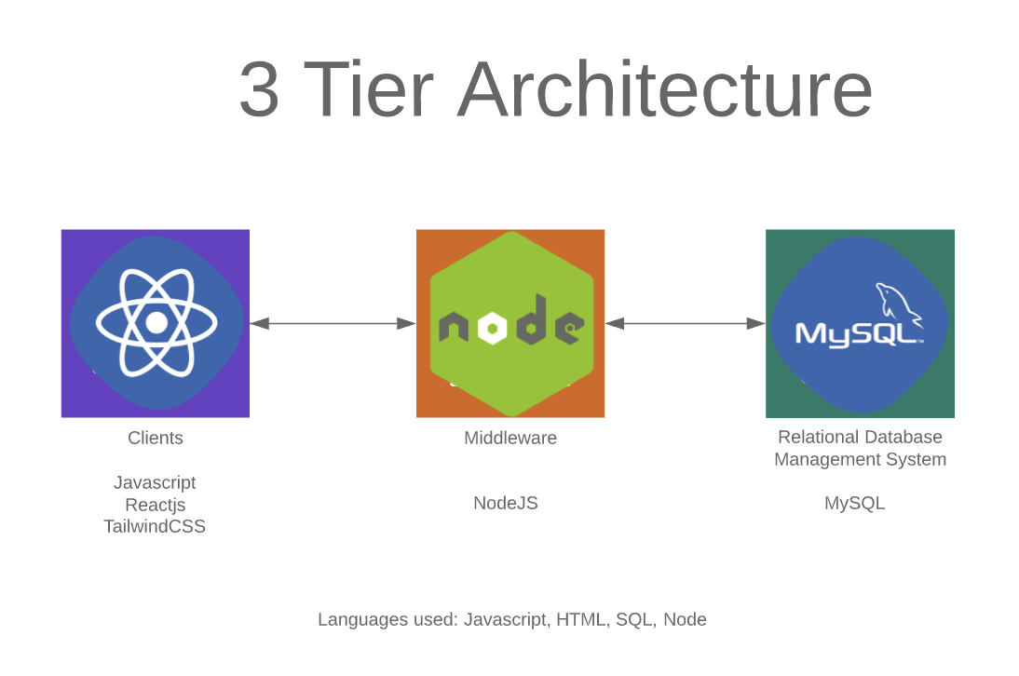

In the diagram above, our client will be run on any browser that has an up to date javascript version. Bookie will be displayed using javascript running with Reactjs. The CSS will be implemented via TailwindCSS. NodeJS will act as the middleware to connect the client to the database, that way any action the user takes, such as signing up, logging in, creating posts or buying books, will have a request and then a response to or from the RDBMS.

**Functional Requirement**

1. **Users**
   * Our clients are SJSU students
   * Students go to web application
   * Search through postings
   * Create a new posting
   * Remove Posting
   * Sign/Login
   * View Previous Postings/Purchases
   * Rate other users after the purchase
   * Messaging Between other users

|  |  |
| --- | --- |
| **Client** | SJSU Students |
| **Client Access** | Students go to web application |
| **Functionality** | Search through postings |
|  | Create a new posting |
|  | Remove posting |
|  | Sign/Login to the web application |
|  | View previous postings/Purchases |
|  | Rate other users after the purchase |
|  | Message Between other users |

SJSU students will be the primary users of the web application.

After a seller has made a posting, they will of course have the option to cancel that posting if they change their mind about selling. Doing this will remove the posting from the database.

1. **User Registration**

All users who choose to sell a textbook will need to make an account beforehand. These accounts will be stored in a separate table

**Non-Functional issues**

1. **Security**

1.1 One poster cannot access to another poster’s post

1.2 Online transaction is secure

1. **Types of Graphical Interface**

2.1 Web Application

2.2 Software tools to build Graphical Bookie web application Interface are Javascript, Reactjs, and tailwindCSS

1. **Access Control**

3.1 Each poster only access to the page that contains his or her own posting

3.2 Users would not be able to see our database

REFERENCE FOR DOCUMENT:

**Chapter 1   Introduction - Jonathan Van**

* 1. Project Goals and Objectives
  2. Problem and Motivation
  3. Project Application and Impact
  4. Project Results and Deliverables
  5. Project Report Structure

**Chapter 2   Background and Related Work - Vincent Diep, Jonathan Van**

* 1. Background and Used Technologies
  2. Literature Survey
  3. State-of-the-art Summary

**Chapter 3   Project Requirements -Vincent Diep, Jonathan Van**

3.1 Domain and Business Requirements

3.2 System (or Component) Functional Requirements

3.3 Non-functional Requirements

3.4 Context and Interface Requirements

3.5 Technology and Resource Requirements

**References**

[1]:<https://www.vox.com/the-goods/2019/3/6/18252322/college-textbooks-cost-expensive-pearson-cengage-mcgraw-hill>

**Bibliography**

Cover page: Yu Xiu

Project Overview: Cole Mckinnon

System Environment: Jonathan Van

Functional Requirement:

Users: Jonathan Van, Yu Xiu

User Registration: Cole Mckinnon

Non-Functional Requirement: Yu Xiu