**MINI PROJECT REPORT**

**Student Management System**

**(using Shell Scripting)**

Submitted in partial fulfilment of the requirements

of the degree of

Bachelor of Engineering

In

Computer Engineering

By

08.JAGANNATH BARIK

11.APURVA CHAUDHARI

21.DNYANESH DHUMAL

47.CHITRANSH SRIVSTAVA

Under the guidance of

Prof. Hasib Shaikh



Department of Computer Engineering

K.C. College of Engineering and Management Studies and

Research, Thane (E)

Mumbai University

2019-2020

**ACKNOWLEDGEMENT**

No project is ever complete without the guidance of those expert who have already traded this

past before and hence become master of it and as a result, our leader. So we would like to take

this opportunity to take all those individuals who have helped us in visualizing this project.

We express our deep gratitude to our mini project guide Prof. Hasib Shaikh for providing

timely assistant to our query and guidance that he gave owing to his experience in this field for

past many years. He has indeed been a lighthouse for us in this journey.

We extend our sincerity appreciation to all our Professors from K.C. College of Engineering &

Management Studies AND Research for their valuable suggestions during the designing of the

project. Their contributions have been valuable in so many ways that we find it difficult to

acknowledge of them individual.

We also express our gratitude to our HOD Prof. Mandar Ganjapurkar for extending his help

directly and indirectly through various channels in our project work.

Thanking You.

**CERTIFICATE**

This is to certify that the report on mini project entitled,

Student Management System

Project Members

08.JAGANNATH BARIK

11.APURVA CHAUDHARI

21.DNYANESH DHUMAL

47.CHITRANSH SRIVSTAVA

As a partial fulfilment for Bachelor of Computer Engineering

Degree course of Mumbai University for Academic year 2018-2019

INTERNAL GUIDE

Prof. Hasib Shaikh

___________________ ___________________

EXTERNAL EXAMINER INTERNAL EXAMINER

___________________ ____________________

HOD PRINCIPAL

(Prof. Mandar Ganjapurkar) (Dr.Vilas Nitnaware

**INDEX**

|  |  |  |
| --- | --- | --- |
| **TABLE OF CONTENTS** | | |
| **Chapter** |  | **Page No.** |
| **1** | **ABSTRACT** | **05** |
| **2** | **INTRODUCTION** | **06** |
| **3** | **PROGRAM CODE** | **07** |
| **4** | **OUTPUT SCREEENSHOTS** | **10** |
| **5** | **APPLICATIONS** | **13** |
| **6** | **CONCLUSION** |  |
| **7** | **REFERENCES** |  |

**ABSTRACT**

Students form a main part of any institution that concerns with. But the institutions find it difficult to keep details of so many students of the organization just in one stretch. It will involve a lot of pen paper work. Sometimes there will be some huge heap of files bundled up and kept together in some corner of the office. If you want any information regarding the particular student then it can be obtained by just entering the roll number or the name of the student to be searched. This student management system will make the work of storing the data in an organized way.

The Student management System is a component covering many student aspects. The system records basic personal information, admission information, education information regarding student.

Leading edge systems provide the ability to “read” applications and enter relevant data to applicable database fields, notify student and provide result. Student management function involves

* Manage new admission and enrolment
* Manage quota
* Manage board
* Manage category
* Manage Fees Structure
* Roll number generation
* Fees payment
* student Basic Information
* Manage faculty
* Manage designation
* Manage course and specialty
* Manage semester and year
* admission seat management
* Exam scheduling
* Result management
* Subject management
* Block management

**INTRODUCTION**

The student management system application will help in managing the student’s reports, results and exams will become easier with one such system. It will also help in saving time and effort. We will be using a file as database to keep record of the data entered by the user

* Student management: The details of the students of the organisation can be stored with the use of this application.
* Results: The results of the students can also be accessed and stored through this application.
* Security: The data that will be disclosed will be more secure since there will be no access to the unknown users.
* Performance: The performance of the students might be in curriculum as well as co-curriculum can also be stored through the use of this application.
* One-click access: You will obtain the details of the students by entering his/her name or the roll number just in one click.

**CODE:**

echo "1. Create database "

echo "2. View database "

echo "3. Insert a record "

echo "4. Delete record "

echo "5. Modify a record "

echo "6. Result of particular student "

echo "7. Exit"

echo "Enter your choice "

read d

case $d in

1)

echo " Enter rollnumber of student "

read rn

echo "Enter name of student: "

read nm

echo " Enter marks in OPERATING SYSTEM: "

read os

echo " Enter marks in APPLIED MATHEMATICS: "

read am

echo " Enter marks in COMPUTER GRAPHICS: "

read cg

record="$rn $nm $os $am $cg "

echo $record>stud

;;

2) echo " Showing database of student"

cat stud ;;

3)

echo " Enter rollnumber of student: "

read rn

echo " Enter name of student: "

read nm

echo " Enter marks in OPERATING SYSTEMS: "

read os

echo " Enter marks in APPLIED MATHEMATICS: "

read am

echo " Enter marks in COMPUTER GRAPHICS: "

read cg

record="$rn $nm $os $am $cg "

echo $record>>stud

;;

4) echo " Enter roll number: "

read rn

grep ^$rn stud

if [ $? -ne 0 ]; then

echo "Record for roll number does not exist "

else

grep -v $rn stud>>tmp

cp tmp stud

echo "Deletion complete "

fi

;;

5) echo "Enter roll number: "

read rn1

grep ^$rn stud

if [ $? -ne 0 ]; then

echo "Record for roll number does not exist "

else

echo " Enter roll number: "

read rn

echo " Enter name of student: "

read nm

echo " Enter marks in OPERATING SYSTEMS: "

read os

echo " Enter marks in APPLIED MATHS: "

read am

echo " Enter marks in COMPUTER GRAPHICS "

read cg

record="$rn $nm $os $am $cg "

var=`grep -n ^$rn1 stud | cut -c 1`

echo $var

var1=`expr $var - 1`

head -$var1 stud>temp

echo $record>>temp

var3=`wc -l < stud`

var2=`expr $var3 - $var `

tail -$var2 stud>>temp

cp temp stud

fi

;;

6) echo " enter roll number "

read rn

echo "printing result "

grep ^$rn stud

;;

7) ;;

* ) echo "wrong choice"

esac

**Output:**

1.CREATE DATABASE COMMAND

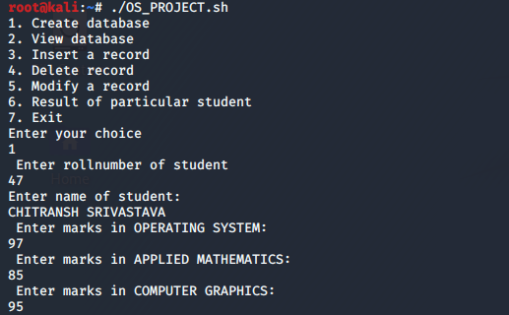

2.VIEW DATABASE COMMAND

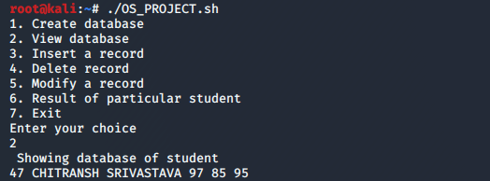

3.INSERT A RECORD COMMAND

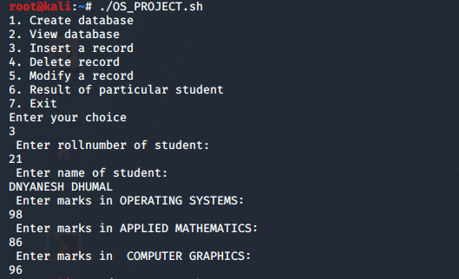

3.INSERT A RECORD COMMAND

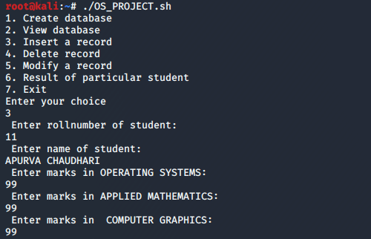

3.INSERT A RECORD COMMAND

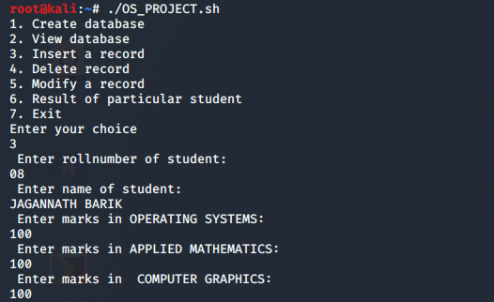

4.DELETE A RECORD COMMAND

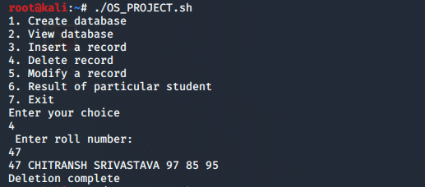

5.MODIFY A RECORD COMMAND

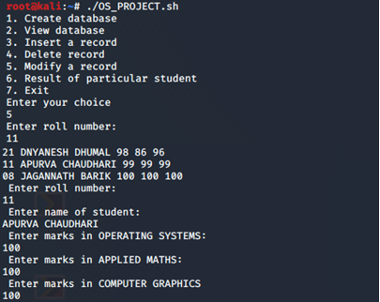

6.RESULT OF A PARTICULAR STUDENT COMMAND

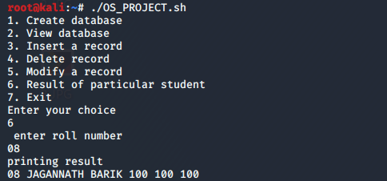

7.EXIT COMMAND

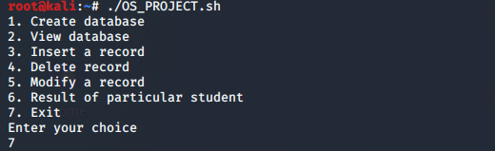

**APPLICATION:**

Student database management system can be useful in educational institutions and with a few modification the same module can be used to store data of members of any organisation in an easy to use and efficient manner.

**Conclusion:**

Thus, with the help of this application the information of the students will be much easier to access.

**Reference:**

<https://www.shellscript.sh/>

<https://www.tutorialspoint.com/unix/shell_scripting.htm>l

<https://www.guru99.com/introduction-to-shell-scripting.html>