Introduction

The main objective of the project is to build an multiplayer, interactive battleship game that the project team has decided to simply title Battleship to excite middle school students about the field of computer science. Secondary to this objective, the project team wishes to use the project as a means to gain experience in Java programming and networking, and to gain experience in solving a larger problem than they have previously encountered. The main constraints on the project are the project team's limited programming experience and the limited time allotted for the project.

Work Breakdown

Activity | Duration (hours) | Constraints
Create UML class diagram | 1 | -
Document UML diagram | 1 | UML class diagram finished
Create test plan | 1 | UML documentation finished
Code Battleship server BG game setup | 3 | UML documentation finished
Code Battleship server BG game play | 5 | Coding BG game setup finished
Mock-up GUI | 1 | UML documentation finished
Test Battleship server and prepare report | 3 | Coding Battleship server game play finished
GUI design document for customer | 3 | GUI Mock-up finished
Text-based Battleship client | 2 | Test report finished
GUI design document for programmers | 2 | GUI design document for customer finished
Code graphical client | 5 | GUI design document for programmers finished
Add sound effects | 2 | GUI design document for programmers finished
Graphical polish | 3 | Graphical client finished
Post-mortem commentary | 2 | Graphical polish finished
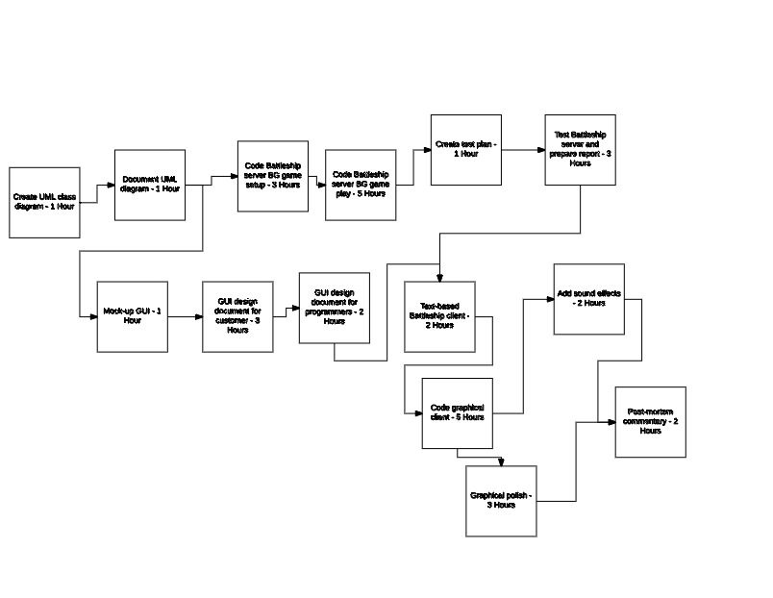
PERT Chart

Firstly, the project team will create a UML class diagram of the Battleship server. Then, they will create a document explaining the UML diagram in more detail, and finally they will update their time sheet to account for the work done. This will culminate with the delivery of deliverable two to the customer. Next, the team will create a test plan for the Battleship server, code the Battleship server, and create a mock-up of the GUI for the battleship client. These three tasks will be performed concurrently since neither of them relies on any other task being completed before the task can be started. The coding of the Battleship server will take place in two steps: firstly, the game setup part of the BG protocol will be implemented; secondly, the game play part of the BG protocol will be implemented. Once the test plan and the coding of the Battleship server is completed, the Battleship server will be tested and a test report will be created. This culminates with the delivery of deliverables three and four. The time sheet will be updated immediately before any deliverable is delivered to the customer. While testing the Battleship server, the team will work on to writing the GUI design document for the customer, followed by writing the design document for future programmers. The time sheet will then be updated, and deliverable five will be delivered. The Battleship client will then be coded in two parts, beginning with implementing a text-based client with the user manually issuing server commands, which will be done at the same time as the GUI design for the customer, and developing into a graphical client that automatically issues server commands. At the same time, sound effects will be developed for inclusion in the game. Then, graphical polish such as explosion or splash animations will be added to finalize the Battleship game. The time sheet will be updated, and deliverable six will be delivered to the customer. Finally, a post-mortem commentary will be written that details how well the project team was able to complete their various tasks and how close their time estimates were to the actual time it took to perform their tasks.

Gantt Chart

1)UML Class diagram -> Document UML class diagram ->BG Game setup ->BG Game play-> Test plan -> Test BattleShip and prepare report ->Text based battleShip client -> Code Graphical client -> sound ->commentary
1+1+3+5+1+3+2+5+2+2 = 25 hours

2)UML Class digram -> Document UML class diagram -> BG Game setup -> BG game play -> Test plan -> Test BattleShip and prepare report -> Text based battleShip client -> Code Graphical client ->Graphical polish -> commentary
1+1+3+5+1+5+1+3+2+5+3+2 = 26 hours

3)UML class diagram -> Document UML class diagram ->mock up GUL -> GUI design Customer ->GUI design programmer -> text based client -> Code graphical client -> graphical polish -> commentary
1+1+1+3+2+2+5+3+2= 20 hours

4)UML class diagram -> Document UML class diagram ->mock up GUI -> GUI design Customer ->GUI design programmer -> text based client ->sound ->commentary

1+1+1+3+2+2+5+2+2 = 19 hours

the second path is the critical path

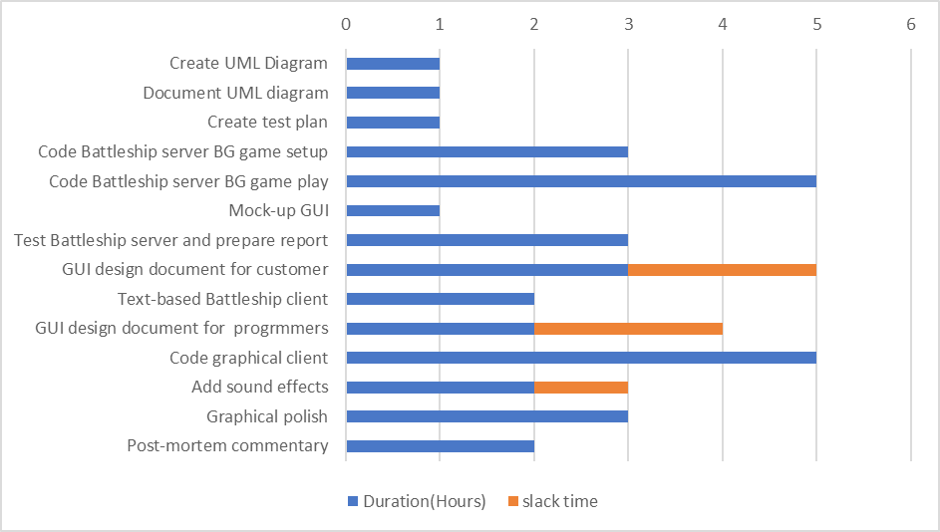

Risk Analysis

Since we are only a team of two, one of the team members becoming unable to work due to sickness or other causes beyond their control will have a large impact on the other member's ability to complete the project. This is not likely, but has been planned for due to its possible impact. Should a team member become incapacitated in any way, the remaining team member will request that a new team member be assigned to the project, and the remaining team member will add at least two hours a week of work to their normal work schedule in order to ensure enough time to complete both team member's tasks.

As with any software development project, there is a risk that our work becomes accidentally deleted. This may be caused by a hardware failure or by a mistake by one of the team members. The accidental deletion of work is not likely, but would cause a disruption in the project and so has been accounted for. In order to prevent work from being lost, the project team will use the Git version control system and the Github service to keep a remote backup of all of our work.

