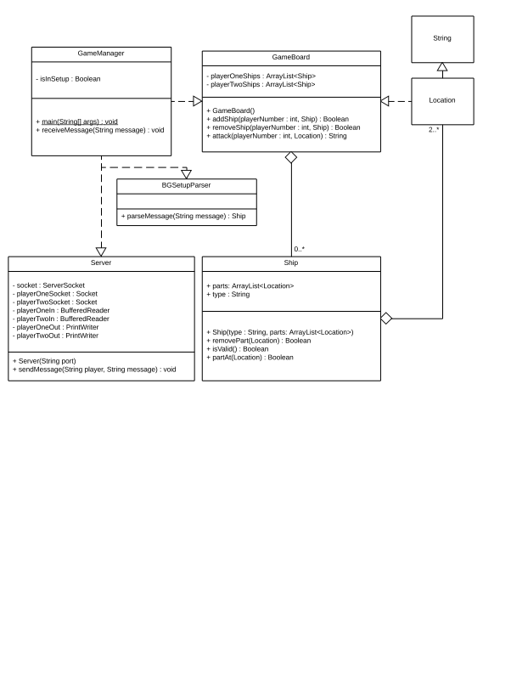

Test Case Number | Method or Subsystem Tested | Input Data To Use | Brief Explanation | Expected (Correct) Result
1 | Ship.isValid() | new Ship(“FR”, new ArrayList<Location>.add(“A1”)); | Testing a ship that's too small | isValid() should return “false”
2 | Ship.isValid() | new Ship(“FR”, new ArrayList<Location>.add(“A1”).add(“A2”).add(“A3”)); | Testing a ship that's too big | isValid() should return “false”
3 | Ship.isValid() | new Ship(“FR”, new ArrayList<Location>.add(“A1”).add(“B2”)); | Testing a ship that's placed diagonally | isValid() should return “false”
4 | Ship.isValid() | new Ship(“FR”, new ArrayList<Location>.add(“A11”).add(“A12”)); | Testing a ship that's placed off the grid | isValid() should return “false”
5 | Ship.isValid() | new Ship(“FR”, new ArrayList<Location>.add(“A1”).add(“A2”)); | Testing a ship that's placed correctly | isValid() should return “true”
6 | Ship.partAt() | new Ship(“FR”, new ArrayList<Location>.add(“A1”).add(“A2”)); | Testing with a part that does not exist at the location | partAt(“A3”) should return “false”
7 | Ship.partAt() | new Ship(“FR”, new ArrayList<Location>.add(“A1”).add(“A2”)); | Testing with a part that does exist at the location | partAt(“A2”) should return “true”
8 | Ship.removePart() | Ship temp = new Ship(“FR”, new ArrayList<Location>.add(“A1”).add(“A2”));  temp.removePart(“A2”); | Testing removing a  part | partAt(“A2”) should return “false”
9 | GameBoard.attack() | Player 1 has FR at locations “A1” and “A2” | Testing attacking a ship that damages, but does not sink, the ship | attack(1, “A2”) returns “hit”
10 | GameBoard.attack() | Player 1 has FR at locations “A1” and “A2” | Testing attacking a ship and missing | attack(1, “A3”) returns “miss”
11 | GameBoard.attack() | Player 1 has FR at locations “A1” and “A2”, with “A1” having already been hit, and player 1 has another ship on the board | Testing attacking a ship that sinks a ship | attack(1, “A2”) returns “sunk”
12 | GameBoard.attack() | Player 1 has FR at locations “A1” and “A2”, with “A2” having already been hit | Testing attacking a ship that has already been hit | attack(1, “A2”) returns “miss”
13 | GameBoard.attack() | Player 1 has FR at locations “A1” and “A2”, with “A1” having already been hit, and player 1 has no more ships on the board | Testing attacking a ship that sinks a ship | attack(1, “A2”) returns “win”
14 | GameBoard.attack() | Player 1 has FR at locations “A1” and “A2” | Testing attacking an invalid location | attack(1, “A11”) returns “err”
15 | GameBoard.addShip() | Player 1 has FR at locations “A1” and “A2”, called with locations “A2” and “A3” | Testing adding an overlapping ship | Returns false
16 | GameBoard.addShip()Player 1 has FR at locations “A1” and “A2”, called with locations “A2” and “A3” | Player 1 has FR at locations “A1” and “A2”, called with locations “A3” and “A4” | Testing adding a ship that does not overlap | Returns true
17 | BGSetupParser.parseMessage() | Called with “AC A1 A2 A3 A4 A5” | Testing parsing a valid message | Returns a Ship where Ship.isValid() returns true
18 | BGSetupParser.parseMessage() | Called with “AC A1” | Testing parsing a ship that is too short | Returns null
19 | BGSetupParser.parseMessage() | Called with “AC A1 A2 A3 A4 A5 A6” | Testing parsing a ship that is too long | Returns null
20 | BGSetupParser.parseMessage() | Called with “AC A1 A2 A3 A4 A6” | Testing parsing a ship with a gap | Returns null
21 | BGSetupParser.parseMessage() | Called with “AC A11 A2 A3 A4 A5” | Testing parsing a ship with a part off the grid | Returns null
22 | Server construction | Called with “3141”, does not connect properly | Testing unsuccessful connection | Throws IOException
23 | Server constructor | Called with “3141” | Testing successful connection | Does not throw an exception

