Local Contrast Enhancement (Histogram Equalization)

0. Original Image

Original (3648\*2432) vs small (304\*203):

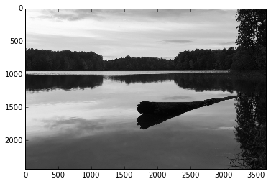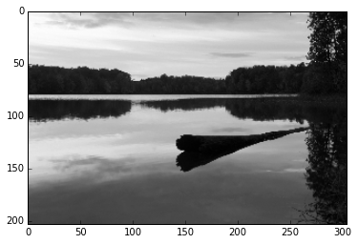

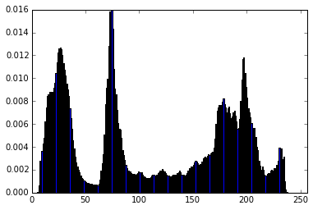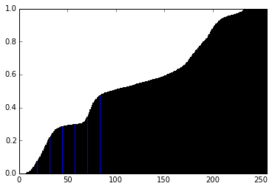

Histogram plotting: 3100 ms

Histogram plotting numpy: 324 ms

Cumulative histogram plotting: 4760 s

Cumulative histogram plotting numpy: 427 ms

1. HE serial (Histogram Equalization)

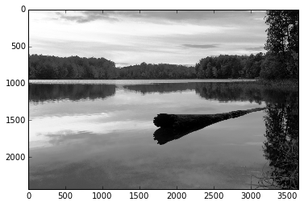

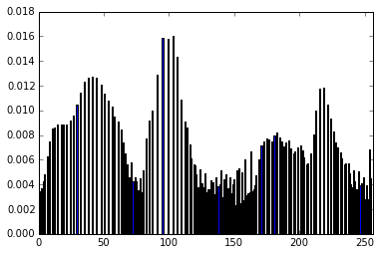 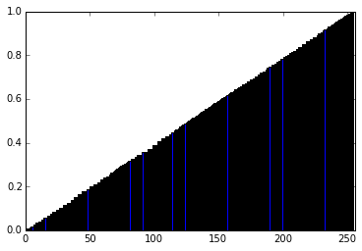

HE serial: 3400 ms

HE serial (on small picture): 39.4 ms

2. HE numpy

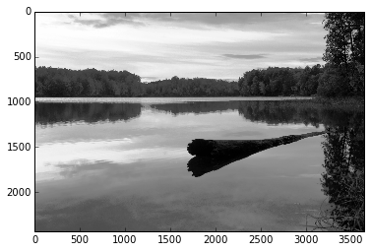 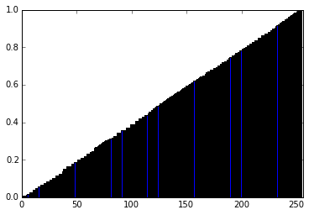

HE numpy: 360 ms

HE numpy (on small picture): 3.25 ms

3. LHE serial (Local Histogram Equalization)

D. J. Ketcham, R. W. Lowe, and J. W. Weber, Real-time image enhancement techniques, in Seminar on Image Processing, Hughes Aircraft, Pacific Grove, California, 1976, pp. 1-6.

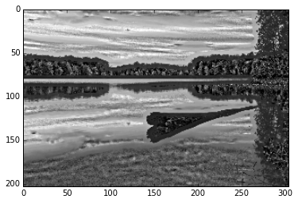

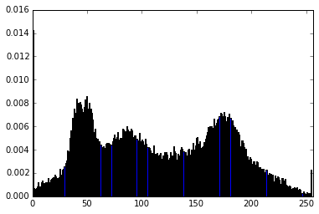 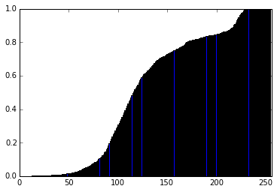

LHE serial: > 5 min

LHE serial (on small picture): 2790 ms

4. AHE serial (Adaptive Histogram Equalization)

R. A. Hummel, Image enhancement by histogram transformation, Comput. GraphicsImage Process. 6, 1977, 184-195.

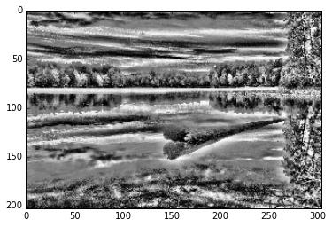

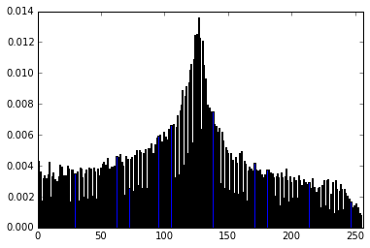 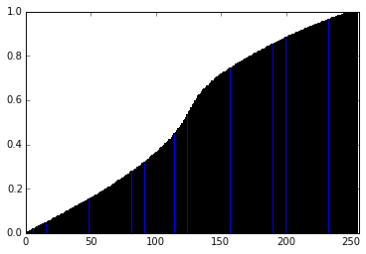

AHE serial: > 5 min

AHE serial (on small picture , windowsize=21): 10500 ms

5. AHE opencl with buffer

On large image, the result is not satisfying due to a small window size (will optimize in later section). I performed this AHE on a small image so as to compare with section 4 of small image.

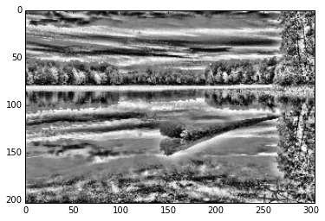

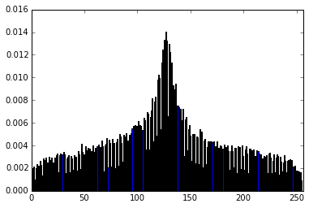 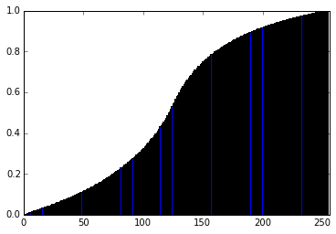

AHE opencl with buffer: 390.71936 ms

AHE opencl with buffer (on small picture with windowsize=21): 3.96824 ms

6. AHE opencl interpolation optimization

S. M. Pizer, E. P. Amburn, J. D. Austin, R. Cromartie, A. Geselowitz, T. Greer, B. H. Romeny, J. B. Zimmerman, and K. Zuiderveld, Adaptive histogram equalization and its variations, *Comput. Vision Graphics Image Process.* **39**, 1987, 355–368.

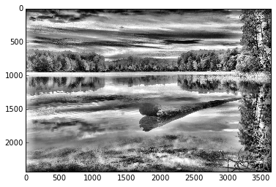

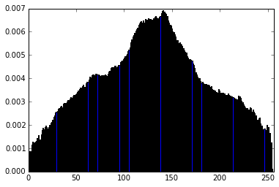 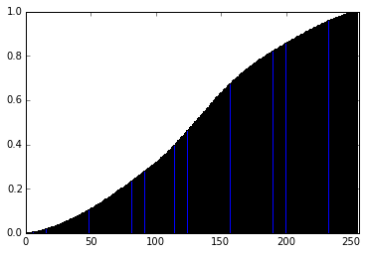

AHE opencl interpolation optimization:

1. histogram calculation: 201.05504 ms

2. transformation: 7.4756 ms

3. total: 208.53064 ms

AHE opencl interpolation optimization (on small picture):

1. histogram calculation: 0.41576 ms

2. transformation: 0.07736 ms

3. total: 0.49312 ms

Segmentation size = 1, 3, 6, 12, 24, 36:

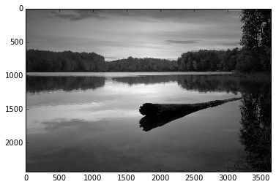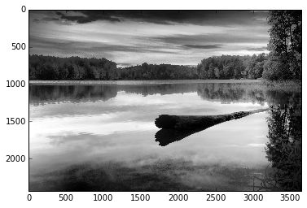

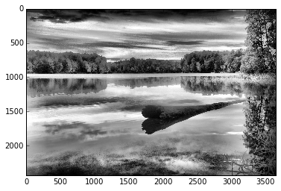

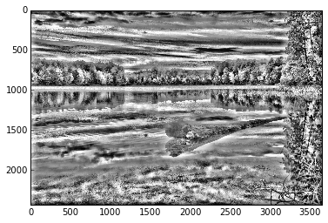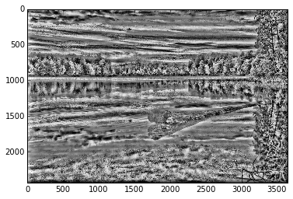

Total time:

Segmentation=2: 272.64904 ms (265.37424 + 7.552)

Segmentation=3: 264.61312 ms (255.14872 + 7.67632)

Segmentation=6: 248.44032 ms (235.45944 + 7.57376)

Segmentation=12: 208.53064 ms (202.96056 + 8.07872)

Segmentation=24: 140.31648 ms (135.84248 + 7.6752)

Segmentation=36: 121.5244 ms (110.9908 + 7.81456)

7. AHE opencl interpolation optimization with buffer

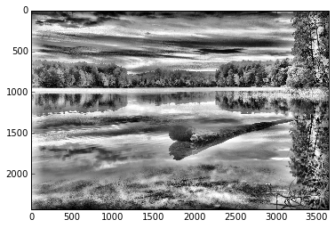

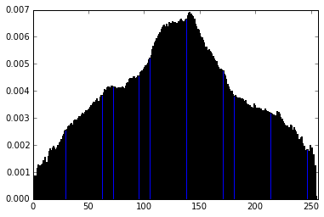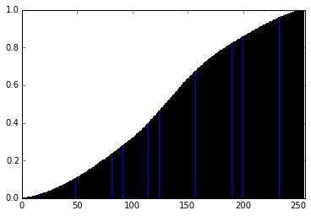

AHE opencl interpolation optimization with buffer:

1. histogram calculation: 203.61952 ms

2. transformation: 514.46936 ms

3. total: 718.08888 ms

AHE opencl interpolation optimization with buffer (on small picture):

1. histogram calculation: 0.42904 ms

2. transformation: 3.30296 ms

3. total: 3.732 ms

8. AHE opencl interpolation optimization with buffer of data type uchar (256 bins vs 32 bins)

Part 1: Still 256 bin histogram

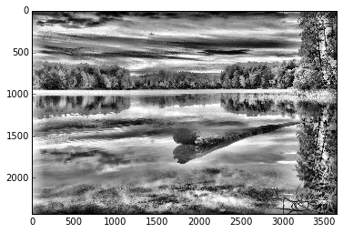

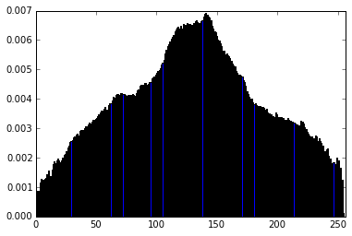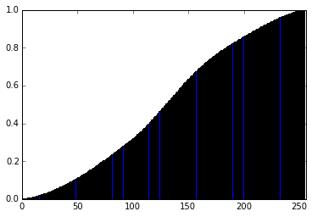

AHE opencl interpolation optimization with buffer of uchar (256 bins):

1. histogram calculation: 191.29048 ms

2. transformation: 302.83328 ms

3. total: 494.12376 ms

AHE opencl interpolation optimization with buffer of uchar (on small picture):

1. histogram calculation: 0.4096 ms

2. transformation: 2.1324 ms

3. total: 2.542 ms

Part 2: 32 bin histogram

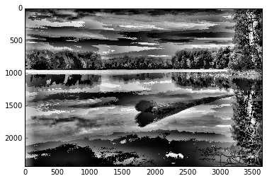

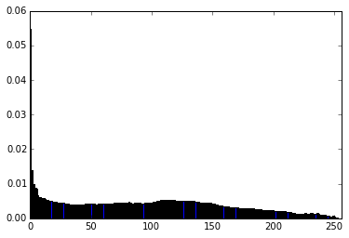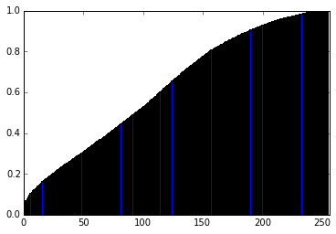

AHE opencl interpolation optimization with buffer of uchar (32 bins):

1. histogram calculation: 197.19608 ms

2. transformation: 166.97552 ms

3. total: 364.1716 ms

AHE opencl interpolation optimization with buffer of uchar (32 bins, on small picture):

1. histogram calculation: 0.41928 ms

2. transformation: 1.60344 ms

3. total: 2.02272 ms

9. AHE opencl interpolation optimization with buffer of data type uchar avoiding bank conflict

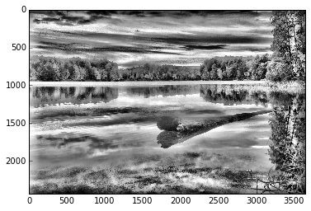 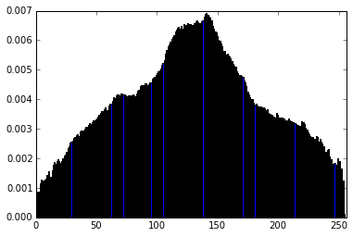 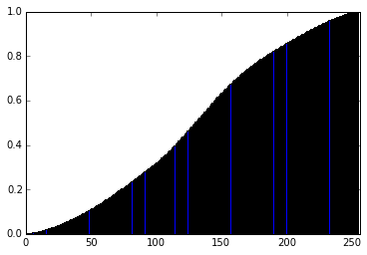

AHE opencl interpolation optimization with buffer of uchar (256 bins) avoiding bank conflict:

1. histogram calculation: 203.91328 ms

2. transformation: 289.16208 ms

3. total: 493.07536 ms

AHE opencl interpolation optimization with buffer of uchar avoiding bank conflict (on small picture):

1. histogram calculation: 0.43032 ms

2. transformation: 2.12488 ms

3. total: 2.5552 ms

10. Summary

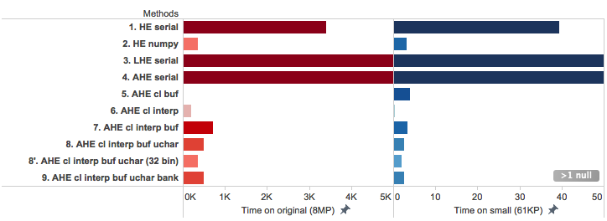

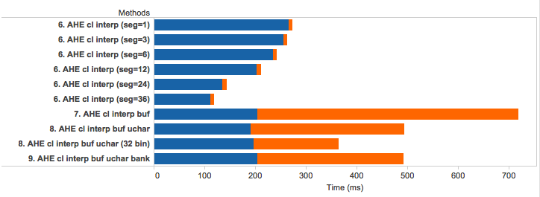Macintosh HD:Users:haosutang:Dropbox:CS205:project:working_notebooks:Tang:result:hist_trans_legend.png