CS2102: DATABASE SYSTEMS

Project

Damien Sim

Rebecca Tan

Khor Shao Liang

Teo Wen Zong (A0104287H)

National University of Singapore

Contents

Server 1

ER Diagram 1

Project 1

Relational Schema 1

Sample Features 1

Images 1

Bibliography 2

# Server

We use WAPP (Windows, Apache, PHP, Postgres) Stack for our project.

# ER Diagram

Figure 1 below shows the ER Diagram for our project.

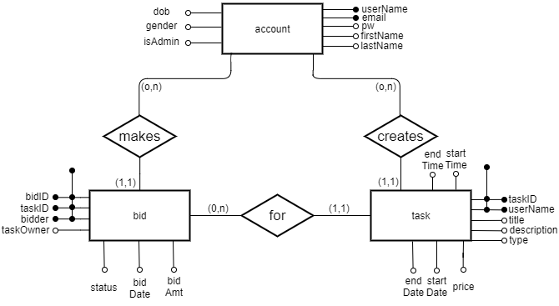

Figure 1: ER Diagram of our Project

# Project

## Relational Schema

## Sample Features

## Images

# Bibliography

**There are no sources in the current document.**