CS2102

Database Systems

Team 18

Topic B: Crowdfunding

Name and matric

Deric

Wei Zheng

Shi Rong

Chen Zhi Liang A0141010L

# Project Specifications

Entity Relationship Diagrams

Fig 1. User Entity

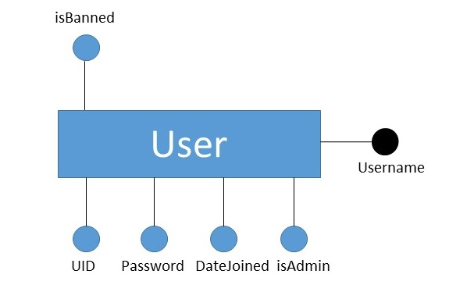

*Fig 2. Project Entity*

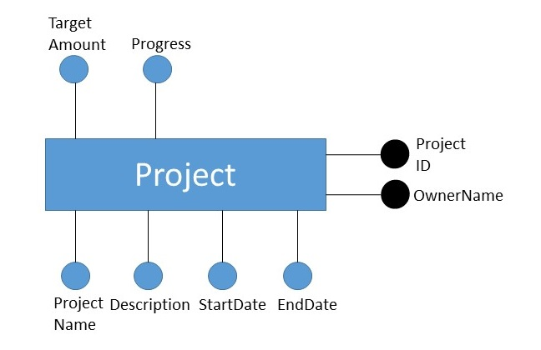

*Fig 3. Investment Relationship*

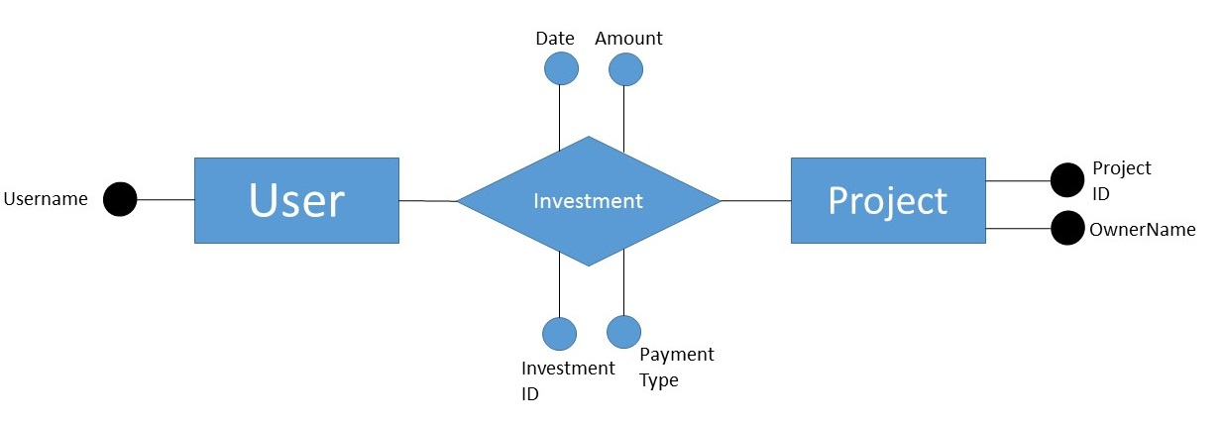

– Description of the implementation of at least one non-trivial integrity constraint (what is the constraint, how is it implemented using which database features, etc.)

Integrity Constraints:

# Data Type constraints:

We need some attributes in the relations to follow certain obvious data type constraints. For example, for crowd funding projects created by users, the target amount to be raised must clearly be more than 0. We use table constraints to achieve this:

targetAmount int NOT NULL CHECK (targetAmount > 0)

When such constraints are broken by users, an exception will be raised in the database which will be converted to relevant feedback on the website.

Other examples of data type constraints during creation of table:

CONSTRAINT chk_InvestmentType CHECK (investmentType IN ('eNETS', 'Paypal', 'Credit Card')),

progress int NOT NULL CHECK (progress >= 0)

# Foreign Key Constraints: