Developer Guide

Contents

**1. Introduction** 2

**2. Setting up** 2

**3. Design** 3

3.1 Architecture 3

3.2 UI component 6

3.3 Logic component 7

3.4 Model component 8

3.5 Storage component 9

3.6 Common classes 9

**4. Implementation** 10

4.1 Logging 10

4.2 Configuration 10

**5. Testing** 11

**6. Dev Ops** 12

6.1 Build Automation 12

6.2 Continuous Integration 12

6.3 Making A Release 12

6.4 Managing Dependencies 12

**7. Appendix** 13

7.1 Appendix A: User Stories 13

7.2 Appendix B: Use Cases 15

7.3 Appendix C: Non Functional Requirements 17

7.4 Appendix D: Glossary 17

7.5 Appendix E: Product Survey 18

## 1. Introduction

Welcome to the developer guide for SmartyDo. This guide is meant to enable budding developers like yourself to better understand the implementation of our program. Through this guide, we hope that you will be able to learn not only about how SmartyDo is implemented, but about different parts of the application that you are able to improve yourself.

## 2. Setting up

#### 2.1 Prerequisites

To ensure that you are able to run SmartyDo smoothly, do ensure that you have met the following prerequisites:

1. Installed **JDK 1.8.0_60** or later.
   * This app may not work as intended with earlier versions of Java 8.
   * This app will not work with earlier versions of Java.
2. Installed **Eclipse** IDE.
3. Installed **e(fx)clipse** plugin for Eclipse.
   * Detailed instructions can be found at http://www.eclipse.org/efxclipse/install.html#for-the-ambitious
4. Installed **Buildship Gradle Integration** plugin from the Eclipse Marketplace.

#### 2.2 Importing the project into Eclipse

To import the latest version of this project into Eclipse, follow the instructions as given below:

1. Fork this repo, and clone the fork to your computer
2. Open Eclipse (Note: Ensure you have installed the **e(fx)clipse** and **Buildship** plugins as given in the prerequisites above)
3. Click File > Import
4. Click Gradle > Gradle Project > Next > Next
5. Click Browse, then locate the project's directory
6. Click Finish

* If you are asked whether to 'keep' or 'overwrite' config files, choose to 'keep'.
* Depending on your connection speed and server load, it can even take up to 30 minutes for the set up to finish (This is because Gradle downloads library files from servers during the project set up process).
* If Eclipse auto-changed any settings files during the import process, you can discard those changes.

## 3. Design

### 3.1 Architecture

The ***Architecture Diagram*** given below will explain to you the high-level design of the App. Below, we will give you a quick overview of each component.

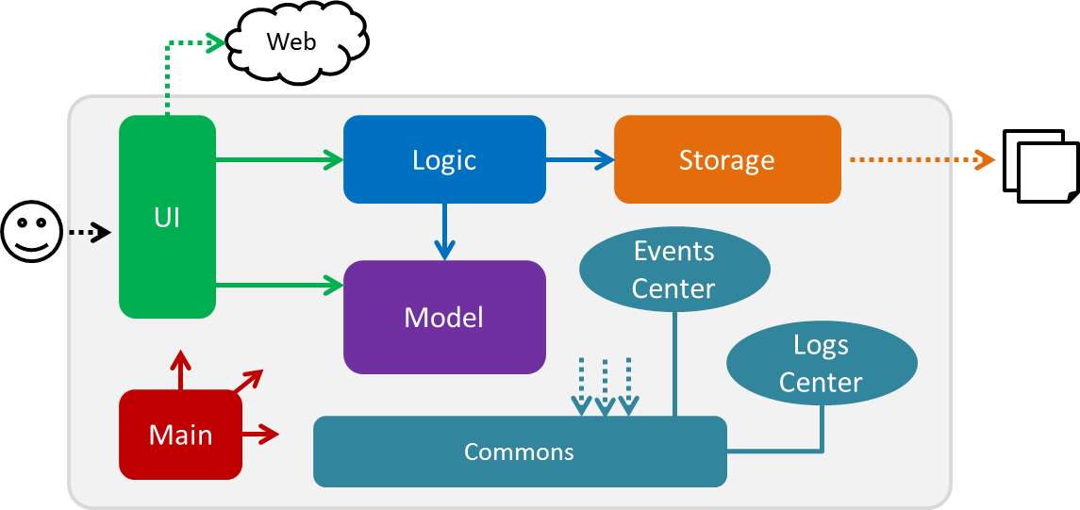

Main has only one class called [MainApp](../src/main/java/seedu/address/MainApp.java). It is responsible for,

* At app launch: Main will initialize the components in the correct sequence, and connect them up with each other.
* At shut down: Main will shut down the components and invoke cleanup method where necessary.

**Commons** represents a collection of classes used by multiple other components. Two of those classes play important roles at the architecture level.

* **EventsCentre**: This class (written using [Google's Event Bus library](https://github.com/google/guava/wiki/EventBusExplained)) is used by components to communicate with other components using events (i.e. a form of *Event Driven* design)
* **LogsCenter**: Used by many classes to write log messages to the App's log file.

The rest of the App consists four components.

* **UI** : The UI of the App.
* **Logic** : Executes commands given by the user.
* **Model** : Holds the data of the App in-memory.
* **Storage** : Reads data from, and writes data to the hard disk.

Each of the four components will

* Define its *API* in an interface with the same name as the Component.
* Expose its functionality using a {Component Name}Manager class.

For example, the Logic component (see the class diagram given below) defines its API in the Logic.java interface and exposes its functionality using the LogicManager.java class.

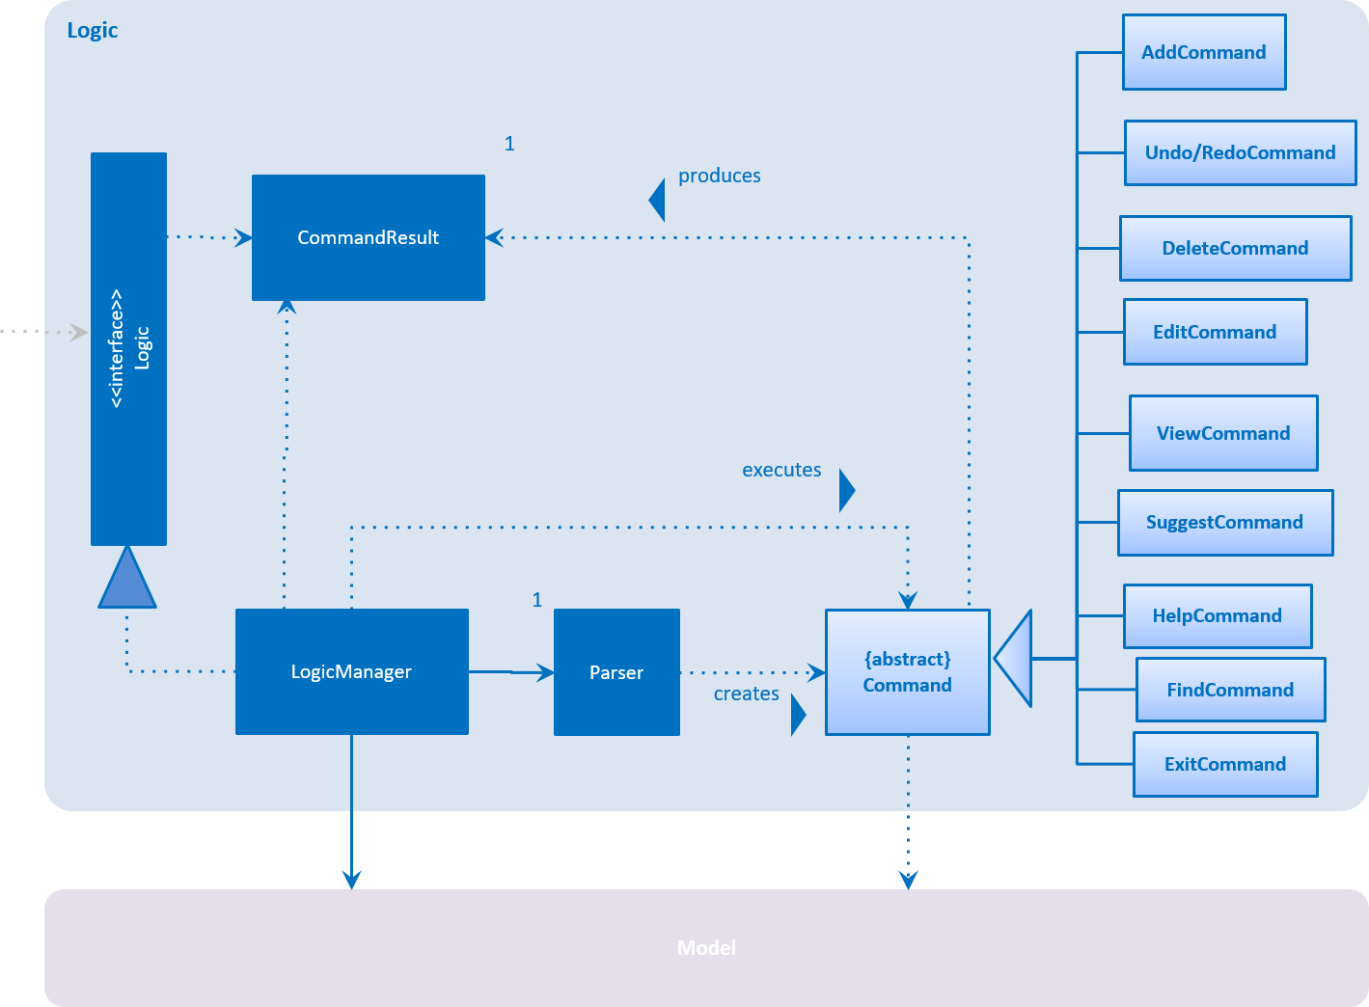

The *Sequence Diagram* below will show you how the components interact for the scenario where the user issues the command delete 3.

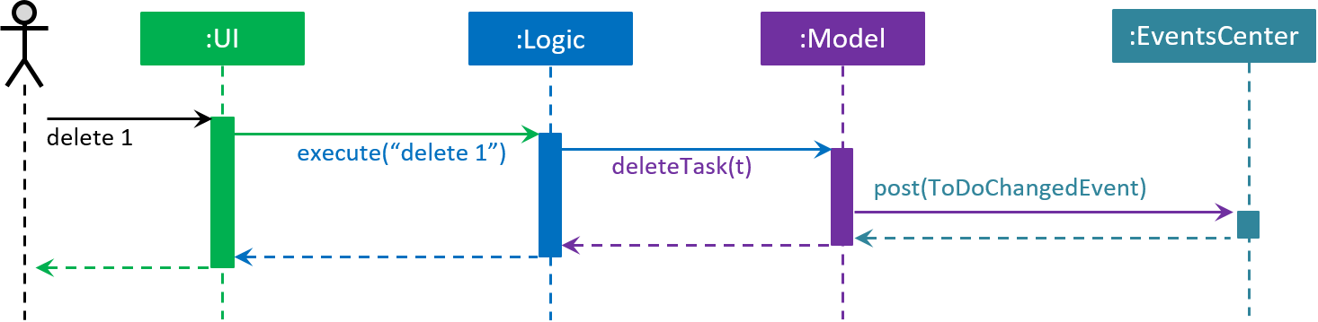

Note how the Model simply raises a **ToDoChangedEvent** when the To-Do data are changed, instead of asking the Storage to save the updates to the hard disk.

The diagram below will show you how the **EventsCenter** reacts to that event, which eventually results in the updates being saved to the hard disk and the status bar of the UI being updated to reflect the 'Last Updated' time.

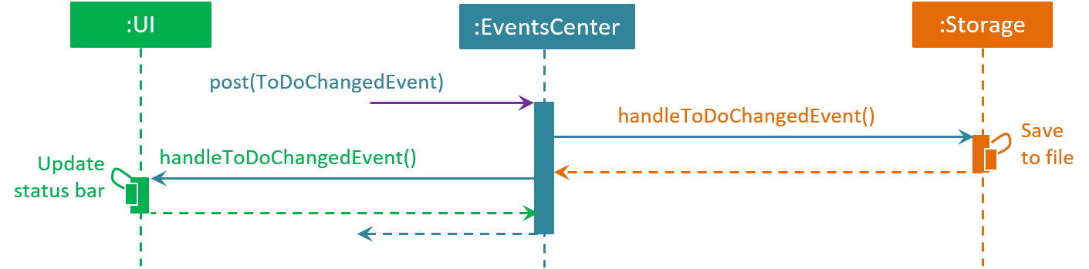

Note how the event is propagated through the EventsCenter to the Storage and UI without Model having to be coupled to either of them. This is an example of how this Event Driven approach helps us reduce direct coupling between components.

The sections below will give you more details of each component.

### 3.2 UI component

The UI consists of a MainWindow that is made up of parts e.g. **CommandBox**, **ResultDisplay**, **TaskListPanel**, **StatusBarFooter**, **BrowserPanel** etc. All these, including the **MainWindow**, inherit from the abstract UiPart class and they can be loaded using the **UiPartLoader**.

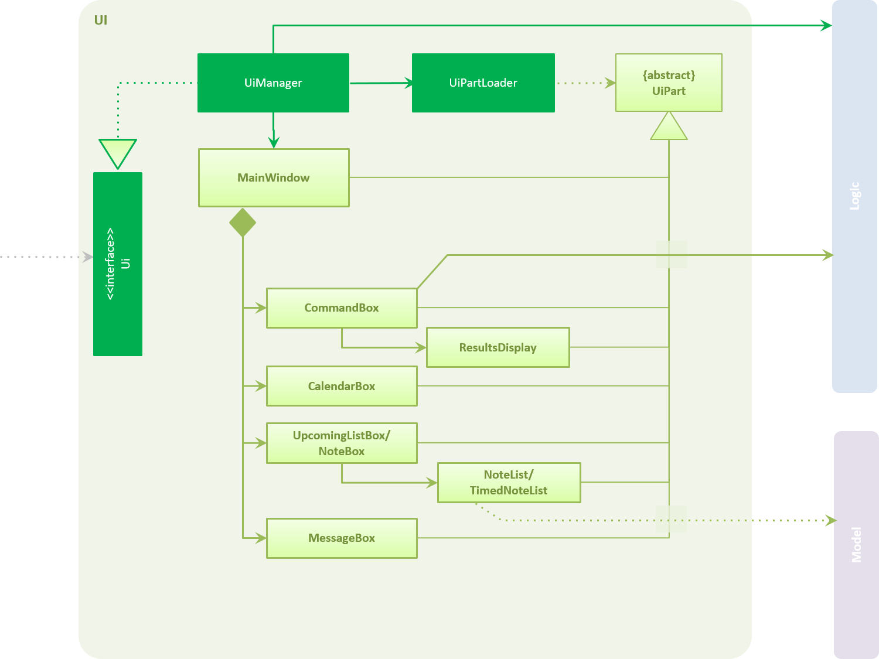

**API** : [Ui.java](../src/main/java/seedu/address/ui/Ui.java)

The UI component uses JavaFx UI framework. The layout of these UI parts are defined in matching .fxml files that are in the src/main/resources/view folder. For example, the layout of the [MainWindow](../src/main/java/seedu/address/ui/MainWindow.java) is specified in [MainWindow.fxml](../src/main/resources/view/MainWindow.fxml)

The UI component will

* Execute user commands using the Logic component.
* Bind itself to some data in the Model so that the UI can auto-update when data in the Model change.
* Respond to events raised from various parts of the App and updates the UI accordingly.

### 3.3 Logic component



**API** : [Logic.java](../src/main/java/seedu/address/logic/Logic.java)

1. Logic uses the Parser class to parse the user command.
2. This results in a Command object which is executed by the LogicManager.
3. The command execution can affect the Model (e.g. adding a task) and/or raise events.
4. The result of the command execution is encapsulated as a CommandResult object which is passed back to the UI.

Below, you will find the Sequence Diagram for interactions within the Logic component for the execute("delete 1") API call.

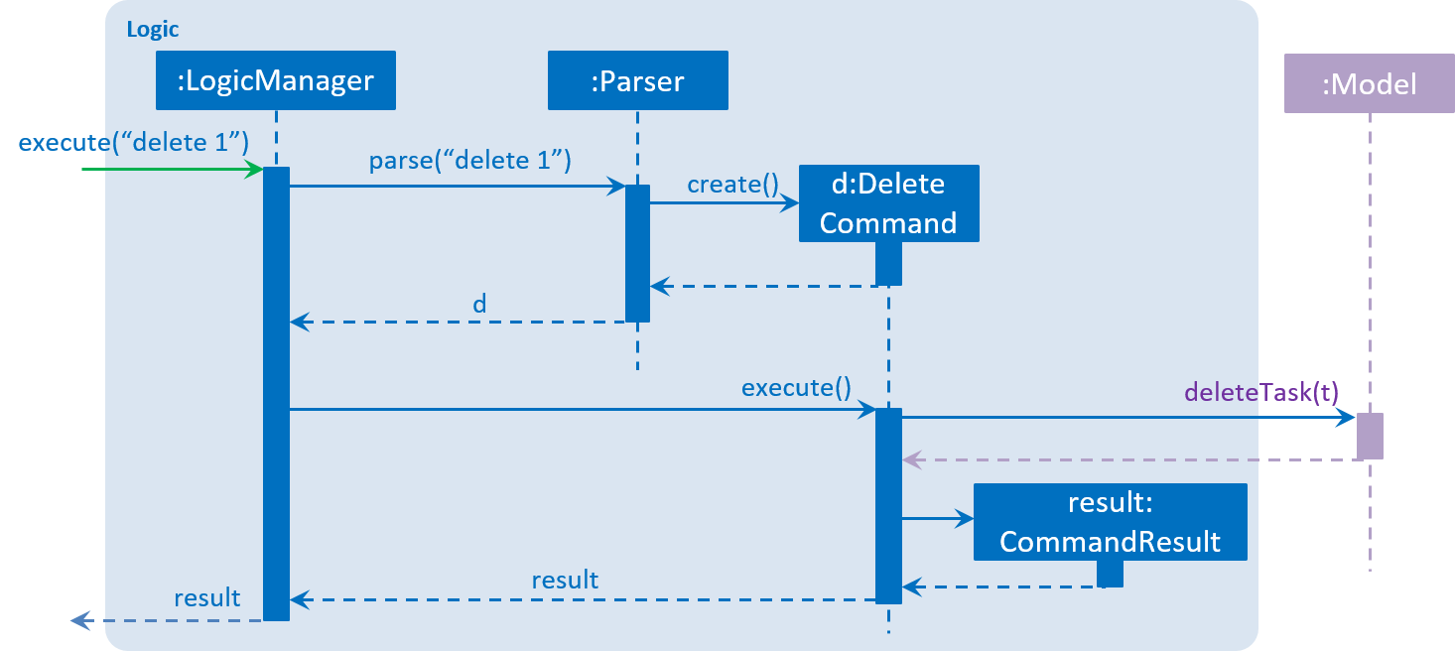

### 3.4 Model component

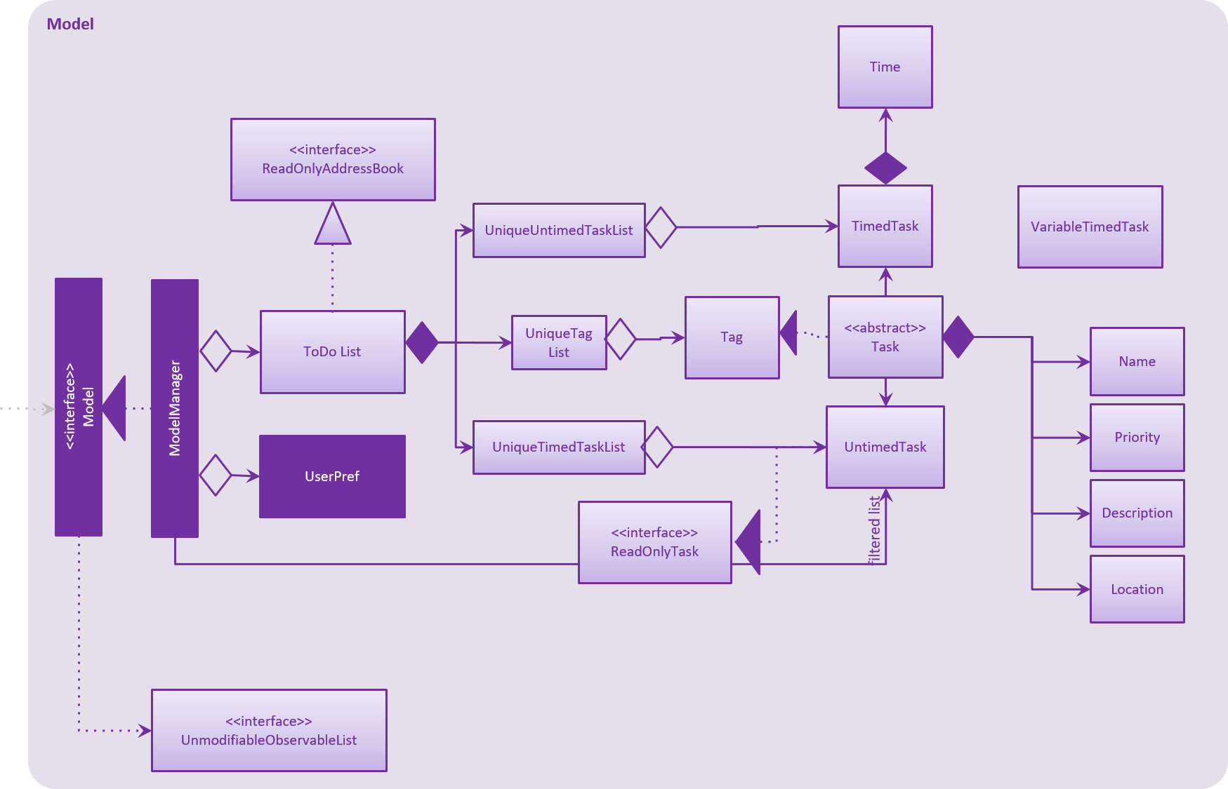

**API** : [Model.java](../src/main/java/seedu/address/model/Model.java)

The Model,

* stores a UserPref object that represents the user's preferences.
* stores the To-Do data.
* exposes a UnmodifiableObservableList<ReadOnlyTask> that can be 'observed' e.g. the UI can be bound to this list so that the UI automatically updates when the data in the list change.
* does not depend on any of the other three components.

### 3.5 Storage component

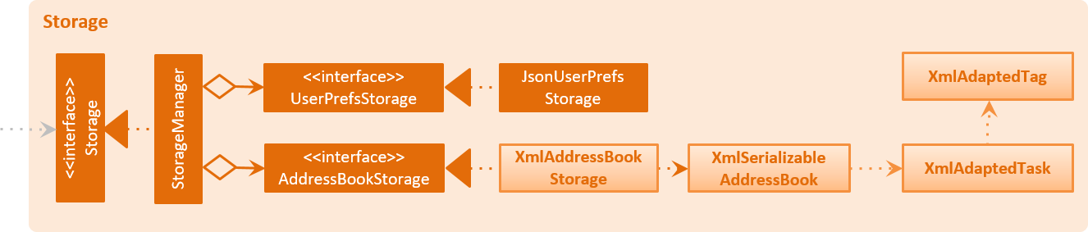

**API** : [Storage.java](../src/main/java/seedu/address/storage/Storage.java)

The Storage component,

* can save UserPref objects in .json format and read it back.
* can save the SmartyDo data in XML format and read it back.

### 3.6 Common classes

You may find classes used by multiple components are in the seedu.addressbook.commons package.

## 4. Implementation

### 4.1 Logging

We are using java.util.logging package for logging. You can use LogsCenter class to manage the logging levels and logging destinations.

* You can control the logging level by using the logLevel setting in the configuration file (See Configuration)
* You can obtain the Logger for a class by using LogsCenter.getLogger(Class) which will log messages according to the specified logging level
* Currently log messages are output through Console and to a .log file.

**Logging Levels**

|  |  |
| --- | --- |
| Level | Details |
| Severe | Critical problem detected which may possibly cause the termination of the application. |
| Warning | Can continue, but with caution. |
| Info | Information showing the noteworthy action by the App. |
| Fine | Details that are not usually noteworthy, but may be useful in debugging (e.g. printout of the actual list instead of its size) |

### 4.2 Configuration

You can control certain properties of the application (e.g App name, logging level) through the configuration file (default: config.json):

## 5. Testing

You can find tests in the ./src/test/java folder.

**In Eclipse**: If you are not using a recent Eclipse version (i.e. *Neon* or later), you will need to enable assertions in JUnit tests as described in this link: (<http://stackoverflow.com/questions/2522897/eclipse-junit-ea-vm-option>)

* You can run all tests by right-clicking on the src/test/java folder and choose Run as > JUnit Test
* You can also run a subset of tests by right-clicking on a test package, test class, or a test and choose to run as a JUnit test.

**Using Gradle**:

* You may refer to <UsingGradle.md> to see how to run tests using Gradle.

We have two types of tests:

1. **GUI Tests** - These are *System Tests* that test the entire App by simulating user actions on the GUI. These are in the *guitests* package.
2. **Non-GUI Tests** - These are tests not involving the GUI. They include,
   1. *Unit tests* targeting the lowest level methods/classes.  
      e.g. seedu.address.commons.UrlUtilTest
   2. *Integration tests* that are checking the integration of multiple code units (those code units are assumed to be working).  
      e.g. seedu.address.storage.StorageManagerTest
   3. *Hybrids of unit and integration tests*. These tests are checking multiple code units as well as how they are connected together.  
      e.g. seedu.address.logic.LogicManagerTest

**Headless GUI Testing** : Thanks to the [TestFX](https://github.com/TestFX/TestFX) library we use, our GUI tests can be run in the *headless* mode. In the headless mode, GUI tests do not show up on the screen. That means the developer can do other things on the Computer while the tests are running. See [UsingGradle.md](UsingGradle.md#running-tests) to learn how to run tests in headless mode.

## 6. Dev Ops

### 6.1 Build Automation

You may read <UsingGradle.md> to learn how to use Gradle for build automation.

### 6.2 Continuous Integration

We use [Travis CI](https://travis-ci.org/) to perform *Continuous Integration* on our projects. You may read <UsingTravis.md> for more details.

### 6.3 Making a Release

Here are the steps to create a new release.

1. Generate a JAR file [using Gradle](UsingGradle.md#creating-the-jar-file).
2. Tag the repo with the version number (e.g. v0.1).
3. [Create a new release using GitHub](https://help.github.com/articles/creating-releases/) and upload the JAR file you created.

### 6.4 Managing Dependencies

A project often depends on third-party libraries. For example, SmartyDo depends on the [Jackson library](http://wiki.fasterxml.com/JacksonHome) for XML parsing. Managing these *dependencies* can be automated using Gradle. For example, Gradle can download the dependencies automatically, which is better than the following alternatives:

1. Include those libraries in the repo (this bloats the repo size)
2. Require developers to download those libraries manually (this creates extra work for developers)

## 7. Appendix

### 7.1 Appendix A: User Stories

Priorities: High (must have) - * * *, Medium (nice to have) - * *, Low (unlikely to have) - *

|  |  |  |  |
| --- | --- | --- | --- |
| Priority | As a ... | I want to ... | So that I can... |
| * * * | new user | see usage instructions | refer to instructions when I forget how to use the App |
| * * * | user | add a task by specifying a task description only | record tasks that need to be done |
| * * * | user | delete a task | remove entries that I no longer need |
| * * * | user | find a task by name | locate details of tasks without having to go through the entire list |
| * * * | user | view list of completed and pending tasks | keep track of what needs to be done |
| * * | user with many tasks at a time | sort my tasks by different criteria | view tasks easily |
| * * | user with large projects/ tasks | add subtasks to the main task | break down a larger task into smaller tasks |
| * * | user with many unconfirmed events | allocate timeslots for tentative meetings/tasks | avoid having plans that might conflict with unconfirmed plans |
| * * | user | undo 1 previous operation | remove commands executed by accident |
| * * | user | specify a target folder as the data storage location | synchronize file with other applications |

## 

### 7.2 Appendix B: Use Cases

(For all use cases below, the **System** is the SmartyDo and the **Actor** is the user unless specified otherwise)

#### 7.2.1 Use case: Add task

**MSS**

1. User requests to add new task
2. SmartyDo shows list of upcoming tasks with new task added

Use case ends.

**Extensions**

1.a. The given index is invalid

Use case ends

#### 7.2.2 Use case: Edit task

**MSS**

1. User requests to view upcoming tasks
2. SmartyDo shows a list of upcoming tasks
3. User requests to edit a specific task in the list
4. SmartyDo edits the task

Use case ends.

**Extensions**

2.a. The list is empty

Use case ends

3.a. The given index is invalid

3.a.1. SmartyDo shows an error message.

Use case resumes at step 2

#### 7.2.3 Use case: Undo task

**MSS**

1. User requests to undo the previous command
2. SmartyDo performs undo and shows updated list of upcoming tasks

Use case ends.

**Extensions**

1.a. There is no previous command.

Use case ends

#### 7.2.4 Use case: Redo task

**MSS**

1. User requests to redo the command reversed by the undo command
2. SmartyDo performs redo and shows updated list of upcoming tasks

Use case ends.

**Extensions**

1.a. There is no previous undo command

Use case ends

#### 7.2.5 Use case: View task

**MSS**

1. User requests to view upcoming tasks that match specific string
2. SmartyDo shows a list of upcoming tasks

Use case ends

#### 7.2.6 Use case: Mark task

**MSS**

1. User requests to view upcoming tasks
2. SmartyDo shows a list of upcoming tasks
3. User requests to mark a specific task in the list
4. SmartyDo marks the task

Use case ends

**Extensions**

2.a. The list is empty

Use case ends

3.a. The given index is invalid

3.a.1. SmartyDo shows an error message

Use case resumes at step 2

#### 7.2.7 Use case: Delete task

**MSS**

1. User requests to view upcoming tasks
2. SmartyDo shows a list of upcoming tasks
3. User requests to delete a specific task in the list
4. SmartyDo deletes the task

Use case ends

**Extensions**

2.a. The list is empty

Use case ends

3.a. The given index is invalid

3.a.1. SmartyDo shows an error message

Use case resumes at step 2

### 7.3 Appendix C: Non-Functional Requirements

1. Should work on any mainstream OS as long as it has Java 1.8.0_60 or higher installed.
2. Should be able to hold up to 2 years of entries estimated to be 8000 entries.
3. Should come with automated unit tests and open source code.
4. Should favor DOS style commands over Unix-style commands.

### 7.4 Appendix D: Glossary

##### Mainstream OS

Windows, Linux, Unix, OS-X

### 7.5 Appendix E: Product Survey

|  |  |  |
| --- | --- | --- |
| **Existing Product** | **Pros** | **Cons** |
| Google Calendar | * Allows creation of task and events and reside them in the same view * Free to use * Synchronizes with Gmail account * Allows conversion of email invites into events | * Does not have blockout slots. |
| Sticky Notes | * Free to use * Easy to bring up * Shows all items, always * Easy addition/editing/removal of tasks * Can store notes/weblinks * Can store handwritten notes * Supports basic text formatting | * No backup mechanism. * No sorting. * No “calendar view”. * Takes up desktop space. |
| Todo.txt | * Does not rely on network access to operate * Able to synchronize with cloud storage * Allows priority scheduling * Breaks difficult objectives into small steps to reach the goal. * Records date of completion for tasks. * Simple GUI * Lightweight application | * No support for recurring tasks. * No reminder for upcoming due dates |