**User Guide**

Quick Start Features

Help Add Edit Delete Clear Done Undo Redo List Find Store Exit

FAQ

Command Summary

# Quick Start

1. Ensure you have Java version or later installed in your computer.

1.8.0_60

Having any Java 8 version is not enough.

This app will not work with earlier versions of Java 8.

1. Download the latest from the releases tab.

DearJim.jar

1. Copy the file to the folder you want to use as the home folder for DearJim.
2. Double-click the file to start the app. The GUI should appear in a few seconds.

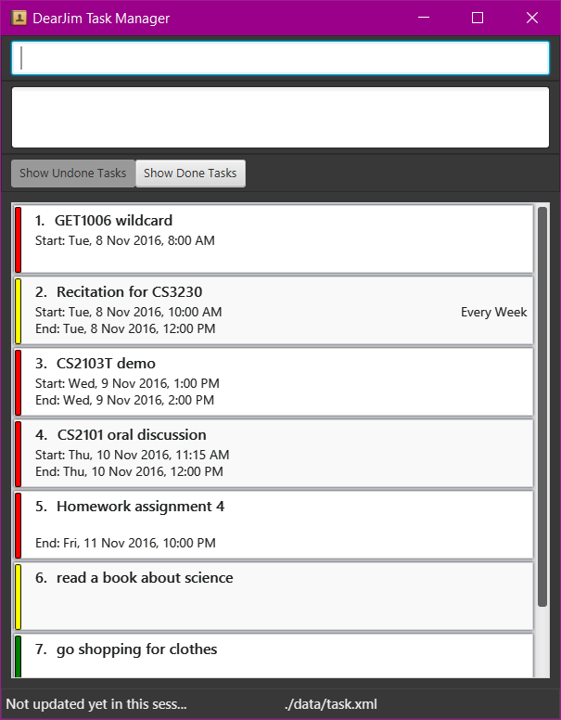

Figure 1: GUI of DearJim

1. Type the command in the command box and press to execute it.

Enter

**help**

Enter

e.g. typing

and pressing

will open the help window.

1. Some example commands you can try:

**list:** lists all tasks. This is the default view.



**add** Learn how to use DearJim: adds a task to DearJim. **delete** 1: deletes the first task shown in the current list. **exit:** exits the app.

1. Refer to the Features section below for details of each command.

# Features

**Command Format**

Format: <command word> <parameters> Words in UPPER_CASE are the parameters. Fields in [] are optional.



The order of parameters is fixed.

## Viewing help:

**help**

Opens a help window that contains a cheat sheet of all the commands of DearJim.

You can leave the help window open while using DearJim if you need to refer to the cheat sheet.

Format:

help

While the help window is selected, you may close it by simply pressing any key on your keyboard!

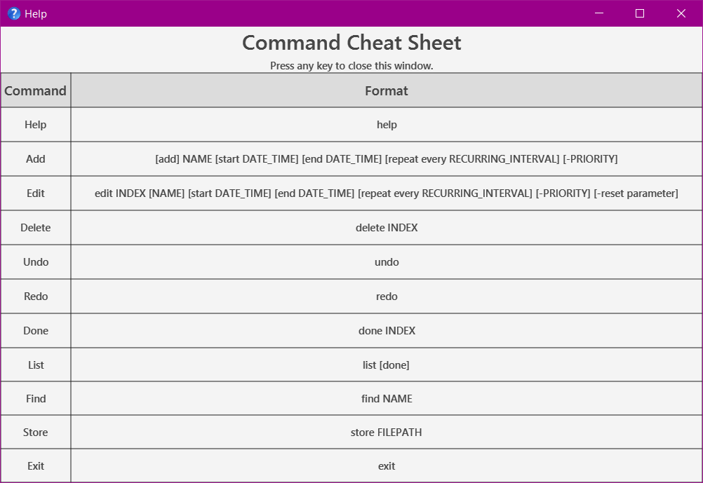

Figure 2: Help Command

## Adding a task:

**add**

Adds a task into DearJim. Format:

[add] NAME [start DATE_TIME] [end DATE_TIME] [repeat every RECURRING_INTERVAL] [-PRIORITY]

start



from / at

end



to / by

You may also substitute

add

with

, with .

By default, if no valid command is specified, the input will be treated as an optional.

add

add

command. This means typing in is

If you would like to add a task with a name that begins with other command words, just include the command words.

Example:

to override the other

**Input**

**Interpreted Command**

**Result**

help my mum to buy cooking ingredients

help

Execute help command

add help my mum to buy cooking ingredients

add

add a task with name help my mum to buy cooking ingredients

### Adding a task

Format:

NAME

The simplest form of a task. Type away!

Example:

help my mum to buy cooking ingredients

### Specifying task priority

You can assign a PRIORITY of low , or Tasks have medium PRIORITY by default.

medium

high

Keyword: -PRIORITY

to your task.

To specify the priority for a task, input followed by the .



a -

low

PRIORITY

high .

also accepts variations of , and

PRIORITY

medium



**PRIORITY**

**Variations**

low

l , low

medium

m , med , medium

high

h , high

Examples:

Watch drama -l

Buy coffee powder -med Buy washing powder -high

### Adding a task with deadline

Nobody likes deadlines. What's worse is missing them.

Add deadlines to your task so you will know when you need to complete them! Format:

NAME end DATE_TIME [repeat every RECURRING_INTERVAL] [-PRIORITY]

denotes a deadline.

end

end

can also be substituted with

or .



by



to

is flexible!

DATE_TIME

DATE

TIME

If no If no

DATE

TIME

is specified, is specified,

will be assumed to be today. will be assumed to be 11:59pm.

### Valid Dates & Times

**Date**

**Format**

**Interpreted Date**

MM/DD/YYYY

MM/DD/YY MM/DD

12/12/2016

12/12/16

12/12

12 December 2016

12 December 2016

12 December, Current Year

Calendar

12 December 2016 , 12th December 2016

12 December 16

12 December 2016

Calendar (Date and Month)

12 December

Calendar (Month)

may , May

dec , Dec , December

Day

monday , Mon

Relative Date

today , tonight

tmr , tomorrow next Tues

5 days later

12 December, Current Year

1 May, Current Year

1 December, Current Year Nearest upcoming Monday

Today Tomorrow Next Tuesday 5 days later

**Time**

**Format**

**Interpreted Time**

24Hr

20.50 , 20:50

8.50pm

AM/PM

8.50pm , 8:50pm , 0850pm

8.50pm

Preset

midnight noon

12am 12pm

DearJim does not support the following 24hr format: , as this input can be misinterpreted as the value of year.

2050

Examples:

Do project proposal by 5pm tmr eat lunch by 1pm today -high Buy coffee for boss by 7:00

finish CS2101 assignment by 13th Sep

with numbers from 0000 to 2359 may be wrongly interpreted as time. If you need to add a with these numbers, you

NAME

NAME

NAME

NAME

can enclose the

with double inverted commas to denote the

explicitly.

Example:

**Input**

**Interpreted Command**

**Interpreted Task Name**

**Interpreted Deadline**

**Result**

Lower word count by 1500

add

Lower word count

by 1500

add a task with name Lower word count and deadline 1500

"Lower word count by 1500"

add

Lower word count by 1500

NONE

add a task with name

Lower word count by 1500

### Adding a task with time interval

Having a company meeting? Planning to have lunch with a friend next week?

Add a task with a time interval so you will know what time your task starts and ends! If you are unsure about the end time for the task, you can leave it blank.

Format:

NAME start DATE_TIME [end DATE_TIME] [repeat every RECURRING_INTERVAL] [-PRIORITY]

Note: You may use

from

or to indicate the start time, and

or to indicate the end time.

Example:



at



to



by

Company meeting tonight at 7pm to 9pm Family dinner at noon

Meet Akshay from 1pm -h

### Specifying repeated tasks

Have one of those pesky tasks you need to do every now and then?

DearJim also allows you to specify tasks that need to be repeated at a specific Keyword:

repeat every RECURRING_INTERVAL

. Never forget them again!

RECURRING_INTERVAL

Note: You may only specify a for tasks that are timed.

RECCURING_INTERVAL

can be specified in a few formats, with some examples listed below.

RECURRING_INTERVAL

**Recurring Interval**

**Format**

Hour

Day Week Month Year

hour , 3 hours

day , 3 days , monday , mon week , 5 weeks

month , 2 months

year , 6 years

Examples:

Run at track at 7am repeat every 3 days

Visit mum repeat every sun

## Editing a task:

**edit**

Just in case you need to change any details, or add in missing ones into your task, simply edit them in DearJim. Format:

edit INDEX [NAME] [start DATE_TIME] [end DATE_TIME] [repeat every RECURRING_INTERVAL] [-PRIORITY]

INDEX refers to the task number in the current displayed list.

Note: edit has a very similar format to .

add

Examples:

Company meeting tonight at 7pm to 9pm

edit 2 Company meeting tomorrow morning at 7am to 9am -high Buy coffee for boss by 8am repeat every day

edit 3 Buy coffee for boss by 7am repeat every 2 days

### Editing out details in a task

You can also remove parameters that are no longer relevant. Format:

edit INDEX [-reset parameter] [repeat] [start] [end]

|  |  |
| --- | --- |
| **-reset parameter** | **Result** |
| -reset repeat | Removes recurring interval from task |
| -reset start | Removes start time from task |
| -reset end | Removes end time from task |

Examples:

Note:

Buy coffee for boss, by 8am repeat every day edit 1 -reset repeat start

edit 2 -reset end

will override any

-reset

of the same field that comes before it in your input.

edit

## Deleting a task:

**delete**

Deletes an existing task in DearJim. This will remove it from the storage. Format:

delete INDEX

You can multiple tasks using a single command by entering the indexes of the tasks you want to delete, separating

delete

each index with a space.

Example:

delete 2

delete 3 5 9

## Clearing all tasks:

**clear**

Deletes all tasks in DearJim. Format:

clear

## Archiving a task:

**done**

Marks a task as done and archives it in DearJim. Format:

done INDEX

You can multiple tasks using a single command by entering the indexes of the tasks you have completed, separating

done

each index with a space.

Example:

done 3

done 1 5

## Undoing a command:

**undo**

Reverses the effects of the previous undoable command. Helps you to undo any accidental mistakes that you have made! Format:

undo

Commands that you can (Undoable commands):

undo

add edit delete clear

done

## Redoing a command:

**redo**

Reverses a previous undo command. Not satisfied with your last undo ?

redo

will reverse the

for you!

undo

Format:

redo

undo

undo

Note:

redo

can only reverse your last

if no undoable commands have been entered after that .

## Listing tasks:

**list**

### Listing all undone tasks

Switches the task list view to the undone list view, to show all undone tasks in DearJim. Format:

list

### Listing all undone tasks of a specific day

Switches the task list view to the undone list view, to show all tasks on the day specified. Format:

list DAY

Example:

list today list tmr

list monday

### Listing all done tasks

Switches the task list view to the done list view, to show all done tasks in DearJim. Format:

list done

and commands do not work in done list view. As such, you are not able to directly add tasks into the done list,

add

edit

or edit the details of done tasks.

## Finding a task:

**find**

Forgot about the details of a task that you have added earlier? You can find an existing task by its name. Format:

find NAME

is case-insensitive - will match

find

find AKSHAY

find akshay

If no NAME is provided, all uncompleted tasks will be displayed Examples:

find company meeting

find

## Changing storage location:

**store**

Need to look at your task on the move? Simply store the data at another location and bring it along with you.

store

In addition to changing the storage file location, you specify is an existing storage file.

handles your existing data in two different ways, depending if the filepath

If the storage file specified is not present, DearJim will create this new file and store your current data in it. If the storage file specified is present, data will be loaded from this storage file into DearJim.

store FILEPATH

Format:

DearJim data is stored in XML file format. There is no need to specify the file extension , it will be appended to your

.xml

target file name automatically. supports both relative and absolute file paths.

store

Examples:

store data/onthemove

store /Users/jim/Dropbox/filename

## Exiting the application:

**exit**

Closes the application. Format:

exit

## Getting hints for command format

If you have forgotten about the command formats, simply type any word and DearJim will provide you hints on the command format that you might want to use!

Examples:

add

Typing

add

in the command input generates the format for

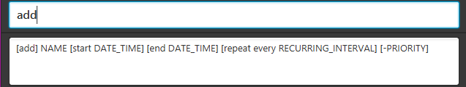in the result display

Figure 3: Hints for add command

delete

Typing

delete

in the command input generates the format for

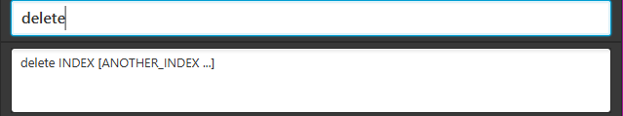in the result display

Figure 4: Hints for delete command

## Instant

**add**

edit

**and**

## task preview

DearJim features an instant input!

**edit**

add

and

command task preview, allowing you to preview the task details as your type your

Now you can be sure of how your input will be interpreted as a task to be added or edited! Examples:

add do my homework from 3pm to 4pm repeat every day -high

add

Typing

generates an instant

preview

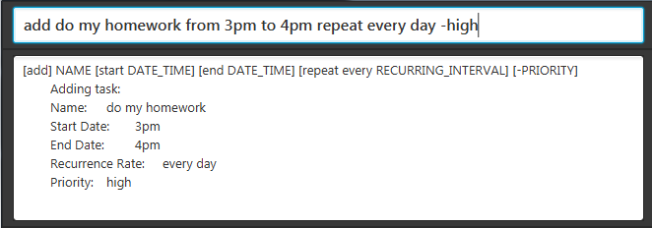

Figure 5: Instant preview for add command

Typing

edit 1 by 10pm -low -reset repeat

generates an instant

preview

edit

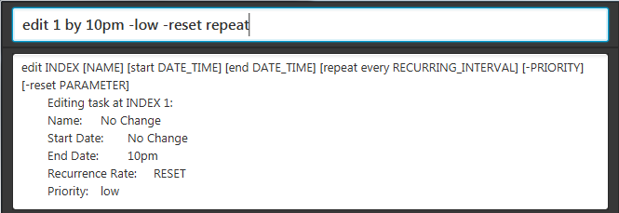

Figure 6: Instant preview for edit command

## Saving the data

Data in DearJim is automatically saved on the hard disk after any command that changes the data is executed. There is no need to save manually.

You will never have to worry about forgetting to save your data while using DearJim! Hurray!

# FAQ

**Q**: How do I transfer my data to another computer?

**A**: Install the app on the other computer. Upon starting DearJim, an empty data file is created. Overwrite the contents of the data file with the data file in your previous *DearJim* folder.

**Q**: How do I install the program?

**A**: Double-click the DearJim.jar file.

# Command Summary

**Command**

**Format**

Help

help

Add

[add] NAME [start DATE_TIME] [end DATE_TIME] [repeat every RECURRING_INTERVAL] [-PRIORITY]

Edit

edit INDEX [NAME] [start DATE_TIME] [end DATE_TIME] [repeat every RECURRING_INTERVAL] [-PRIORITY] [-reset parameter]

Delete

delete INDEX

Clear

clear

Done

done INDEX

Undo

undo

Redo

redo

List

list [done]

Find

find NAME

Store

store FILEPATH

Exit

exit