**About Us**

We are a team based in the [School of Computing, National University of Singapore](http://www.comp.nus.edu.sg).

**Project Team**

[**Yong Zhi Yuan**](https://github.com/Zhiyuan-Amos)

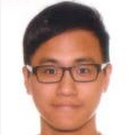

* Responsibilities: Team Leader
* Components in charge of: [Logic](https://github.com/CS2103AUG2016-W13-C4/main/blob/master/docs/DeveloperGuide.md#logic-component)
* Features implemented:
* [Parser](https://github.com/CS2103AUG2016-W13-C4/main/blob/master/docs/DeveloperGuide.md#logic-component)
* [Add task](https://github.com/CS2103AUG2016-W13-C4/main/blob/master/docs/UserGuide.md#adding-a-task-add)
* Code written: [functional code][test code][docs]

[**Edmund Mok**](https://github.com/edmundmok)

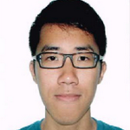

* Responsibilities: UI/UX Designer
* Components in charge of: [UI](https://github.com/CS2103AUG2016-W13-C4/main/blob/master/docs/DeveloperGuide.md#ui-component)
* Features implemented:
* [Undo command](https://github.com/CS2103AUG2016-W13-C4/main/blob/master/docs/UserGuide.md#undoing-a-command-undo)
* [Redo command](https://github.com/CS2103AUG2016-W13-C4/main/blob/master/docs/UserGuide.md#redoing-a-command-redo)
* [Clear command](https://github.com/CS2103AUG2016-W13-C4/main/blob/master/docs/UserGuide.md#clearing-all-tasks-clear)
* [Help command](https://github.com/CS2103AUG2016-W13-C4/main/blob/master/docs/UserGuide.md#viewing-help-help)
* [Input history navigation with Arrow Keys](https://github.com/CS2103AUG2016-W13-C4/main/blob/master/docs/UserGuide.md#input-history)
* Code written: [[functional code](https://github.com/CS2103AUG2016-W13-C4/main/blob/master/collated/main/A0093960X.md)][[test code](https://github.com/CS2103AUG2016-W13-C4/main/blob/master/collated/test/A0093960X.md)][docs]

[**Yong Lin Han**](https://github.com/ylhlh)

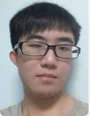

* Responsibilities: Integration
* Components in charge of: [Model](https://github.com/CS2103AUG2016-W13-C4/main/blob/master/docs/DeveloperGuide.md#model-component)
* Features implemented:
* [Delete tasks](https://github.com/CS2103AUG2016-W13-C4/main/blob/master/docs/UserGuide.md#deleting-a-task-delete)
* [Archive tasks](https://github.com/CS2103AUG2016-W13-C4/main/blob/master/docs/UserGuide.md#archiving-a-task-done)
* [List tasks](https://github.com/CS2103AUG2016-W13-C4/main/blob/master/docs/UserGuide.md#listing-tasks-list)
* [Store command](https://github.com/CS2103AUG2016-W13-C4/main/blob/master/docs/UserGuide.md#changing-storage-location-store)
* Code written: [functional code][test code][docs]

[**Hee Han Xiang**](https://github.com/fisherhx)



* Responsibilities: Documentaion
* Components in charge of: [Storage](https://github.com/CS2103AUG2016-W13-C4/main/blob/master/docs/DeveloperGuide.md#storage-component)
* Features implemented:
* [Edit task](https://github.com/CS2103AUG2016-W13-C4/main/blob/master/docs/UserGuide.md#editing-a-task-edit)
* Code written: [functional code][test code][docs]

**Project Mentor:**[**Michelle Tan**](https://github.com/michelletan)

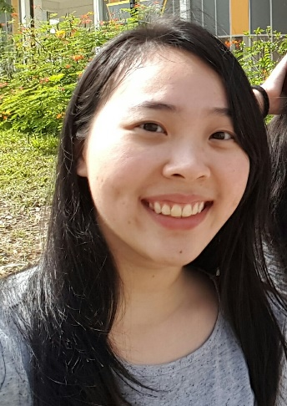

**Contributors**

We welcome contributions. See Contact Us page for more info.