



CelebManager

User Guide



Product of CS2103JAN2018-W14-B4

Last Updated: 27 March 2018

**Table of Contents**

|  |  |  |  |  |  |  |
| --- | --- | --- | --- | --- | --- | --- |
| **1** | Introduction | | | | | **3** |
| **2** | Quick Start | | | | | **4** |
| **3** | Commands | | | | | **5** |
|  | **3.1** | General Commands | | | | **5** |
|  |  | **3.1.1** | Opening help window: help | | | **5** |
|  |  | **3.1.2** | Clearing all entries: clear | | |  |
|  |  | **3.1.3** | Exiting application: exit | | |  |
|  |  | **3.1.4** | Listing past commands: history | | |  |
|  |  | **3.1.5** | Undoing previous command: undo | | |  |
|  |  | **3.1.6** | Redoing undone command: redo | | |  |
|  | **3.2** | Address Book Commands | | | |  |
|  |  | **3.2.1** | | Adding contact: add | |  |
|  |  | **3.2.2** | | Deleting contact: delete | |  |
|  |  | **3.2.3** | | Selecting contact: select | |  |
|  |  | **3.2.4** | | Editing contact: edit | |  |
|  |  | **3.2.5** | | Listing all contacts: list | |  |
|  |  | **3.2.6** | | Finding contact by name: find | |  |
|  |  | **3.2.7** | | Removing tag: removeTag | |  |
|  | **3.3** | Appointment Commands | | | |  |
|  |  | **3.3.1** | | Adding appointment: addAppointment | |  |
|  |  | **3.3.2** | | Editing appointment: | |  |
|  |  | **3.3.3** | | Deleting appointment: | |  |
|  |  | **3.3.4** | | Listing all appointments: listAppointment | |  |
|  | **3.4** | Calendar Commands | | | |  |
|  |  | **3.4.1** | | | Changing calendar view: viewCalendarBy |  |
|  | **3.5** | Map Commands | | | |  |
|  |  | **3.5.1** | Show location on map: showLocation | | |  |
| **4** | Frequently Asked Questions | | | | |  |
| **5** | Command Summary | | | | |  |

1 Introduction

Thank you for using CelebManager!

CelebManager (CM) is for celebrity managers who **prefer to use a desktop app for managing their celebrity’s schedule with ease**. More importantly, CM is **optimized for those who prefer to work with a Command Line Interface** (CLI) while still having a Graphical User Interface (GUI) for visual updates.

If you require a versatile application that can manage contacts, organise schedules, plan trips and email, you are at the right application! CM would be the best platform for you with its integration of address book, calendar and visual maps. Jump to the **Section 2: Quick Start** to get started. Enjoy!

2 Quick Start

Follow these steps to have the CelebManager application quickly up and running on your computer.

1. Ensure you have Java version 1.8.0_60 or later installed in your computer. You can download the latest version of Java [here](https://java.com/en/download/).

|  |  |
| --- | --- |
| Lightbulb | It is important to install Java version 1.8.0_60 or later, as the application will not work with earlier versions of Java. |

1. Download the latest addressbook.jar [here](https://github.com/CS2103JAN2018-W14-B4/main/releases).
2. Copy the file to the folder you want to use as the home folder for your CelebManager application.
3. Double-click the file to start the application. The interface of the application will appear in a few seconds. You should be able to see the application similar to *Figure 1* below.

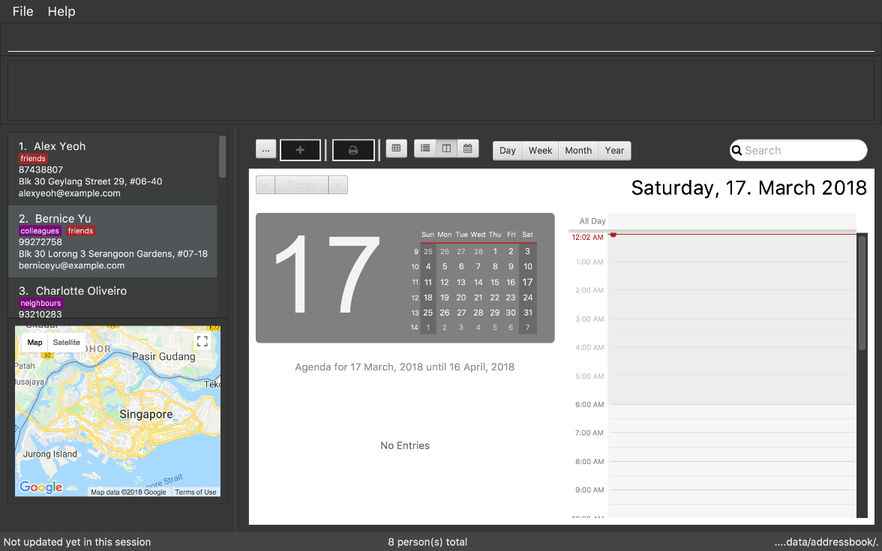

*Figure 1: Interface of CelebManager*

1. Type help in the command box and press Enter on your keyboard to execute the command. A help window should be opened.

|  |  |
| --- | --- |
| Lightbulb | CelebManager uses commands to execute tasks. All available commands are listed in Section 3: Commands. |

3 Commands

All **commands** in CelebManager follow a general format.

* A command has a keyword that identifies itself (e.g. add, exit).
* A command may have an alias which can substitute the keyword to execute the command (e.g. the letter a can be used to substitute the keyword add).
* A command must adhere to the format given, which includes the keyword followed by parameters.

Some commands contain **parameters**, which are information entered by you for executing the command.

* Parameters are denoted in upper case, and may be accompanied by a lower case letter handler to be keyed in with the command (e.g. n/NAME, t/TAG).
* Parameters are optional if it is in square brackets denoted in the command format (e.g. [t/TAG]).
* Parameters can be included any number of times if it is preceded by … symbol (e.g. [t/TAG]… in command format implies that the command can take in multiple tags as parameters).
* Parameters can be included in any order after the command keyword.

**3.1 General Commands**

**3.1.1 Opening Help Window:** help

This command shows a help window that contains the user guide.

Format: help

**4 Frequently Asked Questions**

**Question:** How do I transfer my data to another computer?

**Answer:** Install the app in the other computer and overwrite the empty data file it creates with the file that contains the data of your previous CelebManager folder.

**5 Command Summary**

The following is the summary of all the commands introduced in **Section 3: Commands** displayed in alphabetical order. The commands are displayed with their respective command format and an example highlighting the usage if the command has parameters.

add

Format: add n/NAME p/PHONE_NUMBER e/EMAIL a/ADDRESS [t/TAG]…​

Example: add n/James Ho p/22224444 e/jamesho@example.com a/123, Clementi Rd, 1234665 t/friend t/colleague

addAppointment

Format: addAppointment n/APPOINTMENT_NAME [l/LOCATION] [sd/START_DATE] [st/START_TIME] [ed/END_DATE] [et/END_TIME]

Example: add n/Oscars 2018 l/Hollywood sd/23/03/2018 st/14:00 ed/23/03/2018 et/20:00

clear

Format: clear

delete

Format: delete INDEX

Example: delete 3

edit

Format: edit INDEX [n/NAME] [p/PHONE_NUMBER] [e/EMAIL] [a/ADDRESS] [t/TAG]…​

Example: edit 2 n/James Lee e/jameslee@example.com

find

Format: find KEYWORD [MORE_KEYWORDS]

Example: find James Jake

help

Format: help

history

Format: history

list

Format: list

listAppointment

Format: listAppointment

redo

Format: redo

removeTag

Format: removeTag TAG

Example: removeTag friends

select

Format: select INDEX

Example: select 2

showLocation

Format: showLocation ma/LOCATION

Example: showLocation Prinsep Street

undo

Format: undo

viewCalendarBy

Format: viewCalendarBy VIEW

Example: viewCalendarBy week