**Software Requirements Specification Document**

|  | **PROJECT NAME: ALEXIS**  TEAM-13  CS21B008: Athinagaram Shree Balaji  CS21B054: Vinnakota Charvy |
| --- | --- |

# Brief problem statement

The idea of the web application is to help people take consumables safely. The web application focuses on simulating the reaction of the body to medicine or food based on the contents present it. This indeed helps to analyze the process which can suggest possible cure for people having allergens/any health issues.

# System requirements

* Backend to be built using languages *Node.js*
* Frontend: *HTML*, *CSS*, and *JavaScript* ( UI frameworks and libraries: *React*) for the user interface.
* Web framework for the backend *Express.js* to handle *HTTP requests*, *routing*, and *data management*.
* Database system: *MongoDB* to store user data, medicine information, and simulation results.
* Simulation libraries or APIs for simulating human body reactions to medicines.
* A comprehensive database of medicines, including their chemical properties, dosages, side effects, and interactions.
* To visualize the simulation results libraries like *three.js* to be used.

# Users profile

* Medical Researchers and Scientists, Pharmaceutical Companies, Healthcare Professionals, Medical Students and Educators, Patients can use this software to simulate as per their requirement and can get a diagnostic.
* The web application will be built user friendly to cater a large base of customers with a clear guide of instructions on how to use it
* The web application gives an option for the Medical Professionals to change the parameters and their values as per their requirements.

# Feature requirements (described using use cases)

| **No.** | **User Case Name** | **Description** | **Release** |
| --- | --- | --- | --- |
|  | User Registration and Login | Users can create accounts, log in, and log out to access the simulation system. | R1 |
|  | Search and Select Medicines | Users can search for medicines by name or category and select them for simulation. | R1 |
|  | Input Patient Data | Users can input patient-specific data, including age, weight, medical history, and other relevant parameters. | R1 |
|  | Configure Medication Dosage | Users can specify medication dosages and schedules for the simulation. | R1 |
|  | Run Medication Simulation | Users can initiate simulations to model the effects of selected medicines on the patient's body based on the input data and dosage. | R1 |
|  | Visualize Simulation Results | The system provides graphical representations and reports of the simulation results, including drug concentration over time, physiological responses, and potential side effects. | R2 |
|  | Drug Interaction Analysis | Users can analyze potential interactions between selected medicines and receive warnings or recommendations based on known interactions. | R2 |
|  | Save and Load Simulations | Users can save and load simulation scenarios for future reference and analysis. | R2 |
|  | Integration with Drug Databases | Integrate with external drug databases to provide up-to-date information about medicines. | R2 |
|  | User Roles and Permissions | Implement role-based access control to differentiate between administrators, researchers, students, and general users. | R2 |
|  | Mobile-Friendly Interface | Develop a responsive design to make the system accessible on mobile devices. | R2 |

**Use case diagram**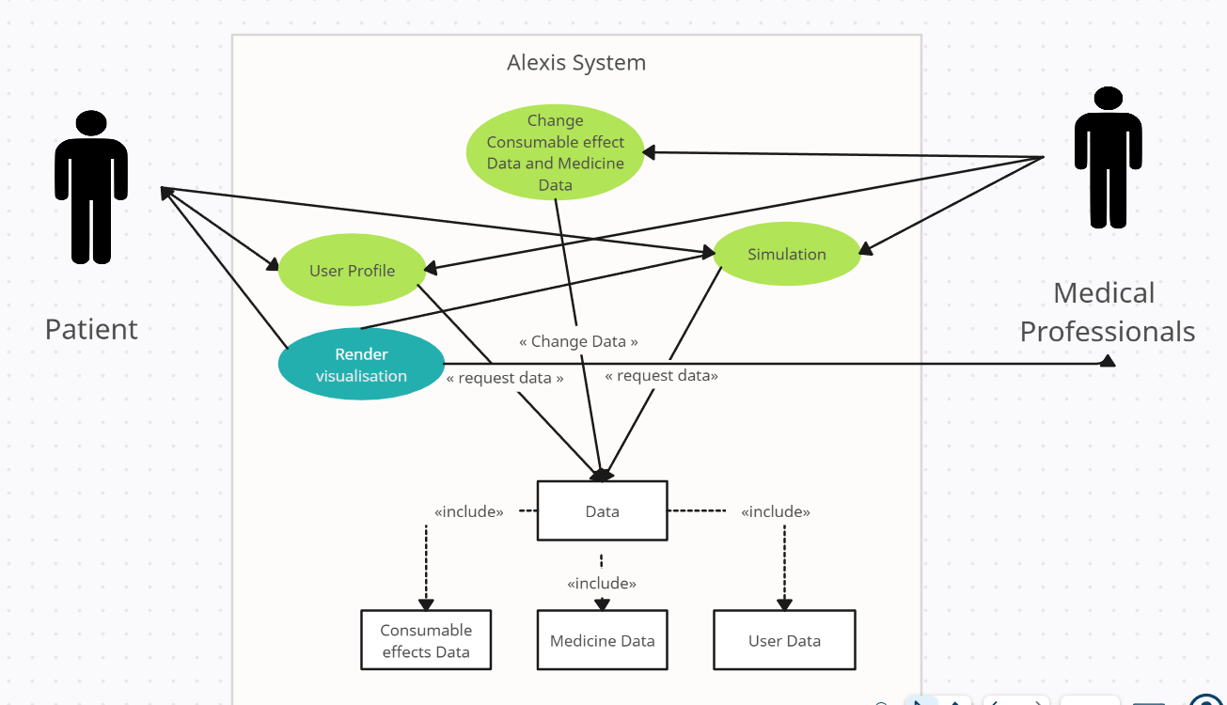

**Use case description**

| **Use Case Number:** | UC-01 |
| --- | --- |
| **Use Case Name:** | User Registration and Login |
| **Overview:** | This use case describes the process of user registration and login within the system. Users, including researchers and students, can create accounts, log in to access the application, and perform various actions related to medication simulation. |
| **Actors:** | User |
| **Pre condition:** | The system is accessible, and the user is not logged in. |
| **Flow:** | **Main (Success) Flow:**  1. User navigates to the application's registration page.  2. User enters registration details, including username, password, email, and personal information.  3. User submits the registration form.  4. System validates the provided information.  5. If the information is valid, the system creates a new user account and logs the user in automatically.  6. Users gain access to the application's features and functionalities. |
| **Post Condition:** | The user is successfully registered and logged in, gaining access to the application's features and functionalities.. |

| **Use Case Number:** | UC-02 |
| --- | --- |
| **Use Case Name:** | Search and Select Medicines |
| **Overview:** | This use case involves users searching for medicines or consumables and selecting them for simulation. Users, including researchers and students, need to find specific medicines or consumables to include in their simulations.. |
| **Actors:** | User |
| **Pre condition:** | The user is logged into the system and has access to the application's main dashboard. |
| **Flow:** | Main (success) Flow:   1. User navigates to the "Medicine Search" section of the application. 2. User enters search criteria, such as medicine name or category. 3. User submits the search request. 4. System retrieves a list of medicines matching the search criteria. 5. User reviews the list of medicines. 6. User selects one or more medicines to include in the simulation by checking checkboxes. 7. User confirms the selection. |
|  | Alternate Flows:  If no medicines match the search criteria, the system displays a message indicating no results and allows the user to refine the search criteria. |
| **Post Condition:** | The user has selected one or more medicines to include in the simulation. |

| **Use Case Number:** | UC-03 |
| --- | --- |
| **Use Case Name:** | Input Patient Data |
| **Overview:** | This use case involves users inputting extra patient-specific data, such as age, weight, medical history, and other relevant parameters. This data is necessary for customizing medication simulations to individual patients. |
| **Actors:** | User |
| **Pre condition:** | The user is logged into the system and has selected one or more medicines for simulation. |
| **Flow:** | Main (success) Flow:   1. User navigates to the "Input Patient Data" section of the application. 2. User fills out a form with patient-specific data, including age, weight, medical conditions, allergies, and other relevant information. 3. User submits the patient data. 4. System validates the input data for completeness and accuracy. 5. If the data is valid, the system associates the patient data with the selected medicines for simulation. |
|  | Alternate Flows:  If the user provides incomplete or inaccurate patient data, the system displays an error message and allows the user to correct the information. |
| **Post Condition:** | The user has successfully provided patient-specific data, which is associated with the selected medicines for simulation. |

| **Use Case Number:** | UC-04 |
| --- | --- |
| **Use Case Name:** | Configure Medication Dosage |
| **Overview:** | This use case allows users to specify medication dosages and schedules for the simulation. Users, including researchers and students, need to customize the dosages to simulate different scenarios accurately. |
| **Actors:** | User |
| **Pre condition:** | The user is logged into the system, has selected medicines for simulation, and has provided patient-specific data. |
| **Flow:** | Main (success) Flow:   1. User navigates to the "Dosage Configuration" section of the application. 2. User selects a medicine for dosage configuration. 3. User specifies the dosage amount (e.g., milligrams) and dosage schedule (e.g., daily, twice a day) for the selected medicine. 4. User adds the configured dosage to the simulation. 5. User repeats the process for other selected medicines if necessary. |
|  | Alternate Flows:  If the user attempts to configure an invalid dosage (e.g., negative dosage amount), the system displays an error message and prompts the user to correct the dosage information. |
| **Post Condition:** | The user has successfully configured medication dosages for the simulation. |

| **Use Case Number:** | UC-05 |
| --- | --- |
| **Use Case Name:** | Run Medication Simulation |
| **Overview:** | .This use case describes the core process of running a medication simulation. Users initiate the simulation to model the effects of selected medicines on the patient's body based on the input data and dosage. |
| **Actors:** | User |
| **Pre condition:** | The user is logged into the system, has selected medicines for simulation, provided patient-specific data, and configured medication dosages. |
| **Flow:** | Main (success) Flow: Steps should be numbered.   1. User navigates to the "Simulation" section of the application. 2. User reviews the selected medicines, patient data, and medication dosages to ensure accuracy. 3. User initiates the simulation. 4. The system processes the simulation, modeling the effects of the selected medicines on the patient's body. 5. The system generates simulation results, including drug concentration over time and physiological responses. 6. User can view and analyze the simulation results. |
|  | Alternate Flows:  If there are technical issues during the simulation process, the system displays an error message and prompts the user to retry the simulation. |
| **Post Condition:** | The user has successfully run the medication simulation and can view the simulation results. |

| **Use Case Number:** | UC-06 |
| --- | --- |
| **Use Case Name:** | Visualize Simulation Results |
| **Overview:** | .This use case involves visualizing the simulation results generated from the medication simulation. Users can analyze the results, including drug concentration over time, physiological responses, and potential side effects. |
| **Actors:** | User |
| **Pre condition:** | The user has successfully run a medication simulation, and simulation results are available for visualization. |
| **Flow:** | Main (success) Flow:   1. User selects a specific simulation result to view. 2. The system displays graphical representations of the simulation results, including drug concentration charts, physiological response graphs, and side effect summaries. 3. User can interact with the visualizations to zoom in, zoom out, or view details. 4. User analyzes the results to gain insights into the effects of the selected medicines on the patient's body. |
| **Post Condition:** | The user has successfully visualized and analyzed the simulation results, gaining insights into the medication's effects on the patient's body. |

| **Use Case Number:** | UC-7 |
| --- | --- |
| **Use Case Name:** | Drug Interaction Analysis |
| **Overview:** | .This use case enables users to analyze potential interactions between selected medicines. Users can receive warnings or recommendations based on known drug interactions to ensure the safe use of medications. |
| **Actors:** | User |
| **Pre condition:** | The user has selected multiple medicines for simulation. |
| **Flow:** | Main (success) Flow:   1. User navigates to the "Drug Interaction Analysis" section of the application. 2. User reviews the list of selected medicines for simulation. 3. The system checks for potential drug interactions among the selected medicines. 4. If drug interactions are detected, the system displays warnings or recommendations to the user. 5. User can acknowledge the warnings or follow the recommendations to adjust medication selection or dosages accordingly. |
| **Post Condition:** | The user has reviewed and addressed potential drug interactions among the selected medicines, ensuring the safe use of medications in the simulation. |