Swing Admin Panel Screenshots:

Create Season Screen:
All working
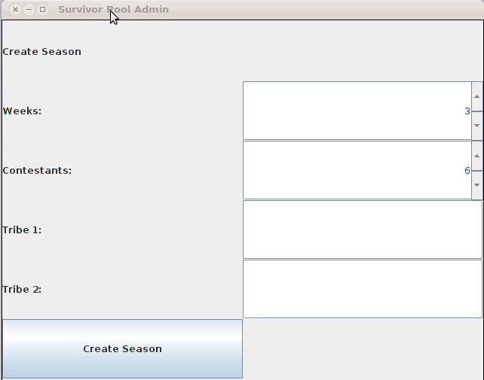

General Tab:
All stubs, there for placement
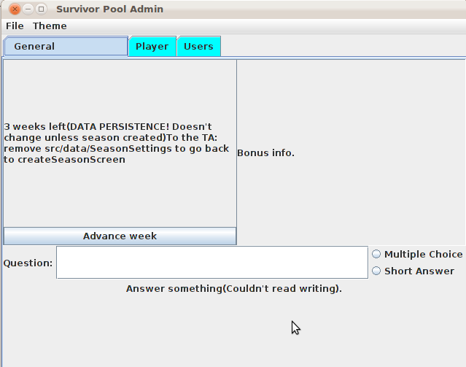
Contestants Tab 1:
Several contestants added
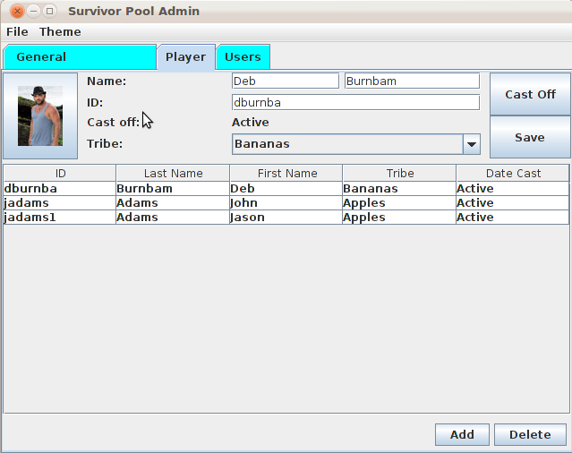
Contestants Tab 2:
Showing contestants added, selecting a row.
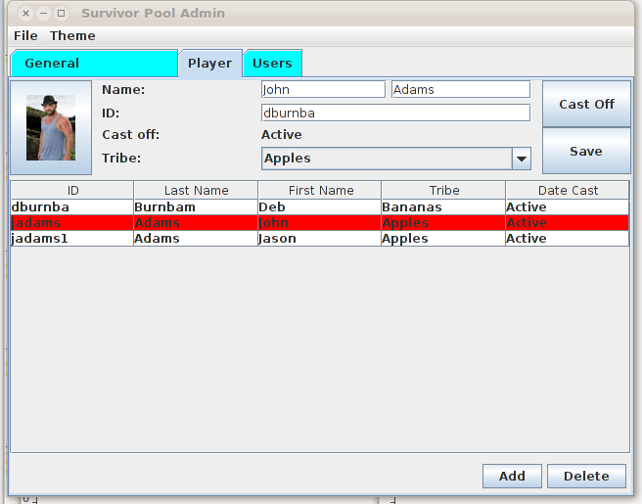
Contestants Tab 3:
Ordered by first name, changed pictures
