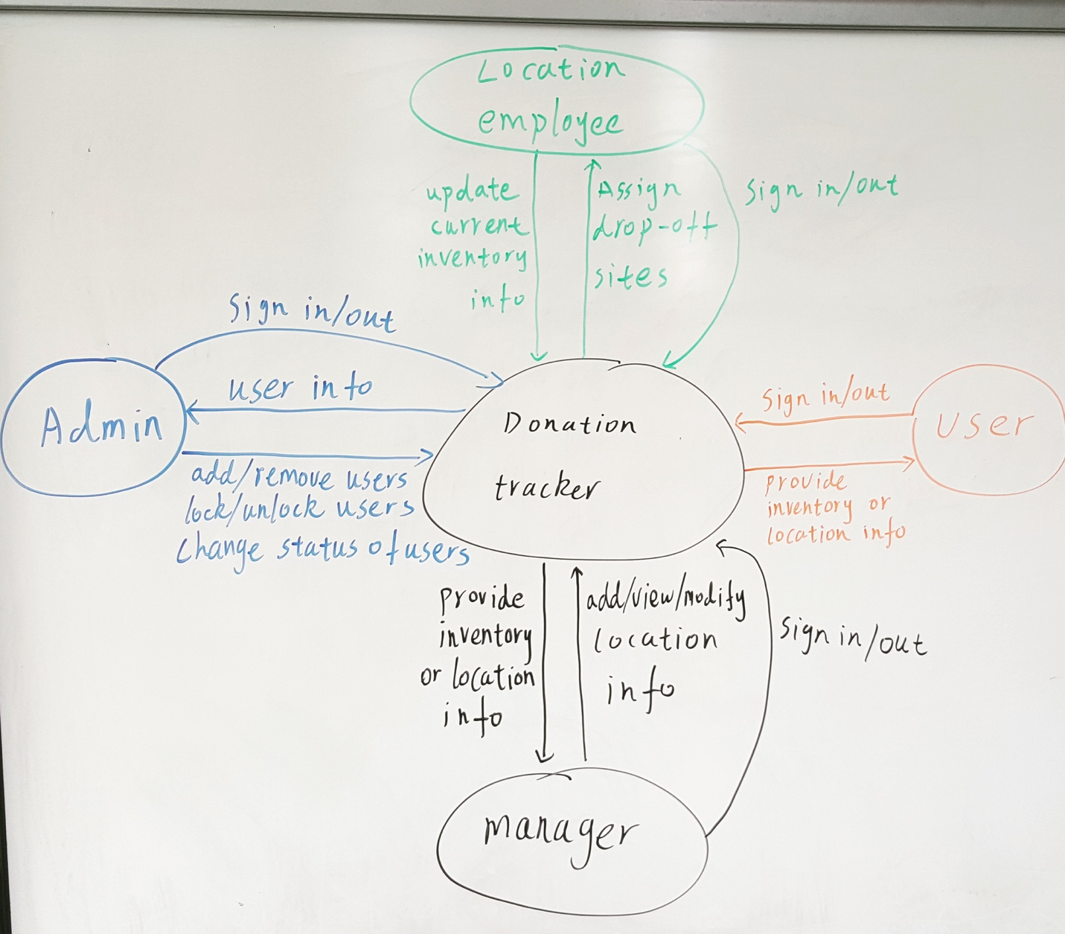

User stories:

1. As a user, I want to be able to sign up so that I can sign in.
2. As a user, I want to be able to sign in so that I can look up donate location/center, view the inventory.
3. As a admin, I want to be able to sign up so that I can sign in.
4. As a admin, I want to be able to sign in so that I can add/remove users, locations, lock/unlock users accounts.
5. As a admin, I want to be able to change a user status and give user more/less privilege.
6. As a location employee, I want to be able to sign up so that I can sign in.
7. As a location employee, I want to be able to sign in so that I can change data.
8. As a location employee, I want to be able to change data so that I can update info.
9. As a manager, I want to be able to sign up so that I can sign in.
10. As a manager, I want to be able to sign in so that I can view and edit all info at all locations.

Everyone’s implementation

Xiaohong chen - As a user, I want to be able to sign up so that I can sign in.

Jiajie - As a admin, I want to be able to sign up so that I can sign in.

Tim - As a location employee, I want to be able to sign in so that I can change data.

Yong - As a location employee, I want to be able to change data so that I can update info.

Uyen - As a manager, I want to be able to sign up so that I can sign in.

Mai - As a manager, I want to be able to sign in so that I can view and edit all info at all locations.

GitHub link: https://github.com/CS2340-Fall2018-Team74/Donation-Tracker