Matrix.org & Bridge tests

Our test consists of simple .exe file:

|  |
| --- |
| ./Exe.exe <uri> <number of requests> <interval between requests in milliseconds> |

This executable POSTs to the SPM Mock events of car check-ins/outs.

Results and conclusions

|  |  |  |  |
| --- | --- | --- | --- |
| Test # | Number of POSTs | Interval (in ms) | Timer (in seconds) |
| 1 | 1 | 1000 | 1.14 |
| 2 | 2 | 1000 | 2.14 |
| 3 | 5 | 1000 | 5.14 |
| 4 | 10 | 1000 | 10.67 |
| 5 | 5 | 500 | 2.64 |
| 6 | 10 | 500 | 5.14 |
| 7 | 5 | 200 | 1.18 |
| 8 | 10 | 200 | 2.15 |
| 9 | 20 | 500 | 10.16 |
| 10 | 50 | 500 | 26.18 |
| 11 | 100 | 500 | 63.37 |
| 12 | 500 | 1000 | 507.23 |

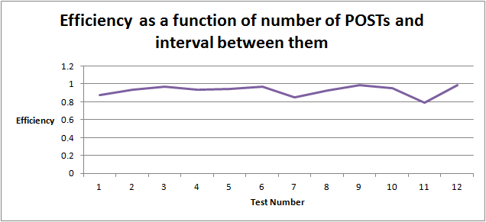

$Efficiency = \frac{num of POSTs}{timer}*\frac{interval}{1000}$

Conclusions:

1. The efficiency is high and stable.
2. There is a minor delay on the first POST. Probably because of a cooldown.
3. After some period of time, the bridges return “Too many requests” - this limitation comes from Matrix.org homeserver.
   1. Configure in the Matrix.org homeserver.yaml the field: rc_messages_per_second