Quadris Design Plan

Group Members: Samatar Abukar, Lester Lim, Pranav Tripathi

**Quick Overview of Major Classes and Structures and their Important Functions**

**Coord Structure:   
Contains:** int x, y -> Coordinates for each square in a block

**BlockCoord Structure:  
Contains:** coord1, coord2, coord3, coord4 -> 4 Coords that store block’s position

**BlockCell Structure:   
Contains:** char c -> the Character corresponding to the type of block  
 int num -> this represents which block the character is part of

**Level Class:  
Contains:** int n -> Corresponds to level(0-6)

Grid*g -> Pointer to grid. Used when initializing blocks

**Block *MakeBlock() -> Creates the blocks**

**void LevelUp() and void LevelDown() -> change the difficulty of   
 the game**

**Block Class(Abstract) Contains 7 Subclasses:  
Contains:** BlockCoord bc -> The coordinates of the block’s current position  
 Grid* g -> Pointer to grid  
 Level *curLevel -> helps in deciding if the blocks are heavy  
 **Note: All following functions are void**

**Left() and Right() and Down() -> Shift the coordinates of the block in the correct direction**

**Clockwise(int version) and Counterclockwise(int version) -> Rotate the block in the correct direction. The version integer stores the current iteration of rotate so the function knows how to rotate the block**

**Drop() ->Drop the block as far as it can go**

**Grid Class:  
Contains:** vector<vector<BlockCell> > theDisplay -> the actual grid itself

**void update(BlockCoord bc, char c) -> Takes the coordinates in bc and updates those respective coordinates in theDisplay to contain c**

**void check(BlockCoord bc) -> checks to see if the new coordinates of the block are valid in respect to the actual game grid itself. Returns a Boolean**

**void rowClear() -> if a row is filled entirely, that row is removed from the display and each row above is moved down one**

**Hint() -> Shows the user where the best possible position for the current block in its current orientation is**

**void estart() -> Resets the grid to the original empty state**

**Graphics Class (friend of Grid Class):  
Contains: void gameOver() –> Displays Game Over screen when player reaches top**

**void endOfFile() -> Displays Game Over screen when file input ends**

**void print(int score, int level) -> Displays the current state of the game**

**int getColour(const char blockType) -> returns the colour depending ‘ on the type of block**

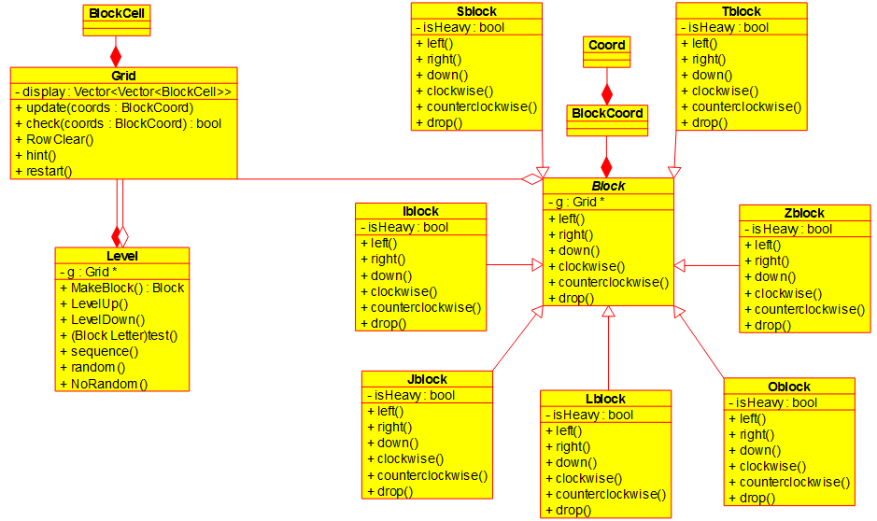**UML Diagram of Major Classes and Structures**

**Description:**

To implement the game of Quadris, our group intends on taking an object-oriented approach.

The design of the game begins through the Level class which takes in an integer value corresponding to the level of difficulty that the game will be played on. This is used in the MakeBlock function which will then use the correct creation scheme to create Block objects according to the level difficulty. As the game progresses, calling LevelUp and LevelDown will change the difficulty accordingly.

The core part of our design involves fluid interaction between the current Block that is to be manipulated and its placement on the grid by using a “check then update” feature.

Each block begins at the top left of the grid leaving enough room for rotations. The Block class contains the functions necessary to manipulate the Block’s position on the grid. Using a BlockCoord(structure containing four (x,y) coordinate pairs) as one of its private fields, the functions left, right, clockwise, counterclockwise, down and drop will modify these coordinate pairs accordingly. Throughout the design document, these will be referred to as the Manipulating Functions.

The check and update functions(written in Grid) take the changes being made to the coordinates in Block and apply them to the Grid. After each call of a Manipulating function, the grid will call Check to make sure that the move is valid. If there are characters already located in one of the coordinates, this will return false and the move will not be made. If it is a valid move, then the grid will call update and the correct characters will be placed. The Graphics class is a friend of the Grid class and creates an exact copy of the grid except in actual Tetris format. This does not break encapsulation since the Grid is a private field of a Level and thus cannot be manipulated by the user and transitively, this also means the Graphics are a private field and the user cannot interfere.

Before each call of a Manipulating function, the grid will first set the existing coordinates of the block to “space” to prevent errors in conversion from one position to another. Since the block will have originally passed a check in the previous manipulation, the four characters can be set to space without worrying about overwriting something important. The program proceeds as usual.

Upon each call of Drop, the grid function will also check if a row has been filled through the vector. If it has, then the grid will call RowClear()(Function in Grid) which will also update the score of the game and check if any blocks have been destroyed using the blockCell structure. The Drop function is the user’s way of communicating to the program that he is done with the current block and that the next one be brought out. Even if the user has reached a position where no further manipulation is possible, **he will have to** call drop to have access to the next block. The Graphics Display will read off the grid as usual and the updated display will be shown.

To make life easier for us developers, the game also provides a Sandbox style mode which allows for certain blocks to be placed at certain times using the commands corresponding to the type of block(e.g L for LBlock). Other functions include norandom and random, which take away and add randomness respectively. A function sequence is provided to allow for a set of commands to be carried out in the game automatically. These functions are not going to be used in a standard play-through of the game and are more suited for testing purposes.

To play the actual game, the user will interact through a controller which will take in standard input from the user and the game will correspond accordingly to the given input. The controller is an important part of the design because it helps keep our main file clutter free and more suited for other purposes, such as handling command line arguments.

The game also allows for reading in a sequence of blocks from a file. This feature is available on Level 0 and also throughout other levels of the game if the norandom function is called. The program knows how to exit properly when the end of the file is reached and will notify the user before doing so.

The rules of the game are that of a standard Tetris game, as soon as the player reaches the top of the grid, the game will end. As stated above, the game will update the view as necessary and let the user know that the game is over while also displaying his final score in the run.

A provided feature for the user’s satisfaction is an option for text display game only. This will appeal to users with less powerful computers as the graphics will play slightly slower for them. This is one of the few command line arguments that the game can be initialized with. The other ones include:  
1) -seed –xxx. Which will take in a seed value from the user to help change the randomization of the blocks  
2) -scriptfile –xxx. This will read in a sequence through a given file  
3) –startlevel –x. This will start the game at the specified level.

The emphasis of the design is on ensuring that we run into as few bugs as possible. Employing the check after each manipulation is the key because it helps us avoid having to undo any moves on the Grid and every change to the Grid that we do finally make is final and need not be changed again.

Provided here is a breakdown of the responsibilities of each group member over the two week completion deadline:

**Summary of Member Responsibilities and Estimated Time of Completion**

|  |  |  |  |
| --- | --- | --- | --- |
| Group Members | Samatar Abukar | Lester Lim | Pranav Tripathi |
| Classes: | -Block (abstract class)  -Sblock  -Iblock  -Tblock  -Score  -Hint/Restart  -Controller Setup | -Zblock  -Jblock  -Lblock  -Oblock  -Command Line Args  -Regex Commands  -Controller Setup | -Level  -GridDisplay  -GraphicsDisplay  -Exception Handling  -View Update and Check  -Controller Setup |
| Projected Completion Date: | December 1st | December 1st | December 4th |

**How the Design Caters to Changes and New Features**

Accommodation of new features and changes to existing features:

To accommodate for potential new features and changes to existing features, we have designed our program with customizability and flexibility in mind. The goal is that we should be able to easily customize the program without breaking the logic of the existing code. Examples of potential new features are adding new levels and adding a feature such that the block is constantly dropping by one row (similar to the classic Tetris game), whereas potential changes to current features could be implementing a grid with a different size, a different scoring system, different block orientations and changing the way blocks are randomized.

For simple enhancements such as implementing a grid of different dimensions, we can simply specify any dimensions larger than 4x4 (at least the size of a block) in the Level class, where grid is initialized. Since the blocks are always checked for validity (by obtaining the new coordinates and checking for clashes in the grid) before they are manipulated, altering the size of the grid will not affect the pre-existing logic. Similarly, Adding a new level simply means adding a new switch statement in Level's public method, MakeBlock, alongside an algorithm for generating the blocks and the rest falls into place naturally.

Even for advanced, CPU heavy features such as having blocks drop by one row constantly with a specific time interval in between each drop, the program's design mindset of customizability and flexibility still holds. In other words, majority of the existing core logic can remain the same for the new feature to work. In this case, it should not be necessary to write new methods for manipulating these constantly moving blocks - we simply need to implement a time delayed loop after making a block (in Level's public method, MakeBlock that calls the block's public method, down, until the block is placed or is out of the grid (game over). We can clearly see that the main functions for performing the block movement have not changed and the only thing we added was a time delayed loop.

From this discussion, we have shown that our Quadris design caters for new features and changes to existing features.