Test case: AL-142
As a borrower, I choose my broker after sign-up and can change them later
Item | Detail
Story | AL-142: As a borrower, I choose my broker after sign-up and can change them later
Epic | AL-4 Accounts & Roles (use case written by Nikoloz)
Owner | Ibrahima Toure (iOS borrower app, al-mobile)
Sprint | Sprint 1 (8 to 25 Oct 2026)
Wireframe | wireframe.png in this folder, exported from Figma (https://www.figma.com/design/l1dzCYxViJsNVEceRstuH1?node-id=5-41), file "AL-80 Borrower app". Frames 05a, 06 Choose broker, Home and 19 Profile.
Code | al-mobile/ (Broker and Home folders) on the stay-signed-in branch, PR #57; not on main yet, repository CS3-Agentic-Lender/agentic-lender

What this tests
After sign-up the borrower picks a broker (name and firm) from al-core's broker list before they can reach home. One gate in front of home sends any borrower without a broker to the picker, whichever way they arrive: sign-up, Google, sign-in or reopening the app. The choice is saved on the borrower's profile through al-core (PUT /core/me/broker), and the borrower can change broker later.

Wireframe
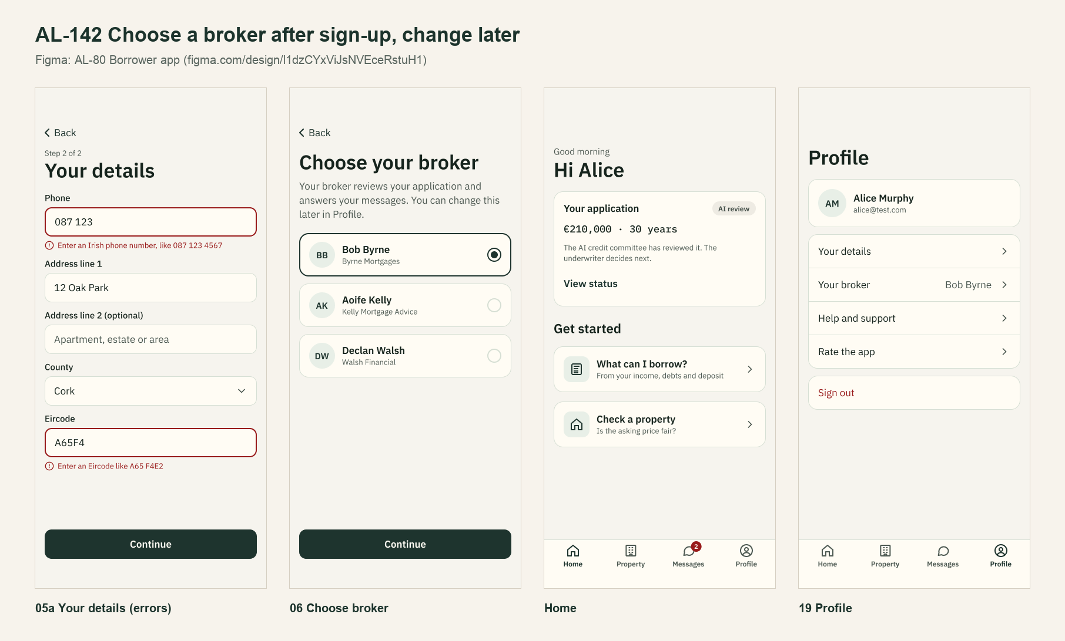
The wireframe is the design target. "Moved to Sprint 2 or not finished" below lists the parts that are not built or not merged yet.

Preconditions and test data
- Local Firebase emulators (Auth and Firestore) with the seed data from main, al-core and al-ai running behind the local Docker gateway, and the app on the iPhone 17 Simulator. The seeded accounts and the people in the test data are made up and exist only in the local emulator. Dumi's broker endpoints in al-core (PR #48).
- Test data: the seeded brokers (Bob Murphy, Murphy Mortgages; Ciara Kelly, Kelly Financial) and a new borrower with no broker.
- Unit tests: cd al-mobile, then xcodebuild test -project AgenticLender.xcodeproj -scheme AgenticLender -destination 'platform=iOS Simulator,name=iPhone 17'. They use fake services, so they need no emulator.
- Unit test results on 22 Oct 2026: 221 tests on the PR #57 branch with main merged in, 0 failures.

Test cases
ID | Acceptance criterion | Steps | Expected result | How it was checked, and the result
TC-142-01 | After sign-up the borrower picks a broker (name and firm) before home; the seeded broker is in the list. | 1. Sign up a new borrower. 2. Look at the broker list. 3. Choose Bob Murphy and Continue. | The list shows each broker's name and firm, and Continue stays off until one is picked. After Continue, home opens. | Automated: BrokerPickerViewModelTests > testListsTheBrokersByNameAndFirm, testContinueNeedsABrokerSelected, testChoosingAfterSignUpSaysContinue; HomeGateViewModelTests > testABorrowerWithoutABrokerMustChooseOneBeforeHome, testChoosingABrokerOpensHome. End to end (15 Oct): the list showed Bob Murphy and Ciara Kelly, and choosing Bob reached home. Pass on the branch.
TC-142-02 | The choice is saved on the borrower's profile, and that broker can see the borrower's application. | 1. Choose Bob. 2. Read the profile back (GET /core/me). 3. Open home. | The profile has Bob as broker, and home shows "Your broker: Bob Murphy, Murphy Mortgages". | Automated: CoreProfileAPITests > testChooseBrokerPutsTheIDAndReadsBackTheProfile, testProfileReadsTheNameAndBrokerFromCoreMe; HomeViewModelTests > testShowsTheChosenBrokerAndFirm. End to end (15 Oct): PUT /core/me/broker returned 200, the choice came back on the next read, and a uid that isn't a broker was refused with 422. Portal side: checked with Nikoloz in the broker portal, where the chosen broker could see the borrower. Pass on the branch.
TC-142-03 | The borrower can change broker later; afterwards only the new broker can see the application. | 1. On home, open Your broker. 2. Pick a different broker and Save. | The picker opens on the current broker with Save off until a different broker is picked. After Save, home shows the new broker. | Automated: BrokerPickerViewModelTests > testChangingStartsOnTheCurrentBrokerAndSaysSave, testSaveStaysOffUntilADifferentBrokerIsPicked, testSavingSendsTheChoiceAndReturnsTheUpdatedProfile; HomeViewModelTests > testChangingBrokerUpdatesTheCard. Simulator: home after changing broker. Who can see the application is enforced by al-core's rules (Dumi's broker assignment subtask), not by the app. Pass on the branch.
TC-142-04 | If no brokers can be loaded, the screen shows an error with Retry rather than an empty list. | Stop al-core, then open the broker list. Start al-core and press Retry. | An error with Retry, not an empty list. Retry loads the list. | Automated: BrokerPickerViewModelTests > testAListThatCantLoadSaysWhyAndRetryLoadsAgain, testNoBrokersShowsTheEmptyMessage; CoreProfileAPITests > testNoConnectionWhenListingBrokersIsANetworkError. Pass on the branch.
TC-142-05 | Beyond the criteria: a failed save keeps the choice and says so. | Make PUT /core/me/broker fail, then Save again. | The picked broker stays selected and an error shows. Saving again clears it. | Automated: BrokerPickerViewModelTests > testAFailedSaveKeepsTheChoiceAndShowsAnError, testSavingAgainAfterAFailureClearsTheError. Pass on the branch.

Moved to Sprint 2 or not finished
- Not merged: PR #58 (AL-95) was merged into the stay-signed-in branch instead of main on 21 Oct, so this code reaches main with PR #57 or its own PR, as agreed with Nic in #dev. AL-95 is In Review.
- Change broker is on a "Your broker" card on home. The wireframe also shows it on the Profile screen (19), which is built in Sprint 2.

Notes
- Figma link: https://www.figma.com/design/l1dzCYxViJsNVEceRstuH1?node-id=5-41

