Test case: AL-24
As a data scientist, I train a property valuation model and report how accurate it is
Item | Detail
Story | AL-24: As a data scientist, I train a property valuation model and report how accurate it is
Epic | AL-6 Fair-Price Property Checker
Owner | Nic (al-ai: the valuation model)
Sprint | Sprint 1 (8 to 25 Oct 2026)
Wireframe | wireframe.png in this folder. AL-24 has no screen, so it is a flow diagram of how the model was built and tested. The screens that use the model are AL-22 and AL-143 (Sprint 2).
Code | al-ai/ml/ (the data, split, benchmark, tuning and final-test scripts), al-ai/app/valuation_model.py (the loader), al-ai/models/valuation/ (the saved model and its model card) and al-ai/tests/, on branch main of CS3-Agentic-Lender/agentic-lender

What this tests
A property valuation model trained on the Daft.ie 2024 listings and tested on listings it never saw, so that the property checker and the valuation agent give estimates whose accuracy we can state and defend. The tests check the data report, the split and the benchmark, the one-time final test, the saved model and its inputs.

Wireframe
The flow diagram (wireframe.png) shows how the model was built and tested, step by step. The screens that will show an estimate, the property checker (AL-22) and the loan file (AL-23), are Sprint 2.
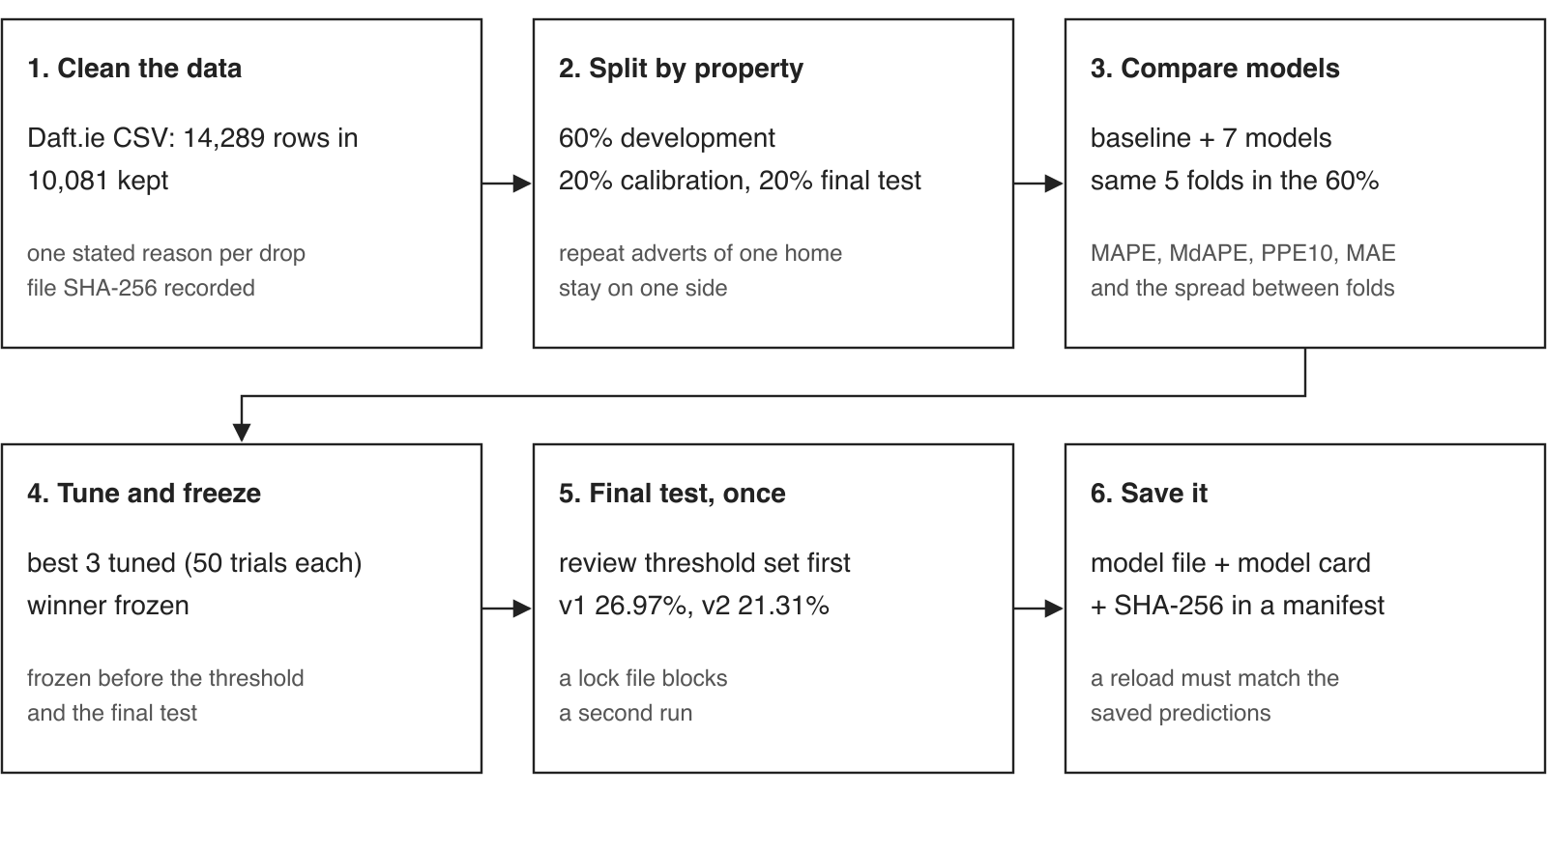

Preconditions and test data
- Python 3.12 or newer and uv. In al-ai run uv sync once. No network, keys or wallet are needed.
- The tests use made-up listings kept in the test files. One test reads the real Kaggle CSV (al-ai/data/raw, not in git) and skips itself when the file is not there.
- No real borrower data is used.
- To run the valuation tests: cd al-ai, then uv run pytest tests/test_data_readiness.py tests/test_split.py tests/test_benchmark.py tests/test_tune.py tests/test_final_eval.py tests/test_valuation_model.py tests/test_valuation_loader.py tests/test_v2_final.py tests/test_v2_models.py tests/test_v2_tune.py

Test cases
ID | Acceptance criterion | Steps | Expected result | How it was checked, and the result
TC-24-01 | The data report accounts for every row of the Daft CSV as kept or dropped, with the reason for each drop, and records the file's SHA-256. The raw CSV stays out of git. | 1. Run the data readiness tests. 2. With the CSV in al-ai/data/raw, run the real-file test. 3. Open ml/reports/data-readiness.md. 4. Check git ignores the raw file. | Every row is kept or dropped exactly once, with one reason. The counts add up to the 14,289 rows in the file and the file's SHA-256 is recorded. The raw CSV is not tracked by git. | Automated: every row is kept or dropped once and the hash is recorded; the real file matches the plan and adds up; each drop reason has its own test (duplicates, land sites, price on application, Northern Ireland, unknown county, unsupported type, floor area outside 15 to 1,000 m2). Report: 14,289 in, 10,081 kept, SHA-256 d4c1ea0b. Pass.
TC-24-02 | One re-runnable benchmark compares the baseline with the seven models on the same five folds inside the 60% development split, and reports MAPE, MdAPE, PPE10, MAE and how much the folds vary. | 1. Run the split and benchmark tests. 2. Open ml/reports/benchmark-report.md. | The data is split 60/20/20 by property, so repeat adverts never sit on both sides of a split. The baseline and all seven models are scored on the same five folds, and the report gives the five measures and the spread between folds. | Automated: the split keeps every property group whole and leaks none across partitions; the benchmark uses the same folds for every model. Report: benchmark-report.md. Pass.
TC-24-03 | The winner is frozen before the 20% calibration split sets the price-review threshold and the 20% final test is scored once, with the result reported even if it is bad. | 1. Run the final evaluation tests. 2. Open ml/reports/final-test-report.md and v2-final-test-report.md. | The winner is frozen first. The threshold is the 90th percentile of the gap between asking price and estimate and cannot depend on the final test split. The final test is scored once, and a second run is refused. The result is reported as it came out. | Automated: the threshold is the 90th percentile of the gaps; the test split cannot change the threshold; the final test cannot be scored twice. Reports: v1 26.97% average miss (baseline 31.93%); v2 21.31%, with 38.8% of estimates within 10%. Pass.
TC-24-04 | The saved pipeline gives the same predictions as the saved reference ones after reloading, and the model card covers the data, features, target transform, metrics, threshold and limits. | 1. Run the package and loader tests. 2. Open al-ai/models/valuation/MODEL_CARD.md. | Reloading the saved file reproduces the saved reference predictions. The file's SHA-256 matches the manifest, and it is the file the final test scored. The model card states the checksum, the threshold and the limits. | Automated: a reload reproduces the saved reference predictions; the model file matches the SHA-256 in the manifest; it is the file the final test scored; the card states the checksum, threshold and limits. Read the card: data, inputs, target transform, metrics, threshold and limits are all there. Pass.
TC-24-05 | The model only takes the app's inputs and accepts both the old A1 to G and the new A to G BER scales. | 1. Value a home with an old BER (such as C1) and the same home with the new band (C). 2. Value a home with the Eircode routing key missing. 3. Check what columns the saved package holds. | The old and new BER scales give the same estimate. The package holds the input columns only (county, floor area, bedrooms, property type, BER and the Eircode routing key), with no prices or listing text. A missing routing key still gives an estimate. | Automated: old and new BER scales give the same value; the routing key changes the value and a missing one still works; the package holds inputs only. Note: the story says five inputs. v2 added the routing key, so the model takes six (decided 23 Oct, see the comment on AL-24). Pass.
TC-24-06 | Beyond the criteria: a model file that does not match its hash is never loaded. | 1. Point the loader at a model file whose hash does not match, or at a manifest with a wrong hash. 2. Try loading a missing model. 3. Load a model that returns nonsense. | The loader refuses the file and the model is unavailable. A missing model is unavailable, not a crash. A model that returns nonsense is treated as unavailable. | Automated: a model file that does not match its SHA-256 is never loaded; a manifest with a wrong hash is refused; a missing model is unavailable, not a crash; a model that returns nonsense is unavailable. Pass.

Moved to Sprint 2 and later
- Serving the model: POST /valuation (AL-60), which now takes the full Eircode.
- Explaining each estimate: AL-131, AL-134 and AL-135 (six contributions).
- The valuation agent in the AI committee (AL-26).
- The property checker screen (AL-22 and AL-143) and the loan-file comparison (AL-23).

Notes
- Test results on main on 23 Oct 2026: the valuation test files give 149 passed and 2 skipped. The two skipped tests need the optional gpboost package, which only one experiment uses. The whole al-ai suite gives 460 passed and 2 skipped.
- Pull requests: PR 75 (data readiness), PR 78 (the split and benchmark), PR 82 (tuning and the v1 freeze), PR 83 (the threshold and the v1 final test), PR 92 and PR 93 (extra inputs and the v2 model) and PR 94 (the saved model and model card).
- The full numbers, graphs and tables are in al-ai/ml/reports/ and on the Model support page in Confluence.

