Test case: AL-25
As an underwriter, an affordability agent reports disposable surplus, stress-tested repayments and DTI
Item | Detail
Story | AL-25: As an underwriter, an affordability agent reports disposable surplus, stress-tested repayments and DTI
Epic | AL-7 AI Credit Committee
Owner | Nic (al-ai: the affordability figures and the agent step)
Sprint | Sprint 1 (8 to 25 Oct 2026)
Wireframe | wireframe.png in this folder. AL-25 has no screen, so it is a flow diagram of the agent step, drawn for this story. The wider committee pipeline is in docs/diagrams/05-committee-pipeline.png. The underwriter's console that will show the result is AL-30 (Sprint 2).
Code | al-ai/app/affordability.py (the figures), al-ai/app/affordability_agent.py (the agent step), al-ai/app/prompts/affordability_agent_v1.md (the prompt), and al-ai/tests/test_affordability.py and test_affordability_agent.py, on branch main of CS3-Agentic-Lender/agentic-lender

What this tests
An affordability step that reports a borrower's net disposable surplus, stress-tested repayment and DTI. Code works out every figure and band. A local Ollama model only explains and recommends, and its reply is checked before anything trusts it: it must be valid JSON, use only the allowed ratings and recommendations, and quote only figures it was given. It can never change a band or approve a loan that breaks the Central Bank cap.

Wireframe
The flow diagram (wireframe.png) shows the agent step from the figures to the three ways it can end. The screen that will show the result to an underwriter, the AI console (AL-30), is Sprint 2.
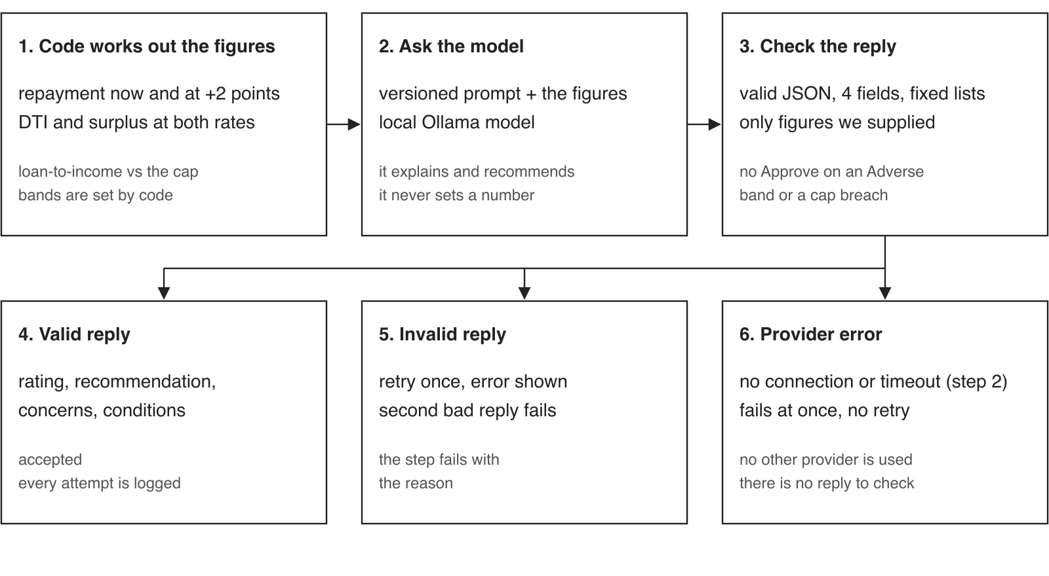

Preconditions and test data
- Python 3.12 or newer and uv. In al-ai run uv sync once. The automated tests need no network, keys or Ollama: they use a fake model.
- The test data is made up: the two reference cases from the calculations module (a single first-time buyer, and a joint mover buying at EUR 270,000 over 25 years at a 4.00% test rate). No real borrower data is used.
- To run: cd al-ai, then uv run pytest tests/test_affordability.py tests/test_affordability_agent.py
- For the real-model check, Ollama must be running with qwen3.5:9b pulled, then uv run python -m app.affordability_agent qwen3.5:9b. A laptop without Ollama asks a teammate on the ticket instead of using a cloud model.

Test cases
ID | Acceptance criterion | Steps | Expected result | How it was checked, and the result
TC-25-01 | For a synthetic application, code (not the LLM) works out the monthly repayment at the benchmark mortgage rate, the repayment at +2 points, DTI and net disposable surplus at both rates, and loan-to-income against the Central Bank limit (4x first-time buyers, 3.5x others). | 1. Run the affordability tests. 2. Check the two reference cases (a single first-time buyer and a joint mover) against the worked numbers. | Every figure comes from code. The reference cases match their worked figures. DTI is debts plus repayment over gross monthly income, and the surplus is take-home pay minus living costs, debts and repayment. | Automated: reference single first-time buyer; reference joint mover; assess gives normal and stressed figures; DTI is debts plus repayment over gross monthly income; net surplus; loan-to-income. Pass.
TC-25-02 | Unit tests cover normal, zero-rate and stressed repayment, joint totals, missing or zero income, and both sides of every band and cap boundary. | 1. Run tests/test_affordability.py. 2. Read the cases it covers. | There is a test for each of: normal repayment, a zero rate, a stress margin, joint totals, bad or zero income, and the values either side of each band and cap. | Automated: zero rate is the loan divided by the months; the stress margin is a parameter; joint totals are summed by the caller; bad input raises and the error names the field; DTI bands, surplus bands and the loan-to-income cap are tested on both sides. Pass.
TC-25-03 | Code sets the stressed DTI band (40% or less, up to 50%, over 50%) and the surplus band (EUR 500 or more, EUR 0 or more, below EUR 0), and a test shows the agent's reply cannot change a band or clear a cap breach. | 1. Check the bands on both sides of each boundary. 2. Give the agent a reply that tries to change a band. 3. Give it a reply that approves a loan over the cap. | The bands come from the stressed figures and are passed to the agent. A reply that changes a band is rejected. Approve is rejected when a band is Adverse or the loan-to-income cap is breached. | Automated: bands follow the stressed values; DTI and surplus bands at each boundary; a reply cannot change a band; Approve is rejected on a cap breach; Approve is rejected on an Adverse band. Pass.
TC-25-04 | Given those figures the agent on Ollama returns JSON that passes our schema: a rating (strong, adequate, weak, unaffordable), a recommendation (Approve, Conditionally Approve, Decline), concerns and conditions, quoting only figures it was given. | 1. Run the agent tests with the fake model. 2. With Ollama running and qwen3.5:9b pulled, run uv run python -m app.affordability_agent qwen3.5:9b. | A good reply passes first time. A reply with a wrong field, a value outside the lists or a figure we did not supply is rejected. The real model's reply is accepted. | Automated: a good reply passes first time; the schema checks reject bad replies; an invented figure is rejected; figures with commas and rounding are accepted; the prompt holds the data and a version. Real run on qwen3.5:9b (reference case, EUR 270,000 over 25 years at 4.00%): accepted on attempt 1, rating strong, recommendation Approve, 62 seconds (recorded in PR 70). Pass.
TC-25-05 | A reply that fails the check is retried once with the error shown, and if it fails again the run stops as failed, with no other provider used in its place. | 1. Give the agent one bad reply, then a good one. 2. Give it two bad replies. 3. Make the call itself fail. | A bad first reply gets one retry with the reason shown. Two bad replies fail the step with the reason and make exactly two calls. A provider error fails at once, with no second call and no other provider. | Automated: a malformed reply is retried once with the error shown; two bad replies fail the step with the reason; a reply that tries to approve a breach is retried then fails; a provider error fails without a second call; a bug in our own code is not hidden as a provider error. Pass.
TC-25-06 | Beyond the criteria: every attempt is logged, and bad figures are rejected with the name of the field, including NaN and infinity. | 1. Run an agent attempt and read its log entry. 2. Call the calculations with NaN, infinity and a negative income. | The log entry holds the run id, attempt, provider, model, prompt version, the parsed reply, the outcome and the duration. Bad figures raise an error that names the field. | Automated: an attempt is logged with everything the ticket asks for; non-finite input is rejected and the error names the field (AL-236, PR 33). Pass.

Moved to Sprint 2 and later
- Putting the agent inside the committee run and logging its calls (AL-130).
- The Amazon Bedrock variant for the deployed app (AL-129).
- The valuation agent, the market agent and the strategist (AL-26, AL-27, AL-28), and the two cloud model clients (AL-29).
- Showing the result to the underwriter (AL-30) and the borrower (AL-31).

Notes
- Test results on main on 23 Oct 2026: the three affordability test files (the calculations, the agent and the endpoint) give 261 passed. The whole al-ai suite gives 460 passed and 2 skipped. The calculations file also holds the HELOC tests added later (AL-198).
- Pull requests: PR 27 (the calculations module), PR 33 (the NaN and infinity bug), PR 70 (the agent step) and PR 32 (the affordability endpoint, which uses the same figures).
- The benchmark rate is the Irish new house-purchase rate (ECB series MIR.M.IE.B.A2C.A.R.A.2250.EUR.P).

