Use case: AL-6 Fair-Price Property Checker
Epic. A borrower or underwriter gets a fair-price estimate for a home from its specs, so they can tell whether the asking price is reasonable.
Item | Detail
Epic | AL-6 Fair-Price Property Checker
Feature (from the brief) | Mobile: Fair-Price Property Checker (county, m2, bedrooms, property type, BER). Web: Loan File & Collateral Assessment (asking price vs ML valuation). AI: Automated Property Valuation Model.
Owner | Nic (al-ai: the valuation model). The checker screen is Ibrahima's (iOS, AL-22) and the loan-file comparison is Nikoloz's (portal, AL-23).
Sprint | Sprint 1 (8 to 25 Oct 2026) trained, tested and saved the valuation model and wrote its model card (AL-24). Serving it from an endpoint, the checker screen and the loan-file comparison are Sprint 2.
Wireframes | Week 3 borrower app prototype, section Property price checker, pages 23 to 35 (docs/week 3 report/Borrower app prototype.pdf). The checker screen also asks for the Eircode (decided 23 Oct, on AL-22), which those Week 3 screens pre-date. AL-24 has no screen: its flow diagram is in AL-24/wireframe.png in this folder.

Goal
As a borrower or underwriter, I want a fair-price estimate for a property from its specs, so that I can tell whether the asking price is reasonable.

Actors
- Borrower: signed in to the iOS app, with the home they want to buy on their application.
- Underwriter: signed in to the portal, reviewing a loan file.
- al-ai (the AI API): serves the saved valuation model (Sprint 2: POST /ai/valuation).
- Valuation model (v2): the average of three models trained on the Daft.ie 2024 listings.
- Data scientist (Nic): trains and tests the model and reports how accurate it is.

Preconditions
- The user is signed in (Firebase Auth) and every request carries their Firebase ID token.
- al-ai is running behind the gateway.
- The saved model file matches its recorded SHA-256. If it does not, it is not loaded.
- The home's details are filled in: county, floor area, bedrooms, property type, BER and Eircode.

Trigger
The borrower opens the property price check, or the underwriter opens a loan file (both Sprint 2).

Main flow
- The user enters the home's details on the checker screen: county, floor area (m2), bedrooms, property type, BER and the full Eircode. The Eircode is required and checked with the same rule as the application form (for example A65 F4E2). The checker screen is Sprint 2. In Sprint 1 the same details, Eircode included, are collected on the application form's "The home you're buying" step.
- The app or portal sends the details to al-ai with the user's Firebase ID token, including the full Eircode. al-ai takes the first three characters, the routing key, which is what the model uses. The loan file sends the Eircode stored on the application.
- al-ai loads the saved model, after checking its SHA-256, and values the home.
- al-ai returns the estimate, an 80% price range and a "price needs review" flag.
- The borrower sees the estimate next to their asking price. The underwriter sees the same estimate next to the asking price in the loan file.
- The check stores nothing.

Alternative flows
A. Older BER scale. Old subgrades (A1 to E3) are turned into their band (A to G) first. Anything not recognised becomes Unknown.
B. Unfamiliar routing key. A valid Eircode whose routing key the model has not seen becomes Other, and the estimate is still given. A missing key becomes Unknown. The app always sends an Eircode, so Unknown only happens for other callers.
C. Asking price far above the estimate. When the asking price is more than 35.7% above the estimate, the "price needs review" flag shows for the underwriter.

Exceptions
These belong to the Sprint 2 endpoint. Sprint 1 built and tested the model and its loader.
- An empty or invalid Eircode: the app shows an error under the field ("Enter an Eircode like A65 F4E2") and sends nothing.
- A floor area outside 15 to 1,000 m2, an unknown county or an unsupported property type: al-ai refuses and names the field. Nothing is estimated.
- Signed out or token expired: the user is asked to sign in again.
- No connection, or a server error: the app says it couldn't calculate and offers Try again.
- The model file does not match its SHA-256: al-ai refuses to load it.

Postconditions
- Success: the user has an estimate, a price range and a review flag. Nothing is saved.
- Failure: no estimate is shown, and the user can try again.

Business rules
- The estimate is the 2024 asking price of similar Irish homes. It is not a sale price or a valuation report, and it says nothing about later years.
- The model takes five inputs plus the Eircode routing key: county, floor area, bedrooms, property type, BER and the key. Nothing else.
- Accuracy on the final test, scored once on 1,630 homes: the average miss is 21.31% and 38.8% of estimates land within 10% of the asking price. The first model (v1, five inputs) missed by 26.97%.
- The 80% price range held 80.4% of the asking prices in the final test.
- The "price needs review" flag marks asking prices more than 35.7% above the estimate. It is a rule of thumb from past listings, not proof that a home is overpriced.
- The estimate is worked out in al-ai, never in the app, so the app and the portal agree for the same home.
- The app sends the full Eircode and al-ai works out the routing key from it, so that rule lives in one place.
- Out of scope: sale prices, valuation reports, and explaining each estimate (a separate epic).

Flow diagram
The affordability check and the valuation, from docs/diagrams/02-flow-affordability-valuation.png (the valuation part is Sprint 2):
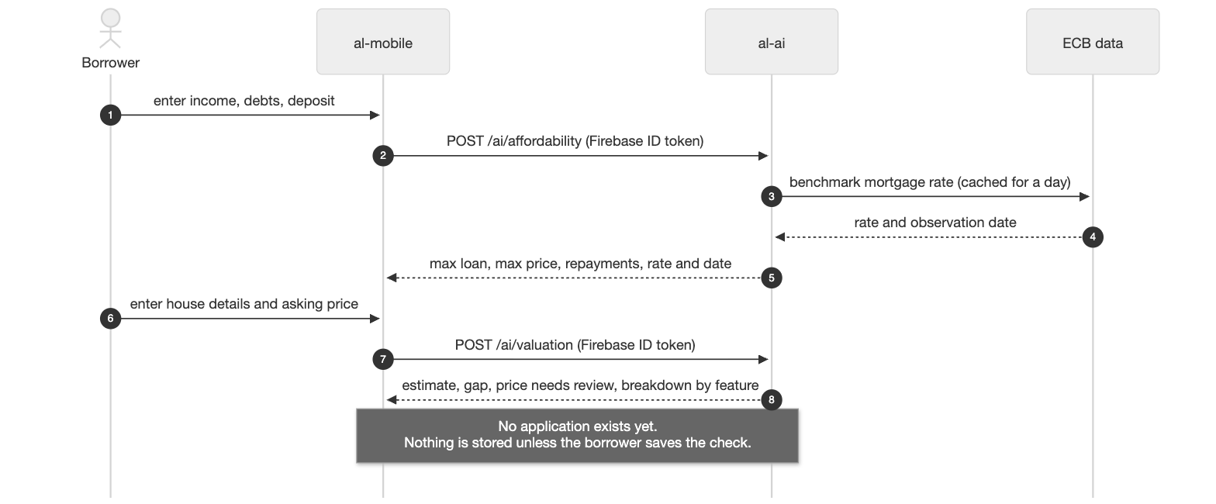

Stories in this epic
Story | What | Owner | Sprint | Status on 23 Oct
AL-22 | Enter property specs (county, size, bedrooms, type, BER) and get a fair valuation | Ibrahima | Sprint 2 | To Do
AL-23 | Compare the seller's asking price against the model's valuation (portal loan file) | Nikoloz | Sprint 2 | To Do
AL-24 | Train a property valuation model and report how accurate it is | Nic | Sprint 1 | Done: model trained, tested once, saved with a model card

Notes
- Model work for AL-24: AL-117 data readiness, AL-118 benchmark, AL-119 tuning, AL-120 threshold and final test, AL-121 saved model and model card. The v2 model came from AL-255 and AL-257.
- The model card is al-ai/models/valuation/MODEL_CARD.md. The full numbers, graphs and tables are on the Model support page in Confluence.
- Test case: AL-24/test-case.docx in this folder.

