Test case: AL-18
As a broker, I see only the files of clients I referred
Item | Detail
Story | AL-18: As a broker, I see only the files of clients I referred
Epic | AL-4 Accounts & Roles
Owner | Nikoloz Chilachava (web portal, al-web)
Sprint | Sprint 1 (8 to 25 Oct 2026)
Wireframe | wireframe.png in this folder, exported from Figma (https://www.figma.com/design/F6lldwqy172ox5SeALdDEU?node-id=539-6992). The Figma page is "AL-Web - V2 - Pine & Oat".
Code | al-web/ on branch main, repository CS3-Agentic-Lender/agentic-lender

What this tests
A broker sees the clients who chose them and the applications those clients made, and nobody else's. The access boundary is the Firestore rules, not the page: an unfiltered query is refused, a broker opening another broker's client sees "not found", and the list changes live when a borrower picks or leaves the broker.

Wireframe
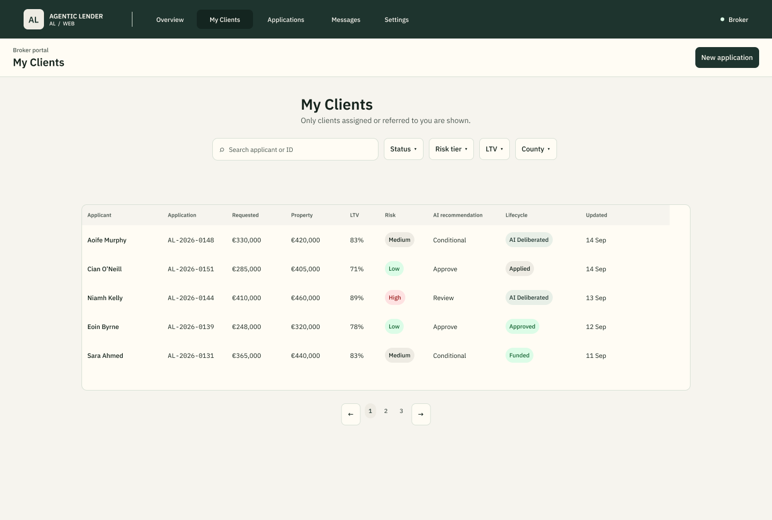
The wireframe is the design target. Section "Moved to Sprint 2" below lists the parts of it that are not built yet.

Preconditions and test data
- Local Firebase emulators (Auth and Firestore) started with the seed data from main: three seeded accounts for the roles under test (an underwriter, a broker and a second broker) with the seed script's test password. These are fixtures that exist only in the local emulator.
- al-web running locally (npm run dev in al-web/), or the Vitest suite (npm test in al-web/).
- The seed holds two brokers (Bob and Ciara). Each has one borrower (Alice for Bob, Ben for Ciara) and that borrower's applications.
- The automated tests use fake data and a fake subscription, so they need no emulator. The rules check (npm run test:clients-emulator in al-web/) needs the seeded Auth and Firestore emulators.

Test cases
ID | Acceptance criterion | Steps | Expected result | How it was checked, and the result
TC-18-01 | Signed in as the seeded broker, the client list shows only that broker's clients. | 1. Sign in as the first seeded broker. 2. Open Clients (/broker/clients). | Only the clients and applications whose broker is this broker are listed. | Automated: broker client list > shows the first broker only their own client; subscribes with the signed-in broker and nobody else; broker clients queries > reads applications where brokerId is the signed-in broker; reads users where brokerId is the signed-in broker. Browser on the emulators, 18 Oct: first broker saw their own clients. Pass.
TC-18-02 | The second seeded broker sees a different list. | Sign out. Sign in as the second seeded broker. Open Clients. | A different set of clients, with none of the first broker's. | Automated: broker client list > shows the second broker a different list. Emulator check (test:clients-emulator, 18 Oct): each seeded broker reads only the applications assigned to them. Pass.
TC-18-03 | Opening another broker's client by URL shows "not found", and the data behind it is protected by the Firestore rules. | 1. Sign in as the first broker. 2. Paste the client file address of one of the second broker's clients. 3. Also paste an address for a client that does not exist. | Both show the same "not found" page, with nothing about the client. The page only looks in the broker's own list, and the Firestore rules limit that list to the broker's clients. | Automated: broker client file > shows not found for another broker's client opened by URL; gives the same answer for a client that does not exist; shows not found once profiles have answered and the client is not in them. Emulator check (test:clients-emulator, 18 Oct): an unfiltered read, and a direct read by ID of the other broker's application, are refused by the rules. Pass.
TC-18-04 | A broker can open each of their clients and see the status of their applications. | 1. Open Clients. 2. Choose a client's name. | The client file opens with the client's applications and a status badge on each, and a way back to the list. | Automated: broker client file > opens one of the broker's own clients with their applications; follows the link from the list to the client file. Pass. Messaging the borrower is not part of Sprint 1 (see below).
TC-18-05 | The list updates without a refresh when a borrower chooses this broker, and when one moves away. | 1. Keep the list open. 2. In the emulator, set a borrower's chosen broker to this broker. 3. Then move them to the other broker. | The client appears in the list without a reload, then disappears from it. The other broker's list changes the opposite way. | Automated: broker client list > adds a client without a reload when a borrower chooses this broker; removes a client who moves to another broker. Browser: live reassignment checked on the emulators. Pass.
TC-18-06 | Loading, empty and failure states tell the truth. | Open the list while the data is loading, with a broker who has no clients, and with the profiles query refused. | A loading state first, never an empty table. "No clients yet" only when the server has answered with nothing. If names cannot be read, clients are listed by client ID with a notice. | Automated: shows a loading state before the first answer and no table; says so when the broker has no clients; shows no clients yet only once profiles have answered with nothing; lists clients by ID and says why when profiles cannot be read; says names could not be loaded, not that there are no clients, when profiles are unavailable; tells apart several clients whose names are unavailable by their client ID. Pass.
TC-18-07 | Search and the status filter narrow the list and keep the count right. | Type part of a name in the search box, then pick a status. | The table shows only matching rows, and the count matches what is shown. | Automated: broker client list > narrows the table with the search box and the status filter and keeps the count in step; client rows > filters by status, which drops clients with no application; combines the search and the status filter. Pass.
TC-18-08 | The portal stops listening when it should. | Leave the Clients page, then sign out. | Both live listeners stop. No data arrives after sign-out. | Automated: stops listening when the broker signs out; stops listening when the page is left; broker clients subscription > stop unsubscribes both listeners and ignores later callbacks. Pass.
TC-18-09 | An underwriter cannot use the broker list. | Sign in as an underwriter and open /broker/clients. | The portal shows Not allowed. | Automated: broker client list > refuses an underwriter. Pass.

Moved to Sprint 2
- Messaging the borrower (criterion 3 originally said "message the borrower"): moved to the Sprint 2 broker inbox story. The team agreed this on 19 Oct 2026 and the ticket text was updated.
- Drafts in the client list: the team decided that brokers do not see Draft applications (AL-263). The list still shows them today; hiding them is Sprint 2 work (a follow-up to AL-248 in the portal, and the matching Firestore rule on the al-core side).
- Broker Overview and Broker Applications screens from the V2 design: not built in Sprint 1. They were triaged as follow-up work under AL-192 and are not part of this story.

Notes
- The web suite on main passes: 280 tests in 13 files, and the production build passes (checked 22 Oct 2026).
- Code: PR 68 (AL-154, the client list and client file, merged 19 Oct) and PR 87 (AL-248, a flaky test in the client list tests). The Firestore rules and the two-broker seed are Dumi's work under AL-56.
- A broker's Firestore query must filter on brokerId equal to their own uid, or the rules refuse the whole query. The client file page only looks inside the broker's own list, so a client that belongs to someone else and one that does not exist look the same.

