Use case: AL-8 Origination Pipeline
Epic. An underwriter sees every application in one live queue, grouped by LTV, risk tier and lifecycle status, with a full loan file behind each, so they can prioritise and review files quickly.
Item | Detail
Epic | AL-8 Origination Pipeline
Feature (from the brief) | Web: Origination Pipeline View (grouped by LTV thresholds, risk tiers and lifecycle status); Loan File & Collateral Assessment View (complete DTI breakdown).
Owner | Nikoloz (the portal: queue and loan file). Dumi owns the backend work: status, LTV and risk-tier fields and the Firestore indexes for the queue, and the status lifecycle.
Sprint | Sprint 1 (8 to 25 Oct 2026) built the queue. The loan file with the DTI breakdown and the status lifecycle are Sprint 2.
Wireframes | AL-32/wireframe.png (the queue) in this folder. The loan file screens are in the Figma file (https://www.figma.com/design/F6lldwqy172ox5SeALdDEU), page "AL-Web - V2 - Pine & Oat".

Goal
As an underwriter, I want every application in one queue grouped by LTV, risk tier and status, with a full loan file behind each, so that I can prioritise and review files quickly.

Actors
- Underwriter: signed in to the web portal with the underwriter role.
- Borrower: their submitted application is what appears in the queue (iOS app).
- Broker: the broker who referred the borrower; a limited broker view of the same files is planned for Sprint 2.
- al-core: stores applications and their status, LTV band and risk tier in Firestore, and holds the rules and indexes.
- al-ai: the AI committee writes the risk tier and recommendation under each application's review (the queue reads them; the committee itself is Sprint 2).

Preconditions
- The underwriter is signed in with the underwriter role claim.
- Applications exist in Firestore with a status from the agreed list. Their LTV figures and risk tier are stored on the application or under its review.
- The Firestore rules let an underwriter read every application and every application's review.

Trigger
The underwriter opens the pipeline at /underwriter/pipeline.

Main flow
- The portal opens one live listener on the applications and one on the reviews, and shows a loading state until the server answers.
- Each application becomes a row: the application ID, the borrower's name, the loan amount, the valuation LTV, the risk tier and a status badge.
- The queue groups the rows. The underwriter picks one of three groupings: LTV band (80% or less, over 80% to 90%, over 90%, and "No LTV yet"), risk tier (A to D) or lifecycle status. Each group shows a count.
- The underwriter filters by status. The summary line says whether the counts are for all applications or only the filtered ones.
- When an application changes (a new submission, a status move, a new risk tier), its row and the group counts update without a reload.
- The underwriter opens a loan file from a row to see the complete DTI breakdown (Sprint 2, AL-33).
- The underwriter leaves the page or signs out. The listeners stop.

Alternative flows
- A. Stored band against valuation LTV. The queue prefers the LTV band and risk tier stored on the application. The percentage shown is the valuation LTV, labelled as such. The stored band uses the asking price, so an application can sit in ">90%" while showing a valuation LTV of 85%.
- B. No stored risk tier yet. The tier is read from the application's review. While that is pending the row shows "Checking"; if it fails, "Unavailable".
- C. Status moves. The lifecycle is Draft, Applied, AI Deliberated, Underwriter Approved, Declined, Funded, Closed. The move between states is Sprint 2 (AL-34).

Exceptions
- A broker or borrower opens the underwriter route: "Not allowed".
- The listener fails or the backend is unreachable: the queue shows a failure state. It never says "No applications yet" when the answer came only from the local cache or the read failed.
- A stored band or tier that is not one of the allowed values: shown as "Invalid stored band" or "Invalid stored tier" in its own group, never replaced by a guess.
- A missing or empty borrower name: a dash. The portal does not invent a name.
- A missing amount, or a missing or negative LTV: a dash.
- A status outside the agreed list: shown as "Unrecognised status", in neutral colour.

Postconditions
- Success: the underwriter sees every application, grouped the way they chose, and the counts match the rows.
- Failure: the queue says what failed (loading, risk tiers unavailable, or the read failed) and shows no false empty result.

Business rules
- Status strings are exact: Draft, Applied, AI Deliberated, Underwriter Approved, Declined, Funded, Closed. The AI run state, the risk tier (A to D) and the AI recommendation are separate fields, never extra statuses.
- Status badges use one shared colour mapping (docs/infrastructure.md): Draft, Applied and Closed neutral; AI Deliberated tint; Underwriter Approved and Funded success; Declined danger. Every badge also shows the status as text.
- The LTV figure is a whole-number percentage (83 means 83%), shown to one decimal, with more decimals at a band boundary (80.04 shows as 80.04%). The total in the summary line is always all applications; with a filter on, the group counts are of the filtered applications and the line says so.
- Underwriters see Draft applications. The queue reads every application and filters statuses in the browser, so a document without a submission date is not dropped.
- All colours come from the Pine & Oat design tokens.

Flow diagram
The application lifecycle the queue groups by, from docs/diagrams/08-status-transitions.png:
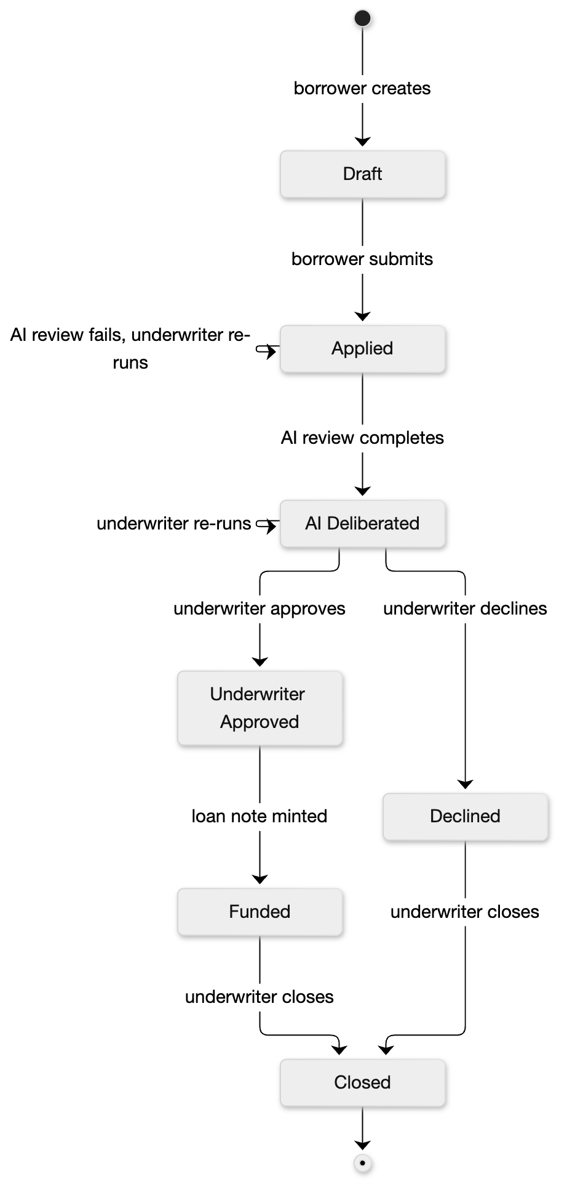

Stories in this epic
Story | What | Owner | Sprint | Status on 23 Oct
AL-32 | An underwriter sees all applications in a queue grouped by LTV, risk tier and status | Nikoloz | Sprint 1 | Done
AL-33 | An underwriter opens a loan file with the borrower's full DTI breakdown | Nikoloz | Sprint 2 | To Do
AL-34 | An application moves through Applied, AI Deliberated, Approved, Funded, Closed | Dumi | Sprint 2 | To Do

What Sprint 1 delivered
- The pipeline queue with grouping by LTV band, risk tier and status, a status filter, live updates and loading and failure states (AL-157, PR 69). It now groups by the stored band and tier, and keeps an invalid stored value apart from an absent one (AL-247, PR 77).
- The borrower's name in the queue (AL-260, PR 97).
- The shared status colour mapping, recorded in docs/infrastructure.md (AL-235, PR 67).
- Backend fields and indexes for the queue: status, LTV, risk tier (Dumi: AL-64).

Epic done when (from Jira)
- A use case for this feature is written in Confluence and linked here: this document.
- Every story in this epic meets its acceptance criteria and is merged to main. AL-32 is Done. AL-33 and AL-34 are planned for Sprint 2, so the epic stays open.
- The seeded applications appear in the queue grouped by each of the three categories (checked on the emulators: 7 applications, grouped by band, tier and status). Opening one to see its full DTI breakdown is not built yet: it is AL-33 in Sprint 2.

Notes
- Test case: AL-32/test-case.docx in this folder.
- Moved to Sprint 2 and recorded on the tickets: opening a loan file from a row (AL-158, the loan file page), the broker's limited view of the same files, and the V2 metric strip, sort tabs and selected-file card.

