Test case: AL-35
As a bank, an approved loan is minted as a digital loan note (principal, APR, term, borrower ID)
Story | AL-35: As a bank, an approved loan is minted as a digital loan note (principal, APR, term, borrower ID)
Epic | AL-9 On-Chain Settlement
Owner | Solomon Sosanya (al-core: the loan note contract)
Sprint | Sprint 1 (8 to 25 Oct 2026)
Wireframe | wireframe.png in this folder. AL-35 has no screen, so it is a flow diagram of the contract's mint call, drawn for this story. The wider sign-off flow is in docs/diagrams/04-flow-signoff-mint.png.
Code | al-core/chain/contracts/LoanNote.sol and al-core/chain/test/LoanNote.test.js on branch main, repository CS3-Agentic-Lender/agentic-lender

What this tests
A Solidity contract, LoanNote, mints one ERC-721 note for each approved loan. The note holds the principal, APR, term, loan type and two references: one for the application and one for the borrower, with no personal data in either. Only al-core's wallet can mint, the same application can't be minted twice, and every stored field can be read back.

Wireframe
The flow diagram (wireframe.png) shows the mint call and the three checks that run before a note is stored. The grey dashed box on it, the underwriter's sign-off in the portal that makes al-core call the contract, is Sprint 2 work. Sprint 1 built and tested the contract and a local-chain demo script.
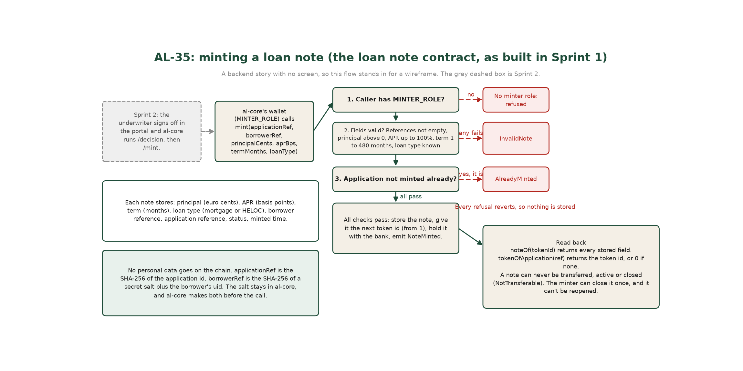

Preconditions and test data
- Node.js and npm. In al-core/chain run npm install the first time. No network, wallet or key is needed: Hardhat runs its own in-process test chain with test accounts.
- Test data is made up: placeholder application and borrower references (hashes of placeholder text) and sample loan amounts. No real borrower data is used.
- To run everything: cd al-core/chain, then npx hardhat test. For the demo: npm run deploy:local and npm run demo:local against npx hardhat node.

Test cases
ID | Acceptance criterion | Steps | Expected result | How it was checked, and the result
TC-35-01 | A contract mints one note per approved loan, storing principal, APR, term, loan type and the application and borrower references. | 1. Deploy LoanNote with an admin, a minter and a holder account. 2. As the minter, call mint with a made-up application reference, borrower reference, principal in cents, APR in basis points, term in months and loan type. 3. Read the note back. | Token 1 exists with status Active and every value as sent, plus the mint time. The note is held by the bank, not the minter. A NoteMinted event carries the loan terms. The next mint gets the next token id. | Automated (Hardhat): the minter mints a note and every field reads back; the note is held by the bank, not the minter, and linked to its application; emits NoteMinted with the loan terms; numbers notes from 1 upwards. Pass.
TC-35-02 | The loan type is stored: mortgage, with HELOC supported. | Mint one note with loan type 0 and another with loan type 1. Then try a loan type that does not exist. | Mortgage (0) and HELOC (1) are stored as sent. An unknown loan type is refused and nothing is stored. | Automated: stores a HELOC as loan type 1; refuses an unknown loan type. Pass.
TC-35-03 | The borrower identifier contains no personal data. | Make the borrower reference the way al-core does (SHA-256 of a secret salt plus the uid) and mint with it. Try an empty application reference and an empty borrower reference. Change the salt and compare. | The reference does not reveal the uid, and a different salt gives a different reference. Empty references are refused. The note has no field for a name, email or address. | Automated: the borrower reference doesn't reveal the uid and changes with the salt; refuses an empty application reference; refuses an empty borrower reference. Contract read: the Note struct holds no personal data. Pass.
TC-35-04 | Only sensible loan values are accepted. | Mint with a zero principal, an APR above 100%, a zero term and a term over 40 years. Then mint at the edges: 0% APR, 100% APR, 1 month and 480 months. | Each invalid value is refused with InvalidNote and nothing is stored. The edge values are accepted. | Automated: refuses a zero principal; refuses an APR above 100%; refuses a zero term; refuses a term over 40 years; accepts the edge values: 0% APR, 100% APR, 1 and 480 months. Pass.
TC-35-05 | Only the authorised minter can mint; another account is refused. | 1. Mint from an account without MINTER_ROLE. 2. As the admin, give the minter role to a new wallet, then mint from it. 3. Deploy with a zero admin, minter or holder address. | The mint from the account without the role is refused. The new minter can mint, and other accounts still can't. A zero address is refused at deploy. | Automated: refuses a mint from any account without the minter role; the admin can hand the minter role to a new al-core wallet, and others can't; gives the admin and minter roles to the accounts passed in; refuses a zero admin address; refuses a zero minter address; refuses a zero holder address. Pass.
TC-35-06 | Minting the same application twice is rejected. | Mint a note for an application, then mint again with the same application reference. | The second mint is refused with AlreadyMinted and the first note's token id. Only one note exists for the application. An application with no note has token 0. | Automated: refuses a second mint for the same application; an unminted application has token 0. Local-chain demo (npm run demo:local): the second mint for the same application is refused with AlreadyMinted. Pass.
TC-35-07 | Hardhat tests read back every stored field of a minted note. | Mint a note, call noteOf for it and compare each field with what was sent. | Application reference, borrower reference, principal, APR, term, loan type, status, minted time and closed time all read back. Asking for a note that doesn't exist reverts. | Automated: the minter mints a note and every field reads back; reading a note that doesn't exist reverts. Pass.
TC-35-08 | The choice of ERC-721 over a plain stateful contract, and why, is written in al-core/README.md. | Open al-core/README.md and find the loan note section. Check the deployed token's name and standard. | The README explains the choice: each loan is unique and owned, OpenZeppelin's implementation is standard and audited, and explorers and wallets understand ERC-721. The token is an ERC-721 called AL Loan Note. | Read of al-core/README.md ("Why ERC-721 (OpenZeppelin) rather than a plain stateful contract"). Automated: is an ERC-721 called AL Loan Note. Pass.
TC-35-09 | Beyond the criteria: a note can't be moved, and the minter can close it once. | Try to transfer an active note and a closed note, as the holder and as an approved account. As the minter, close a note, then close it again. Try to close a note that doesn't exist. | Every transfer is refused with NotTransferable. A note closes once and can't be reopened or closed twice. Closing an unknown note, or closing without the minter role, is refused. | Automated: the holder can't transfer an active note; the holder can't transfer a closed note; an approved account can't move a note either; the minter closes an active note; a closed note can't be closed again or reopened by minting; can't close a note that doesn't exist; refuses a close from any account without the minter role. Pass.

Moved to Sprint 2 and later
- The sign-off step that makes al-core mint from the portal: the sign-off endpoint (AL-66) and the portal action (AL-37).
- Syncing the note's on-chain state back to the application record (AL-67).
- The audit registry contract (AL-171) and the canonical decision record with its SHA-256 (AL-172).
- Deploying the contracts to a public testnet is Sprint 3 (AL-183).

Notes
- Test results on main on 22 Oct 2026: 32 Hardhat tests pass (npx hardhat test in al-core/chain).
- Pull requests: PR 49 (the contract and its tests) and PR 51 (the Hardhat project and the local deploy and demo scripts).
- Built with Solidity 0.8.28 and OpenZeppelin 5.6.
- The note is held by one fixed holder address (the bank), separate from the minter, so changing the minter wallet never strands a note. The API signs mints with a server-held testnet wallet, so the portal never holds a key.

