Use case: AL-9 On-Chain Settlement
Epic. An approved loan is recorded on a blockchain with a tamper-proof hash of the decision.
Epic | AL-9 On-Chain Settlement
Feature (from the brief) | Web: On-Chain Settlement and Decision Export (sign-off triggers minting; PDF/CSV audit packs). Core: Loan Tokenization Contract; Immutable Audit and Decision Registry; Execution Environment (Hardhat or Anvil locally, or Polygon Amoy or Arbitrum Sepolia). Mobile: lifecycle state of the digital loan note.
Owner | Solomon Sosanya (al-core: contracts and API). The portal stories are Nikoloz's and the mobile story is Ibrahima's.
Sprint | Sprint 1 (8 to 25 Oct 2026) delivered the loan note contract (AL-35). The other stories follow in Sprints 2 and 3.

Goal
As a bank, I want approved loans recorded on a blockchain with a tamper-proof hash of the decision, so that anyone can later verify the loan and the reasons behind it.

Actors
- Underwriter: reviews an application in the web portal and signs it off.
- al-core (the backend API): records the decision and holds the minter wallet, the only wallet that can mint. The portal never holds a key.
- The ledger: a local Hardhat chain in Sprints 1 and 2, then a public testnet (Polygon Amoy or Arbitrum Sepolia) in Sprint 3.
- Bank: the holder of every loan note.
- Borrower: sees the lifecycle state of their loan note in the iOS app.
- Auditor: downloads an audit pack and checks its hash against the one on the chain.

Preconditions
- The application has been through the AI committee review (status AI Deliberated) and the underwriter is signed in with the underwriter role.
- The loan note contract and the audit registry are deployed, and al-core's wallet holds the minter role.

Trigger
The underwriter approves an application after reviewing the application, the valuation and the AI committee's reasoning.

Main flow
- The underwriter opens the loan file and reviews the application, the valuation and the AI committee's reasoning.
- The underwriter approves, with a justification. The portal asks al-core to record the decision.
- al-core checks the caller's role and that the application's status allows the move, then saves the decision (who, when, why) and sets the status to Underwriter Approved.
- al-core builds the canonical decision record (credit memo, valuation and approval) and its SHA-256 hash: canonical JSON with sorted keys and no spaces, timestamps in UTC.
- al-core mints the loan note from its minter wallet. The note stores the principal in euro cents, the APR in basis points, the term in months, the loan type and two references: a hash of the application id and a salted hash of the borrower id. No personal data goes on the chain.
- al-core stores the decision hash in the audit registry.
- al-core saves the token id and transaction hashes on the application and sets the status to Funded. The portal and the borrower's app update from Firestore.
- The borrower sees the loan note's lifecycle state in the app. The underwriter, or an auditor, can download a PDF or CSV audit pack for the decision and recompute the hash from it. It matches the hash on the chain.

Alternative flows
A. Decline. The underwriter declines with a justification. The decision is saved and the status becomes Declined. No loan note is minted.

Exceptions
- The caller is not an underwriter, or the application is not in a status that can be approved. al-core refuses and nothing changes.
- A second mint for the same application, for example after a double click or a retry. The contract refuses it (AlreadyMinted), so only one note ever exists for an application.
- The loan values are invalid, such as a zero principal, an APR above 100% or a term over 40 years. The contract refuses them (InvalidNote) and nothing is stored.
- The chain or the transaction fails. The application stays at Underwriter Approved and the mint can be retried. Nothing is marked Funded until the mint is confirmed. This is the intended behaviour for Sprint 2.

Postconditions
- Success: the application is Funded, one loan note exists for it and its token id is saved, the decision hash is in the registry, and an audit pack can be downloaded.
- Failure or decline: no note exists, and the application's status shows where it stopped.

Business rules
- Only al-core's wallet can mint or close a note, and a note can be closed once.
- One note per application.
- No personal data on the chain: only hashes and the loan terms.
- Notes are held by the bank and can't be transferred. A note is a record of the loan, not a tradable asset. Selling loans on is future work.
- The hash is SHA-256 of the canonical decision record, so the same record always gives the same hash.

Flow diagram
The sign-off to mint flow, from docs/diagrams/04-flow-signoff-mint.png:
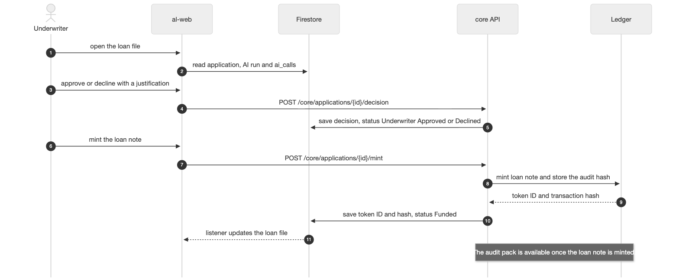

Stories in this epic
Story | What | Owner | Sprint | Status
AL-35 | An approved loan is minted as a digital loan note (principal, APR, term, borrower ID) | Solomon | Sprint 1 | Done
AL-36 | A SHA-256 hash of the credit memo, valuation and approval is stored on-chain (audit registry) | Solomon | Planned | To Do
AL-151 | An underwriter signs off an application and the decision is recorded | Nikoloz | Planned | To Do
AL-37 | Signing off from the portal triggers the loan note mint | Nikoloz | Planned | To Do
AL-38 | An underwriter downloads a PDF or CSV audit pack for a decision | Nikoloz | Planned | To Do
AL-39 | A borrower sees their loan note's on-chain lifecycle status | Ibrahima | Planned | To Do

What Sprint 1 delivered
- The loan note contract (AL-35): an ERC-721 with minter-only minting, one note per application, no personal data, non-transferable notes. 32 Hardhat tests pass. PR 49.
- The Hardhat project, a local chain, and deploy and demo scripts (AL-87): the demo mints a note and shows the second mint for the same application refused. PR 51.

Epic done when (from Jira)
- A use case for this feature is written and linked on the epic.
- Every story in this epic meets its acceptance criteria and is merged to main.
- Signing off a seeded application mints a loan note and stores its audit hash on the chain; the borrower's app shows the note; and the hash recomputed from a downloaded audit pack matches the one on the chain.

