Test case: AL-195
As a homeowner, I apply for a home equity line of credit against my property's value
Item | Detail
Story | AL-195: As a homeowner, I apply for a home equity line of credit against my property's value
Epic | AL-194 Home equity line of credit (HELOC)
Owner | Ibrahima Toure (iOS borrower app, al-mobile)
Sprint | Sprint 1 (8 to 25 Oct 2026)
Wireframe | wireframe.png in this folder, exported from Figma (https://www.figma.com/design/l1dzCYxViJsNVEceRstuH1?node-id=393-1604), file "AL-80 Borrower app". Section "HELOC (AL-205)": choice, check, errors, result, no equity and application.
Code | al-mobile/: the mortgage-or-HELOC choice on main (PR #62, merged 22 Oct); the HELOC check form on the local AL-207 branch, repository CS3-Agentic-Lender/agentic-lender

What this tests
A homeowner borrows against the value of a home they already own. At the start of "What can I borrow?" they choose mortgage or HELOC, and the choice is carried into the application. The HELOC check asks for the five house details, the balance left on the mortgage, income, debts and a term, never a deposit or an asking price, and the result shows the maximum credit line and what limited it. In Sprint 1 the choice and the wireframes were built; the check, result and application need the HELOC endpoint and fields, which are Sprint 2.

Wireframe
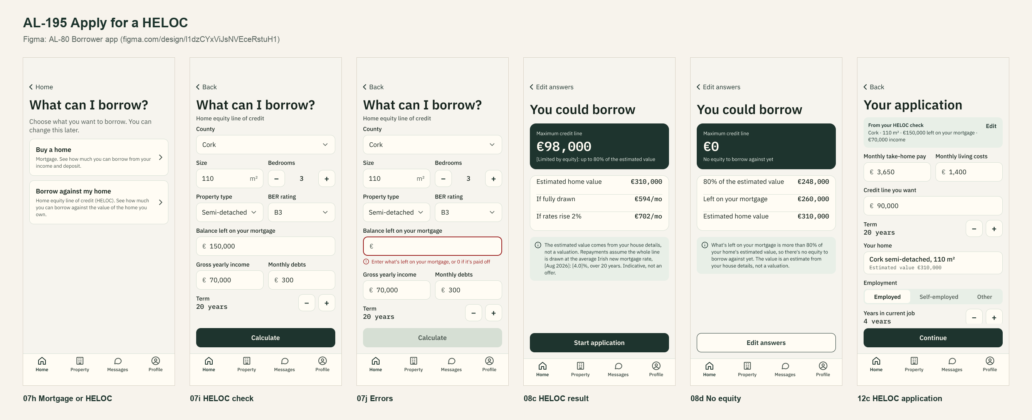
The wireframe is the design target. "Moved to Sprint 2 or not finished" below lists the parts that are not built or not merged yet.

Preconditions and test data
- Local Firebase emulators (Auth and Firestore) with the seed data from main, al-core and al-ai running behind the local Docker gateway, and the app on the iPhone 17 Simulator. The seeded accounts and the people in the test data are made up and exist only in the local emulator.
- Test data: Cork, 110 m2, 3 bedrooms, semi-detached, B3, a €150,000 balance, €70,000 income, €300 monthly debts, 20 years.
- Unit tests: cd al-mobile, then xcodebuild test -project AgenticLender.xcodeproj -scheme AgenticLender -destination 'platform=iOS Simulator,name=iPhone 17'. They use fake services, so they need no emulator.
- Unit test results: 292 tests on PR #62 just before it merged into main (22 Oct), 0 failures; 18 tests for the HELOC form on the local AL-207 branch.

Test cases
ID | Acceptance criterion | Steps | Expected result | How it was checked, and the result
TC-195-01 | At the start of the check the borrower picks mortgage or HELOC, and mortgage works exactly as before. | 1. Home > What can I borrow?. 2. Choose Buy a home and calculate case 1 from AL-19. 3. Start application and save the draft. | The choice screen shows both cards. Mortgage gives the same figures as AL-19. The saved draft carries loanType mortgage. | Automated: LoanTypeTests > testChoiceCardsUseTheFigmaWording, testValuesMatchTheApplicationsSchema; AffordabilityViewModelTests > testTheChosenLoanTypeIsCarriedIntoTheApplication; ApplicationValidatorTests > testDraftBodyCarriesTheChosenLoanType. Simulator screenshot of the choice. Pass (on main) for mortgage. The HELOC card is hidden until its check can calculate (LoanTypeTests > testOnlyMortgageIsOfferedUntilTheHELOCCheckExists).
TC-195-02 | The HELOC check asks for the house details, mortgage balance, income, debts and term, never a deposit or asking price. | Choose HELOC, enter the test data, then clear the balance. | Every listed field is asked for and checked; no deposit or asking price. With no balance: "Enter what's left on your mortgage, or 0 if it's paid off". | Automated (local AL-207 branch): 18 tests for the form's field checks. Simulator screenshot of the form. Form only: not in a PR, and Calculate is not connected. Partly done, moved to Sprint 2.
TC-195-03 | The result shows the maximum line and what limited it, matching the endpoint, labelled indicative. | Calculate the test data. | A maximum line, what limited it and the repayment fully drawn and at +2 points. A balance at or above 80% of the value gives €0 and a no-equity message. | Not built. Needs the HELOC endpoint (Nic, AL-198, done) and the valuation model in al-ai. Moved to Sprint 2 (AL-207), agreed with Nic on 19 Oct.
TC-195-04 | Start application opens the HELOC application pre-filled; submitting saves loanType heloc with status Applied. | Press Start application, then submit. | No deposit field; the saved application has loanType heloc and status Applied, with a reference. | Not built (AL-208, Sprint 2). Needs the HELOC fields in al-core (AL-197).
TC-195-05 | The screens say "estimated value", never "asking price". | Read the HELOC check, result and application screens. | Only "estimated value" appears. | Checked on the wireframes (07i to 12c). Will be checked on the built screens in Sprint 2.

Moved to Sprint 2 or not finished
- Most of this story moved to Sprint 2, agreed with Nic on 19 Oct: the HELOC check needs the HELOC endpoint, which needs the valuation model. AL-207 (check and result) and AL-208 (application) are Sprint 2 work.
- Done in Sprint 1: the wireframes (AL-205) and the mortgage-or-HELOC choice (AL-206, PR #62, merged 22 Oct).
- Nic's answers on the HELOC request shape are on AL-198, for AL-207.

Notes
- Figma link: https://www.figma.com/design/l1dzCYxViJsNVEceRstuH1?node-id=393-1604
- HELOC prototype: https://www.figma.com/proto/l1dzCYxViJsNVEceRstuH1/AL-80-Borrower-app?page-id=0:1&starting-point-node-id=393:1605

