Test case: AL-26
As an underwriter, a valuation agent flags overvalued collateral and computes LTV
Item | Detail
Story | AL-26: As an underwriter, a valuation agent flags overvalued collateral and computes LTV
Epic | AL-7 AI Credit Committee
Owner | Nic (al-ai: the valuation checks and the valuation agent)
Sprint | Sprint 2 (27 Oct to 15 Nov 2026)
Wireframe | wireframe.png in this folder. AL-26 has no screen, so it is a flow diagram.
Code | al-ai/app/valuation_checks.py, al-ai/app/valuation_agent.py, al-ai/app/prompts/valuation_agent_v2.md and al-ai/app/llm/agents.json, on main at commit 86cd8d4
Tested by | Nicholas Groenewald, 9 Nov 2026

What this tests
Code works out the price gap, the “price needs review” flag and both LTVs, so the numbers never come from the LLM. The agent then explains those results and gives a recommendation. These tests check the maths, the edge cases and that the agent’s reply is checked before it’s used.

Wireframe
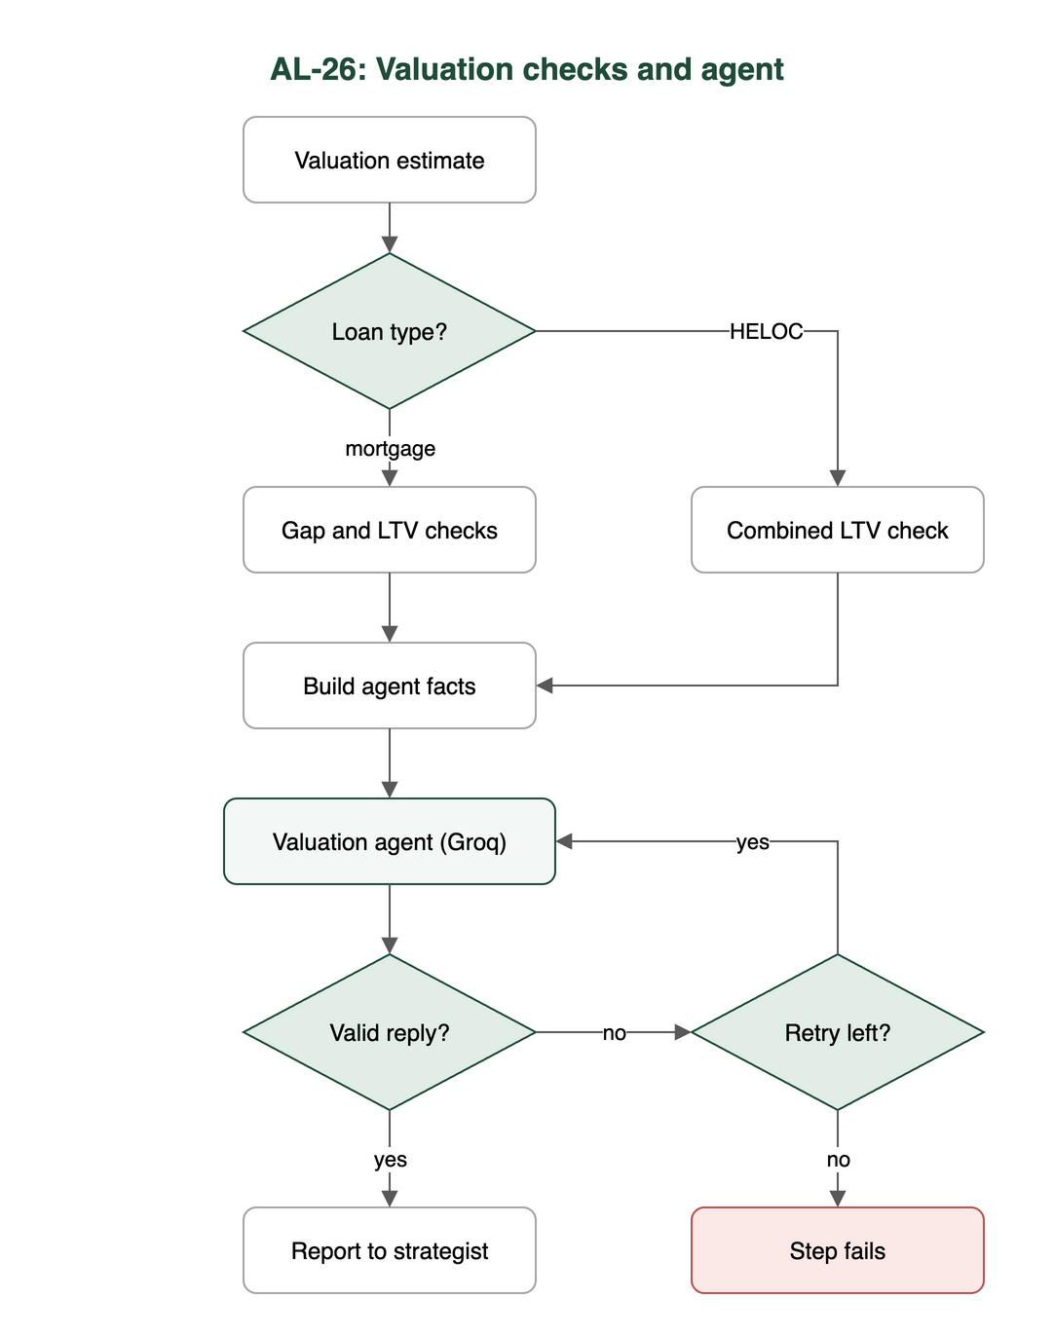

Preconditions and test data
- I installed the al-ai dependencies with uv (cd al-ai && uv sync). The saved valuation model is in al-ai/models.
- The automated tests need no API keys and no network, because the agent step uses a fake network.
- AL_LIVE_LLM isn’t set, so the live test skips.
- The manual live run (criteria 4 and 5) needs a Groq key in al-ai/.env as GROQ_API_KEY.

Test cases
ID | Acceptance criterion | Steps | Expected result | How it was checked, and the result
TC-26-01 | Code works out the signed gap (asking price / estimate - 1) and flags the price for review when the gap is above the threshold. Exactly at the threshold doesn’t count. | 1. Call check_valuation with the gap exactly at the threshold. 2. Call it again with the gap just above. | needs_review is false at the threshold and true just above it. | Automated: test_valuation_checks.py: test_the_gap_is_signed_asking_over_estimate_minus_one, test_a_gap_exactly_at_the_threshold_does_not_trigger_review, test_a_gap_just_above_the_threshold_triggers_review. test_valuation_shared_gap.py: test_a_gap_exactly_at_the_threshold_does_not_trigger_review_and_just_above_does, test_through_the_endpoint_a_gap_exactly_at_the_threshold_does_not_trigger_review, test_check_valuation_takes_the_gap_and_the_flag_from_the_same_shared_function. Pass.
TC-26-02 | Code works out purchase LTV and model LTV and checks each against the 90% limit. | 1. Call check_valuation with a loan at exactly 90% and just over. 2. Try an asking price above and below the estimate. | Purchase LTV is loan / asking price, model LTV is loan / the lower of asking price and estimate, and both are fine at 90% but over the limit just above. | Automated: test_valuation_checks.py: test_purchase_price_ltv_is_loan_over_asking_price, test_model_ltv_uses_the_lower_of_asking_price_and_estimate, test_an_ltv_of_exactly_90_percent_is_within_the_limit, test_an_ltv_just_above_90_percent_is_over_the_limit, test_the_two_ltvs_can_disagree. Pass.
TC-26-03 | Tests cover a gap at the threshold, an asking price below the estimate, LTV at exactly 90% and a low-support warning. | 1. Run the tests for the four named cases. | No flag at the threshold, a negative gap and no flag for a lower asking price, 90% is within the limit and the warning reaches the agent unchanged. | Automated: test_valuation_checks.py: test_a_gap_exactly_at_the_threshold_does_not_trigger_review, test_an_asking_price_below_the_estimate_is_never_flagged, test_an_ltv_of_exactly_90_percent_is_within_the_limit, test_support_warnings_are_passed_through_unchanged. test_valuation_agent.py: test_the_support_warnings_are_passed_through_unchanged. test_valuation_shared_gap.py: test_through_the_endpoint_an_asking_price_below_the_estimate_is_a_negative_gap_and_no_flag. Pass.
TC-26-04 | The agent on Mistral (Groq backup, switched by hand) returns JSON that passes the schema check: rating, recommendation, concerns and suggested conditions. | 1. Give the agent step the facts from build_facts. 2. Feed it fake good and bad replies. 3. Live (manual, not run in this test): cd al-ai && uv run python -m app.valuation_agent. | Only a reply with rating, recommendation (Approve / Conditionally Approve / Decline), conditions and explanation passes. A bad reply gets one retry then the step fails. Approve is refused over a flag or an LTV over the limit. The model only comes from agents.json. | Automated: test_valuation_agent.py: test_a_good_reply_passes, test_a_reply_with_a_bad_field_is_rejected, test_a_reply_with_the_wrong_fields_is_rejected, test_a_reply_cannot_recommend_approve_when_the_code_says_the_price_needs_review, test_a_reply_cannot_recommend_approve_when_a_loan_to_value_is_over_the_limit, test_two_bad_replies_in_a_row_fail_the_step_with_the_reason_and_no_other_model_is_used, test_the_step_uses_the_valuation_agent_from_the_config_by_default. test_llm_config.py: test_the_valuation_agent_runs_on_groq_and_its_manual_backup_is_gemini_flash_lite, test_mistral_is_not_named_anywhere_in_the_agents_config. The tests pass. Live run not done in this test. Not met as worded: the code uses a different model and different reply fields (Notes 1 and 2).
TC-26-05 | The report calls the model figure “indicative” and never a verified valuation. | 1. Read the prompt rule. 2. Read the saved real runs in al-ai/docs/valuation-agent-runs.json. 3. Live (manual, not run in this test): cd al-ai && uv run python -m app.valuation_agent. | The report says the figure is indicative and never calls it a verified valuation. | No automated test checks the wording. Partly met: it’s a rule in the prompt only, not checked in code (Note 3).

Test run
From al-ai on main at 86cd8d4, 9 Nov 2026: uv run pytest -q -p no:cacheprovider tests/test_valuation_checks.py tests/test_valuation_shared_gap.py tests/test_valuation_agent.py tests/test_llm_config.py tests/test_groq_decision_recorded.py
132 passed, 1 skipped. The skipped one is test_live_the_configured_valuation_agent_answers_a_made_up_application, which only runs with AL_LIVE_LLM=1 because it makes a real Groq call. I made no live model call for this test case.

Notes
- Model. The criterion says Mistral with Groq as the backup. The code runs the agent on Groq openai/gpt-oss-120b, with Gemini gemini-3.1-flash-lite as the manual backup (al-ai/app/llm/agents.json).
  - We dropped Mistral on 28 Oct because it has no free API tier. The team agreed in #announcements and it’s recorded in docs/infrastructure.md (PR #124).
  - The “switched by hand, never automatically” part still holds. The backup is only used when a person edits agents.json.
- Reply fields. The criterion asks for a rating of fair / slightly high / needs review and a list of concerns. The code is different:
  - rating is strong, adequate, weak or unsupported. It rates the collateral, not the price.
  - There’s conditions and a free-text explanation, but no separate concerns field.
  - The price judgement is the code’s price_needs_review flag, and the agent can’t clear it.
  - Conditions like an independent surveyor’s valuation are allowed. They show up in all three saved real runs.
- “Indicative”. The prompt (al-ai/app/prompts/valuation_agent_v2.md) tells the model the estimate “is an indicative estimate and not a surveyor’s valuation”. The three saved real runs (Groq, Gemini, Ollama) all say this. But check_reply doesn’t require the word or reject “verified valuation”, so a reply that leaves it out would still pass.
- The HELOC path (combined LTV against 80%) is part of the same step and is tested in test_valuation_agent.py, but it’s outside this story’s criteria.

