Test case: AL-27
As an underwriter, a market research agent pulls current central bank rates and mortgage trends
Item | Detail
Story | AL-27: As an underwriter, a market research agent pulls current central bank rates and mortgage trends
Epic | AL-7 AI Credit Committee
Owner | Nic (al-ai: the market agent and the rate wiring). Dumi wrote the ECB rate tool (rates.py).
Sprint | Sprint 2 (27 Oct to 15 Nov 2026)
Wireframe | wireframe.png in this folder. AL-27 has no screen, so it is a flow diagram.
Code | al-ai/app/market_agent.py, al-ai/app/serper.py, al-ai/app/rates.py, al-ai/app/committee.py and al-ai/app/prompts/market_agent_v1.md, on main at commit 86cd8d4
Tested by | Nicholas Groenewald, 9 Nov 2026

What this tests
Code gets two official rates from the ECB and caches them, and the run stops if it can’t get a rate it trusts. The market agent then searches the web with Serper and writes a short outlook on Gemini, which the code checks before keeping it. These tests check the rates, the stop rules, the agent’s reply, report reuse and logging.

Wireframe
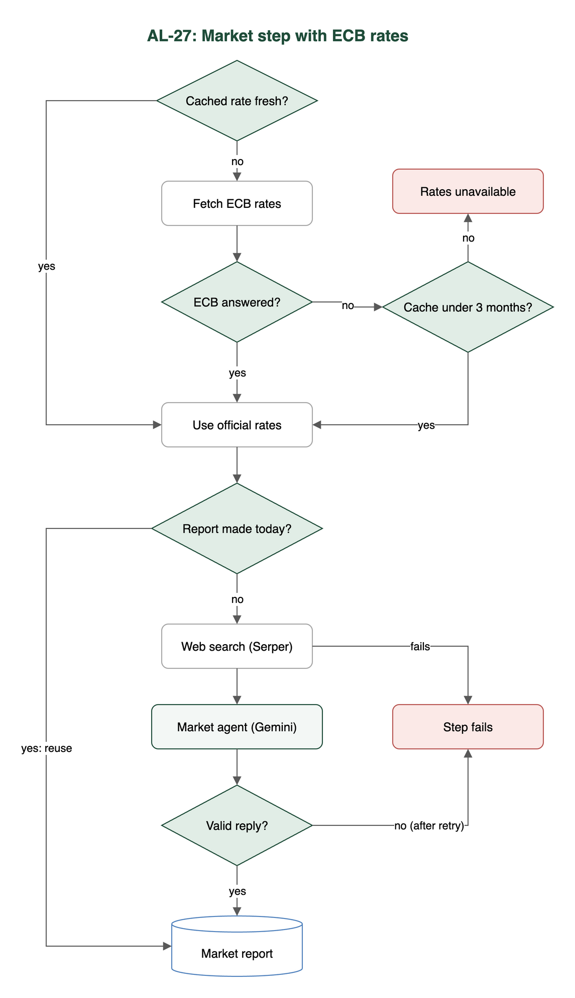

Preconditions and test data
- I installed the al-ai dependencies (cd al-ai && uv sync).
- The automated tests use a fake ECB, a fake Serper, a fake Gemini and an in-memory or fake Firestore, so they need no keys and no network.
- A live run (criteria 3 and 4 by hand) needs GEMINI_API_KEY and SERPER_API_KEY in the repo-root .env.
- I made no live calls for this test.

Test cases
ID | Acceptance criterion | Steps | Expected result | How it was checked, and the result
TC-27-01 | A code tool fetches the ECB main refinancing rate and the Irish benchmark mortgage rate (MIR.M.IE.B.A2C.A.R.A.2250.EUR.P), now and 12 months earlier, with dates, and caches them in Firestore. | 1. Run cd al-ai && uv run python -m app.rates against the Firestore emulator. 2. Open rates_cache/ecb_mrr and rates_cache/mortgage_ie in the Emulator UI. 3. Call it again. | Each document has ratePct, observed, yearEarlierPct, yearEarlierObserved and fetchedAt, and a second call within a day reads the cache instead of the ECB. | Automated: test_rates.py: test_the_mortgage_rate_is_the_latest_month_with_the_month_a_year_earlier, test_the_refinancing_rate_is_the_latest_change_and_the_rate_in_force_a_year_earlier, test_the_request_names_the_series_and_how_far_back_to_look, test_a_rate_fetched_less_than_a_day_ago_comes_from_the_cache_without_asking_the_ecb, test_an_empty_cache_fetches_and_keeps_the_result_with_its_dates, test_the_firestore_cache_keeps_one_document_per_rate_in_rates_cache; test_committee_rates.py: test_the_market_figures_are_both_rates_with_their_dates_and_their_values_12_months_earlier. Pass.
TC-27-02 | If the official data can’t be fetched or is more than 3 months old, the run fails with that reason. No rate is made up or taken from LLM text. | 1. Make the ECB unreachable. 2. Run the committee with an empty cache. 3. Run it again with a cached rate from June 2026. | The run is saved as failed at the market step, the reason names the rate and no model is called. | Automated: test_rates.py: test_a_reply_we_cannot_use_raises_with_the_reason_and_returns_no_number, test_the_cutoff_is_three_calendar_months, test_if_the_fetch_fails_and_the_cached_observation_is_too_old_the_error_carries_both_reasons_and_no_number, test_if_the_fetch_fails_and_nothing_is_cached_there_is_no_rate_to_return; test_committee_rates.py: test_a_missing_rate_with_the_ecb_down_stops_the_run_naming_the_rate_and_calls_no_model, test_a_rate_older_than_three_months_with_the_ecb_down_stops_the_run, test_the_benchmark_rate_missing_stops_the_run_naming_that_rate, test_no_stand_in_rate_or_sample_figures_file_is_left_in_the_live_path. The tests pass. Partly met: the 3-month check only happens when the ECB is down (see Notes).
TC-27-03 | The agent on Gemini uses Serper search and returns JSON that passes the schema check: outlook (rising / stable / falling), a short summary and dated source links. It gets no borrower data and has no vote. | 1. Run cd al-ai && uv run python -m app.market_agent (real Serper and Gemini, made-up official figures; manual, not run in this test). 2. Read the saved evidence in al-ai/docs/market-agent-runs.json (28 Oct 2026). | The report has outlook, summary and 1 to 5 dated sources from the search results. The prompt holds only the official figures and search results. The strategist’s votes are Affordability and Valuation only. | Automated: test_market_agent.py: test_a_good_reply_passes, test_a_reply_with_a_bad_field_is_rejected, test_a_reply_with_the_wrong_fields_is_rejected, test_a_summary_that_quotes_a_figure_it_was_not_given_is_rejected, test_a_run_searches_then_asks_the_configured_model_once_and_stores_a_report, test_the_facts_hold_the_official_figures_and_numbered_results_and_nothing_about_a_borrower, test_the_model_is_sent_the_data_and_no_borrower_details, test_the_agent_is_the_one_agents_json_names_for_market, test_a_model_that_obeys_the_injection_is_rejected_and_the_report_is_not_stored; test_strategist_agent.py: test_the_agents_that_disagree_are_worked_out_by_code. Live run not done in this test. Pass.
TC-27-04 | The LLM report is reused within the same day unless the official figures change, and each run records the ID of the report it used. | 1. Run the market step twice on the same day with the same figures. 2. Run it once more with a changed rate. | The second run calls no search or model and records reused_report_id, the changed rate makes a new report and the run record keeps steps.market.report_id. | Automated: test_market_agent.py: test_the_same_day_and_the_same_figures_reuse_the_report_and_call_nothing, test_changed_official_figures_make_a_new_report, test_a_new_day_makes_a_new_report; test_committee_rates.py: test_a_changed_rate_date_makes_a_new_market_report, test_the_run_record_shows_the_rates_the_run_used. Recorded run: al-ai/docs/committee-evidence/mortgage-run.json has report_id market-2026-11-04-bbb15157b172. Pass.
TC-27-05 | Every Serper search and LLM call is logged with its query or prompt version, results, timing and outcome. | 1. Run the committee. 2. Read the ai_calls collection in the Emulator UI. | There is one ai_calls document per search and per model attempt. | Automated (log lines only): test_market_agent.py: test_every_model_call_is_logged_with_prompt_version_links_duration_and_outcome_and_never_the_key, test_every_search_is_recorded_with_the_ids_it_ran_under_whether_it_worked_or_not; test_serper.py: test_every_query_is_logged_with_its_outcome_and_links_and_never_the_key, test_a_query_is_logged_with_the_run_and_prompt_version_that_asked_for_it. Not met yet: it needs PR #177 (saving every call as an ai_calls document), which isn’t merged into main.

Test run
From al-ai on main at 86cd8d4, 9 Nov 2026: uv run pytest -q -p no:cacheprovider tests/test_rates.py tests/test_committee_rates.py tests/test_market_agent.py tests/test_serper.py tests/test_strategist_agent.py tests/test_committee.py
188 passed, 0 failed, 2 skipped. The two skipped are the live tests test_live_a_real_search_and_the_configured_model_make_a_checked_report (test_market_agent.py) and test_live_the_configured_strategist_writes_a_checked_memo (test_strategist_agent.py). They only run with AL_LIVE_LLM=1 and real keys. None of these tests need the Firestore emulator, because the Firestore cache is tested with a fake client.

Notes
- Criterion 2 gap. rates.get_rate only checks the 3-month limit when the ECB can’t be reached and it falls back to the cache.
  - If the ECB answers but its latest value is already over 3 months old, the rate is accepted.
  - I checked this with a fake ECB reply whose latest month was 2026-05, on 9 Nov 2026. get_rate returned 3.9 from 2026-05 with no error.
  - No test covers this case. The monthly MIR series usually lags by a month or two, so it could matter in practice.
- Criterion 4, where reports are kept. Reports are stored in MemoryReportStore, which the committee runner and the Firestore listener (committee.local_deps) both use.
  - Reuse works inside one running process, but it isn’t shared between processes or kept after a restart.
  - The two recorded runs on 4 Nov have the same report_id, but reused_report_id is null on both, because each was its own process.
- Criterion 5. The logging itself exists. Every search (al-ai.serper) and model attempt (al-ai.market-agent) goes to the log as JSON with the run ID, prompt version, links or reply, duration_s and outcome. The run record also keeps searches and attempts.
  - What’s missing is the saved ai_calls collection from PR #177.
  - The searches entries in the run record don’t have a duration. Only the log line does.
- The recorded committee runs in al-ai/docs/committee-evidence/ are from 4 Nov. That’s before the rates were wired in from the ECB tool (8 Nov), so they don’t show steps.market.rates. A fresh run would.
- The saved market-agent-runs.json (28 Oct) used made-up official figures. Its source dates are as Serper gave them (“2 days ago”). The code now rewrites those to ISO dates.
- Dumi wrote the ECB rate tool (rates.py). My work on this story is the agent step and the wiring.

