Test case: AL-28
As an underwriter, a strategist agent decides Approve / Conditionally Approve / Decline and writes a credit memo
Item | Detail
Story | AL-28: As an underwriter, a strategist agent decides Approve / Conditionally Approve / Decline and writes a credit memo
Epic | AL-7 AI Credit Committee
Owner | Nic (al-ai: the strategist agent and the policy gate)
Sprint | Sprint 2 (27 Oct to 15 Nov 2026)
Wireframe | wireframe.png in this folder. AL-28 has no screen, so it is a flow diagram.
Code | al-ai/app/strategist_agent.py, al-ai/app/policy_gate.py, al-ai/app/committee.py and al-ai/app/prompts/strategist_agent_v1.md, on main at commit 86cd8d4
Tested by | Nicholas Groenewald, 9 Nov 2026

What this tests
The strategist reads the other agents’ reports and a loan summary and writes a recommendation and a credit memo on Gemini. After it, a policy gate in code adds conditions for any Central Bank limit breach and can turn an Approve into Conditionally Approve. These tests check the reply, the disagreement rule, the gate and what gets saved.

Wireframe
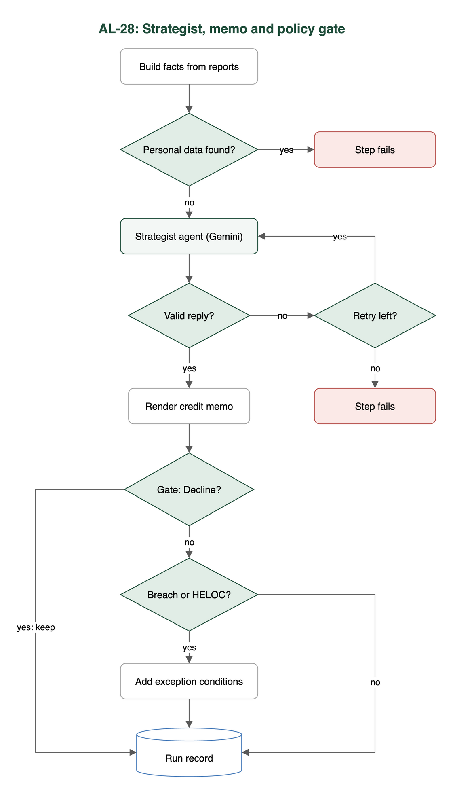

Preconditions and test data
- I installed the al-ai dependencies with uv (cd al-ai && uv sync).
- The automated tests need no API keys and no network, because the strategist and the committee use a fake network.
- AL_LIVE_LLM isn’t set, so the live test skips.
- The manual live run needs a Gemini key in al-ai/.env as GEMINI_API_KEY.

Test cases
ID | Acceptance criterion | Steps | Expected result | How it was checked, and the result
TC-28-01 | Given the three reports and a loan summary with no name or contact details, the agent on Gemini returns JSON that passes the schema check: recommendation, conditions and a memo under the fixed headings. | 1. Build the facts from three reports and a loan summary. 2. Try a loan summary with an extra field and a report holding an email or phone number. 3. Feed fake good and bad replies. 4. Live (manual, not run in this test): cd al-ai && uv run python -m app.strategist_agent. | Only the chosen loan fields are allowed and an identifier stops the step before the prompt is built. A reply passes only with recommendation (Approve / Conditionally Approve / Decline), conditions and a memo with exactly the six sections, written out under the fixed headings in order. The model is Gemini from agents.json. | Automated: test_strategist_agent.py: test_the_facts_hold_the_three_reports_and_the_loan_summary, test_a_loan_summary_with_any_field_we_did_not_choose_is_refused, test_a_personal_identifier_inside_a_report_is_refused_before_it_reaches_the_prompt, test_no_personal_identifier_reaches_the_prompt, test_a_good_reply_passes, test_a_reply_with_a_bad_field_is_rejected, test_every_memo_section_is_needed_and_must_be_text, test_an_extra_memo_section_is_rejected, test_the_memo_is_written_out_with_the_headings_from_the_ticket_in_order, test_the_agent_is_the_one_agents_json_names_for_the_strategist. Live run not done in this test. Pass.
TC-28-02 | When the voting agents disagree, the Disagreements section names who disagreed and why the strategist sided as it did. | 1. Give facts where the affordability and valuation votes differ. 2. Feed a fake reply whose Disagreements section doesn’t name both agents. | Code sets voting_agents_disagree. A Disagreements section that doesn’t name the Affordability agent and the Valuation agent is rejected, retried once, then the step fails. | Automated: test_strategist_agent.py: test_the_agents_that_disagree_are_worked_out_by_code, test_when_the_voting_agents_disagree_the_disagreements_section_names_both, test_when_they_agree_the_disagreements_section_may_say_so, test_a_reply_that_hides_a_disagreement_is_retried_then_fails. Pass for naming who disagreed. “Why it sided” is a prompt rule only, not checked in code (Note 1).
TC-28-03 | A code gate runs after the agent. Every breach adds a “requires lender exception review” condition, Approve becomes Conditionally Approve and Decline stays Decline. | 1. Call apply_policy_gate with Approve and a breach, Conditionally Approve and a breach, and no breach. 2. Run a committee with a mortgage over the 90% LTV limit. | Each breach adds “Requires lender exception review (RULE)”. Approve becomes Conditionally Approve, Conditionally Approve keeps its conditions plus the new one, Decline stays Decline and no breach changes nothing. | Automated: test_policy_gate.py: test_approve_with_a_breach_becomes_conditionally_approve_with_the_exception_condition, test_conditionally_approve_with_a_breach_keeps_its_conditions_and_adds_the_new_one, test_approve_with_no_breach_is_left_alone, test_conditionally_approve_with_no_breach_keeps_its_conditions_exactly, test_every_breach_adds_its_own_condition, test_decline_with_a_breach_stays_decline_and_the_breach_is_recorded, test_the_gate_never_makes_a_recommendation_more_favourable. test_committee.py: test_a_mortgage_over_the_ltv_limit_gets_an_exception_condition_and_the_approve_becomes_conditional. Pass.
TC-28-04 | The original and the effective recommendation are both saved, with the rule that changed it. | 1. Run the committee. 2. Read the saved run record. | The record has original_recommendation, effective_recommendation and steps.policy_gate with the breaches (rule IDs) and changed. | Automated: test_committee.py: test_a_run_saves_one_record_with_a_unique_run_id_and_the_fields_from_the_ticket, test_a_mortgage_over_the_ltv_limit_gets_an_exception_condition_and_the_approve_becomes_conditional, test_the_record_can_be_written_as_json_and_kept_in_a_file. Pass in the run record. Not in Firestore yet (Note 2).
TC-28-05 | The result is labelled a recommendation, and the underwriter’s sign-off in the portal is the lending decision. | 1. Read the record fields and the prompt. 2. Open the loan file in the portal as an underwriter. | The result is called a recommendation and the underwriter’s sign-off is the decision. | No automated test for the portal. The record fields are named original_recommendation / effective_recommendation, and the prompt says “You recommend and the human underwriter decides”. Not met yet: the portal doesn’t show the recommendation, because the agent output isn’t written to Firestore yet (Note 2).

Test run
From al-ai on main at 86cd8d4, 9 Nov 2026: uv run pytest -q -p no:cacheprovider tests/test_strategist_agent.py tests/test_policy_gate.py tests/test_committee.py
110 passed, 1 skipped. The skipped one is test_live_the_configured_strategist_writes_a_checked_memo, which only runs with AL_LIVE_LLM=1 because it makes a real Gemini call. I made no live model call for this test case.

Notes
- Why the strategist sided. check_reply only checks that the Disagreements section names both agents when they disagree. The “say which one you side with and why” part is in the prompt (al-ai/app/prompts/strategist_agent_v1.md).
  - The saved real run in al-ai/docs/strategist-agent-runs.json (Gemini gemini-3.1-flash-lite) does it: “I side with the Valuation agent because the model LTV of 95.0% exceeds the 90% limit”.
  - I didn’t repeat that run today.
- Where it’s saved. The committee keeps the original and effective recommendation and the gate’s output in its run record. The local runner writes that as a JSON file (JsonFileRunStore), and two saved runs are in al-ai/docs/committee-evidence/.
  - On the deployed path, auto_start.finish only writes the run status, finish time and failure fields to ai_runs.
  - The originalRecommendation, effectiveRecommendation, policyGate and creditMemo fields are in al-core/SCHEMA.md, but al-ai doesn’t write them yet. The code comment says a later ticket adds the agent output.
  - Until then the portal has nothing to show for criterion 5.
- The rule IDs are LTI_CAP, LTV_CAP and CLTV_CAP, so the added condition reads, for example, “Requires lender exception review (LTV_CAP)”.
  - A HELOC also always gets “Requires an independent surveyor’s valuation (HELOC)”. That alone turns an Approve into Conditionally Approve. It’s policy, not a breach.

