Test case: AL-29
As a developer, the agents run on two cloud LLM APIs plus a local Ollama model
Item | Detail
Story | AL-29: As a developer, the agents run on two cloud LLM APIs plus a local Ollama model
Epic | AL-7 AI Credit Committee
Owner | Nic (al-ai: the provider clients and the model config)
Sprint | Sprint 2 (27 Oct to 15 Nov 2026)
Wireframe | wireframe.png in this folder. AL-29 has no screen, so it is a flow diagram.
Code | al-ai/app/llm/agents.json, al-ai/app/llm/config.py, al-ai/app/llm/clients.py and al-ai/app/llm/smoke.py, on main at commit 86cd8d4
Tested by | Nicholas Groenewald, 9 Nov 2026

What this tests
One config file pins each agent to an exact model, and there’s one small client per provider. Nothing switches model on its own. These tests check the config, the smoke test, a real committee run on three models and that a dead Ollama fails instead of falling back to the cloud.

Wireframe
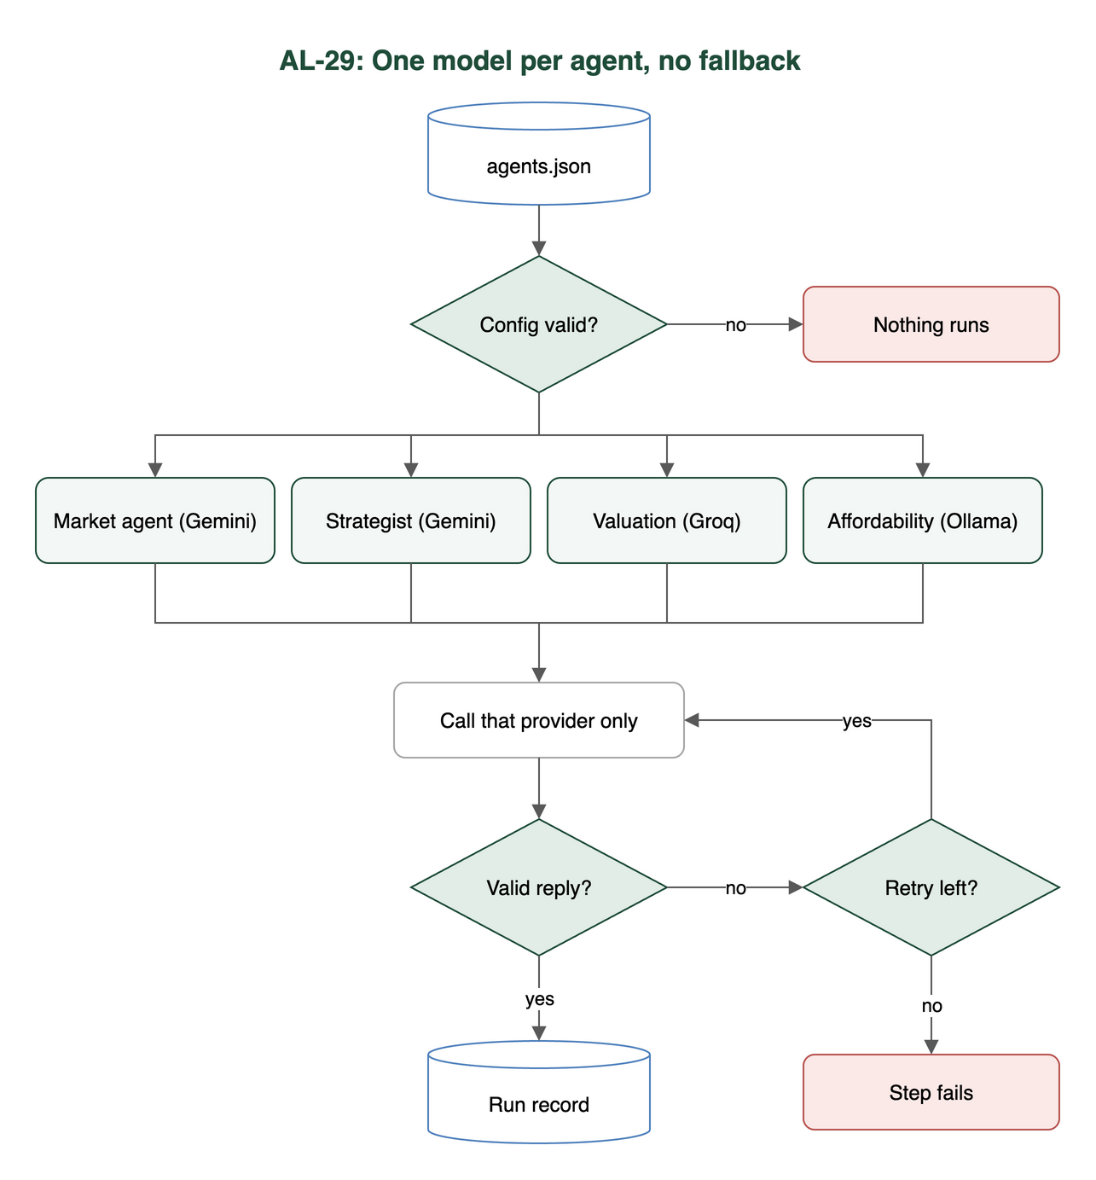

Preconditions and test data
- I installed the al-ai dependencies (cd al-ai && uv sync).
- The automated tests use a fake network for every provider, so they need no keys and no Ollama.
- A live run needs GEMINI_API_KEY and GROQ_API_KEY in the repo-root .env and ollama serve running with qwen3.5:9b pulled.
- I made no live calls for this test. Criteria 2 and 3 use evidence already saved in the repo.

Test cases
ID | Acceptance criterion | Steps | Expected result | How it was checked, and the result
TC-29-01 | One config maps each agent to a provider and an exact pinned model: Market & Macro and Strategist on Gemini, Valuation on Mistral Small 4 (Groq gpt-oss-120b as the backup, switched by hand, never automatically), Affordability on Ollama. | 1. Open al-ai/app/llm/agents.json. 2. Run the config tests. | Market & Macro and Strategist: gemini gemini-3.1-flash-lite. Valuation: groq openai/gpt-oss-120b, manual backup gemini gemini-3.1-flash-lite. Affordability: ollama qwen3.5:9b. No moving aliases and no fallback section. | Automated: test_llm_config.py: test_the_real_config_loads_and_pins_a_model_for_every_agent, test_no_model_in_the_real_config_is_a_moving_alias, test_the_valuation_agent_runs_on_groq_and_its_manual_backup_is_gemini_flash_lite, test_a_bad_config_is_refused, test_every_agent_in_the_real_config_reaches_the_provider_it_names_and_only_that_one; test_groq_decision_recorded.py (every test in the file). Pass, against the team decision of 28 Oct 2026: Valuation is on Groq, not Mistral (see Notes).
TC-29-02 | A schema smoke test passes for each provider before the committee uses it, and the exact Gemini and Ollama model IDs go into docs/infrastructure.md when it does. | 1. Live (manual, not run in this test): cd al-ai && uv run python -m app.llm.smoke. 2. Read al-ai/docs/llm-smoke-results.json. 3. Read the “Smoke test (27 Oct 2026)” entry in docs/infrastructure.md. | Each provider in use answers the tiny structured request with {"answer": 4}. | Automated: test_llm_smoke.py: test_a_provider_with_no_key_is_skipped_not_failed, test_a_working_provider_is_recorded_as_passed_with_its_details, test_a_wrong_answer_is_a_fail_even_if_the_schema_passes, test_the_saved_evidence_never_contains_a_key; test_llm_config.py: test_each_provider_in_use_has_one_model_to_smoke_test. Recorded evidence: llm-smoke-results.json shows a pass on 27 Oct 2026 for Gemini gemini-3.1-flash-lite, Ollama qwen3.5:9b and Groq openai/gpt-oss-120b (Mistral skipped, no key), and docs/infrastructure.md records those IDs. Pass (from the recorded evidence; I didn’t re-run the live smoke test).
TC-29-03 | One end-to-end committee run’s log shows real calls to Gemini, Mistral and Ollama, each with its exact model ID, and the three voting agents use three different models. | 1. Live (manual, not run in this test): cd al-ai && uv run python -m app.committee app/committee_samples/mortgage-application.json. 2. Read the saved record al-ai/docs/committee-evidence/mortgage-run.json. | The 4 Nov 2026 record shows market and strategist on gemini gemini-3.1-flash-lite, valuation_agent on groq openai/gpt-oss-120b and affordability on ollama qwen3.5:9b, all with outcome ok. That’s three models for the three agents that feed the decision. | Automated (fake network): test_committee.py: test_each_agent_calls_the_provider_agents_json_gives_it. Recorded evidence: mortgage-run.json and heloc-run.json in al-ai/docs/committee-evidence/. Pass (from the recorded 4 Nov run, with Groq instead of Mistral; not re-run live).
TC-29-04 | On a machine that can’t run Ollama, the affordability step fails instead of quietly using a cloud model. | 1. Stop Ollama (or point OLLAMA_HOST at a dead address) with the cloud keys set. 2. Run the committee. | The affordability step fails after its retries, which all go to Ollama. The run is saved as failed and nothing goes to Gemini, Groq or Mistral. | Automated: test_ollama_no_fallback.py: test_an_unreachable_ollama_fails_the_affordability_step_and_no_cloud_model_is_called, test_the_same_holds_when_no_ollama_address_is_set_and_the_default_local_one_is_unreachable, test_a_committee_run_with_ollama_down_is_saved_as_failed_and_the_affordability_prompt_goes_nowhere_else; test_llm_clients.py: test_a_rate_limit_is_an_error_and_there_is_no_fallback_to_another_provider. Pass.

Test run
From al-ai on main at 86cd8d4, 9 Nov 2026: uv run pytest -q -p no:cacheprovider tests/test_llm_config.py tests/test_llm_clients.py tests/test_llm_smoke.py tests/test_ollama_no_fallback.py tests/test_groq_decision_recorded.py tests/test_committee.py
122 passed, 0 failed, 4 skipped. The four skipped are test_live_provider_answers_the_tiny_structured_request in test_llm_smoke.py, one per provider. They only run with AL_LIVE_LLM=1 and real keys. None of these tests need the Firestore emulator.

Notes
- Mistral was replaced by Groq. Criteria 1 and 3 name Mistral Small 4. On 28 Oct 2026 the team agreed to run the valuation agent on Groq openai/gpt-oss-120b instead, because Mistral has no free API tier. It’s recorded in docs/infrastructure.md.
  - The manual backup is Gemini gemini-3.1-flash-lite, switched by editing agents.json. The code never falls back on its own.
  - Mistral is still a supported provider in clients.py, but the config doesn’t name it.
  - So the two cloud APIs are now Gemini and Groq.
- Criterion 2, “before the committee uses it”. The smoke test is a script a person runs (app.llm.smoke). The committee doesn’t run it or check its result before a run. The recorded pass is from 27 Oct 2026, before the first committee runs on 4 Nov.
- Criterion 3, “log”. The evidence is the saved run record, where each step lists its attempts with provider, model, prompt version and outcome. The model in each attempt is the one the config asked for. The provider’s own model name isn’t saved separately.
- In heloc-run.json the market and strategist steps each had one provider_error, and the valuation agent one invalid_reply, before they worked on retry. All retries were on the same model.
- The saved runs are from before the rates were wired in from the ECB tool, so they show the models but not the rates.

