Test case: AL-19
As a borrower, I see how much I can borrow from my income, debts and deposit
Item | Detail
Story | AL-19: As a borrower, I see how much I can borrow from my income, debts and deposit
Epic | AL-5 Loan Application
Owner | Ibrahima Toure (iOS borrower app, al-mobile)
Sprint | Sprint 1 (8 to 25 Oct 2026)
Wireframe | wireframe.png in this folder, exported from Figma (https://www.figma.com/design/l1dzCYxViJsNVEceRstuH1?node-id=5-69), file "AL-80 Borrower app". Sections "Affordability variants (AL-107)" and the sample form and result screens.
Code | al-mobile/AgenticLender/Affordability on branch main (form, endpoint call and, since PR #60 merged on 22 Oct, the result screen), repository CS3-Agentic-Lender/agentic-lender

What this tests
The borrower enters single or joint, gross yearly income, monthly debts, deposit, a term of 5 to 35 years and whether they are a first-time buyer. The app sends it with their Firebase ID token to al-ai's affordability endpoint (POST /ai/affordability), which does the calculation, so the app and the underwriter portal always agree. The result shows the maximum loan, the maximum price, the monthly repayment, the repayment if rates rise 2 points, which limit applied, and the rate with its month, labelled indicative.

Wireframe
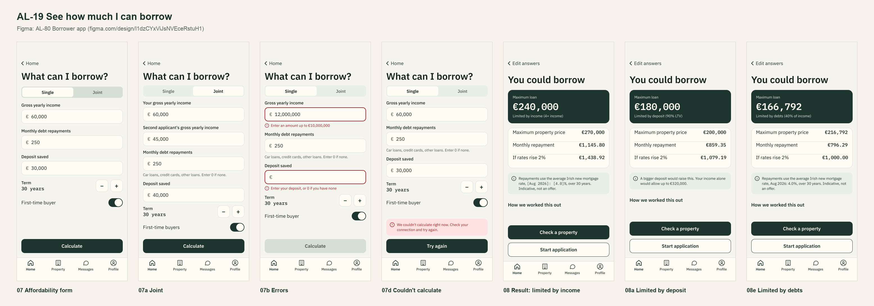
The wireframe is the design target. "Moved to Sprint 2 or not finished" below lists the parts that are not built or not merged yet.

Preconditions and test data
- Local Firebase emulators (Auth and Firestore) with the seed data from main, al-core and al-ai running behind the local Docker gateway, and the app on the iPhone 17 Simulator. The seeded accounts and the people in the test data are made up and exist only in the local emulator. al-ai's affordability endpoint (Nic, AL-57).
- Test data: the three reference cases from AL-57 at its 4.00% test rate (below).
- Unit tests: cd al-mobile, then xcodebuild test -project AgenticLender.xcodeproj -scheme AgenticLender -destination 'platform=iOS Simulator,name=iPhone 17'. They use fake services, so they need no emulator.
- Unit test results on 22 Oct 2026: 192 tests on PR #60 just before it merged into main, 0 failures.

Test cases
ID | Acceptance criterion | Steps | Expected result | How it was checked, and the result
TC-19-01 | Valid inputs show maximum loan, price, repayment, repayment at +2 points and which limit applied. | Case 1: single first-time buyer, €60,000 income, €0 debts, €40,000 deposit, 30 years. | €240,000 "limited by income (4x income)", €280,000 price, €1,145.80 a month, "If rates rise 2%: €1,438.92 a month". | Automated: AffordabilitySummaryTests > testReferenceCaseOneSingleFirstTimeBuyer, testIncomeLimitIsThreeAndAHalfTimesForOtherBuyers; AffordabilityResultTests > testDecodesEachLimit. Simulator: case 1 showed €240,000, €1,145.80 and "Limited by income (4x income)". Pass (on main).
TC-19-02 | For the reference cases the app shows exactly the endpoint's figures. | Case 2: joint, not first-time, €90,000 income (two incomes), €30,000 deposit, 25 years. Case 3: single first-time, €60,000 income, €1,000 monthly debts, €50,000 deposit, 30 years. | Case 2: €270,000 "limited by deposit (90% LTV)", €300,000, €1,425.16, €1,739.61. Case 3: €166,792 "limited by debts (40% of income)", €216,792, €796.29, €1,000.00. | Automated: AffordabilitySummaryTests > testReferenceCaseTwoJointMoversLimitedByDeposit, testCaseThreeLimitedByDebtsRoundsTheLoanToTheEuro; AffordabilityResultTests > testDecodesTheReferenceCaseOneResponse, testJointRequestSendsOneHouseholdIncome. Real endpoint (13 Oct): POST /ai/affordability returned 200 with max loan 240,000 and the app showed it. Simulator: case 3 showed €166,792 and €796.29. Pass (on main).
TC-19-03 | The rate is shown with its month and labelled indicative, not an offer. | Calculate any case and read the note under the figures. | "Average Irish new mortgage rate, <month year>: <rate>%", labelled indicative. | Automated: AffordabilitySummaryTests > testRateNoteShowsTheRateWithItsMonthAndSaysItIsIndicative, testAnUnreadableRateDateIsShownAsSent. Pass (on main).
TC-19-04 | Invalid inputs show an error under the field, and Calculate stays disabled until the form is valid. | Enter €12,000,000 income, a negative deposit, and step the term down from 5 and up from 35. | "Enter an amount up to €10,000,000", an error under the deposit, the term stops at 5 and 35, and Calculate stays disabled and says what is missing. | Automated: AffordabilityValidatorTests (21 tests, including testIncomeAboveTenMillionIsRejected, testNegativeOrNonNumericAmountsAreRejected, testTermOutsideFiveToThirtyFiveIsRejected); AffordabilityViewModelTests > testCalculateIsDisabledUntilTheFormIsValid, testADisabledCalculateSaysWhatIsMissingFirst, testTermStepsByOneYearWithinFiveToThirtyFive. Simulator screenshots. Pass (on main).
TC-19-05 | From the result, Start application opens the application form filled in from these inputs. | Calculate case 1, then press Start application. | The application form opens with the check's answers summarised and used. | Automated: ApplicationValidatorTests > testStartsFromTheAffordabilityCheck; ApplicationViewModelTests > testSummarisesTheAffordabilityAnswers. Simulator: application from the check. Pass (on main, PR #61 merged 22 Oct). "Check a property" is Sprint 2 (below).
TC-19-06 | Beyond the criteria: the endpoint call handles waiting, no connection and double taps. | Calculate with al-ai stopped, then with it running; tap Calculate twice quickly. | "Calculating..." while waiting; with no connection a message and Try again; a second tap sends nothing, and a failure clears the old result. | Automated: AffordabilityViewModelTests > testShowsCalculatingWhileTheEndpointIsAnswering, testNoConnectionShowsTheCouldNotCalculateMessage, testASecondCalculateWhileOneIsRunningSendsNothing, testAFailedCalculationClearsTheEarlierResult; APIAffordabilityServiceTests (7 tests). The two guard tests failed before the fix and passed after (21 Oct). Pass (on main, AL-98).

Moved to Sprint 2 or not finished
- "Check a property" opens the property checker, which is built in Sprint 2, so criterion 5 is only half testable in Sprint 1.
- Bug AL-237: the result shows a bare €0 when nothing can be borrowed. Bug AL-250: a euro amount shows the wrong grouping after deleting a digit (display only). Both wait for triage.

Notes
- Pull requests: #53 (form), #59 (endpoint call) and #60 (result screen, 22 Oct) are merged.
- Figma link: https://www.figma.com/design/l1dzCYxViJsNVEceRstuH1?node-id=5-69

