Test case: AL-20
As a borrower, I submit a loan application with my requested term and target property
Item | Detail
Story | AL-20: As a borrower, I submit a loan application with my requested term and target property
Epic | AL-5 Loan Application
Owner | Ibrahima Toure (iOS borrower app, al-mobile)
Sprint | Sprint 1 (8 to 25 Oct 2026)
Wireframe | wireframe.png in this folder, exported from Figma (https://www.figma.com/design/l1dzCYxViJsNVEceRstuH1?node-id=6-385), file "AL-80 Borrower app". Section "Application and status (AL-109)", frames 12 to 13b.
Code | al-mobile/AgenticLender/Application: the form and draft on main (PR #61, merged 22 Oct), edit a draft in PR #79 and review and submit on the local AL-100 branch, repository CS3-Agentic-Lender/agentic-lender

What this tests
From the affordability result the borrower opens the application form, filled in from the check, and adds the loan amount, take-home pay, living costs, employment, years in the job and the home they want to buy. Save draft sends it to al-core (POST /core/applications) as a Draft. The borrower can come back later and change the draft (GET and PATCH). Check your application shows every field with an Edit link, and Submit asks for confirmation, then calls POST /core/applications/{id}/submit, which sets the status to Applied, and shows a short reference.

Wireframe
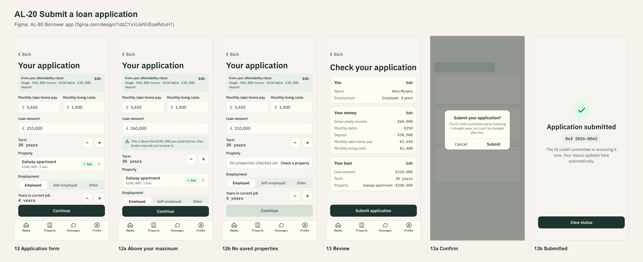
The wireframe is the design target. "Moved to Sprint 2 or not finished" below lists the parts that are not built or not merged yet.

Preconditions and test data
- Local Firebase emulators (Auth and Firestore) with the seed data from main, al-core and al-ai running behind the local Docker gateway, and the app on the iPhone 17 Simulator. The seeded accounts and the people in the test data are made up and exist only in the local emulator. al-core's application endpoints (Dumi: AL-58, AL-244, AL-245, AL-251).
- Test data: a borrower with a broker and a completed affordability check; loan €210,000, €3,650 take-home pay, €1,400 living costs, Employed, 4 years; home: Cork, T12 X8Y2, Semi-D, 98 m2, 3 bedrooms, BER C2. The seeded alice@test.com already has an application in progress.
- Unit tests: cd al-mobile, then xcodebuild test -project AgenticLender.xcodeproj -scheme AgenticLender -destination 'platform=iOS Simulator,name=iPhone 17'. They use fake services, so they need no emulator.
- Unit test results: 284 tests on PR #61 just before it merged into main (22 Oct), 221 on PR #79 (19 Oct) and 252 on the local AL-100 branch (20 Oct). 0 failures.

Test cases
ID | Acceptance criterion | Steps | Expected result | How it was checked, and the result
TC-20-01 | The form is filled in from the affordability check and asks for loan amount, target property, employment, years in job, take-home pay and living costs. | From a completed check, Start application, then fill in the test data and the home. | The check's answers are summarised at the top; every listed field is asked for; take-home pay and living costs can be 0 but not empty. | Automated: ApplicationValidatorTests > testStartsFromTheAffordabilityCheck, testTakeHomePayAndLivingCostsAreRequired, testEveryPropertyFieldIsRequiredExceptAddressLine2, testEircodeMustBeAValidEircode; ApplicationViewModelTests > testSummarisesTheAffordabilityAnswers. End to end (19 Oct): Save draft sent the home (201) and al-core read back loan €210,000, Eircode T12 X8Y2, Cork, 98 m2, 3 bedrooms, BER C2. Pass (on main).
TC-20-02 | A loan amount above the calculated maximum shows a warning. | Enter €260,000 against a €240,000 maximum, then €240,000. | A warning, but the borrower can still continue. No warning at or below the maximum. | Automated: ApplicationValidatorTests > testLoanAboveTheMaximumIsAWarningNotAnError, testLoanAtOrBelowTheMaximumHasNoWarning; ApplicationViewModelTests > testWarningShowsAsSoonAsTheLoanIsAboveTheMaximum. Pass (on main).
TC-20-03 | Submitting asks for confirmation, saves the application as Applied and shows a reference; a borrower with an active application can't start a second one. | 1. Save the draft, Review, Submit, then Cancel. 2. Submit and Confirm. 3. As alice, try to save a new application. | Cancel leaves it a Draft. Confirm shows "Application submitted" and a reference (first 8 characters of the id). Alice is told an application is already in progress. | Automated (local AL-100 branch): ApplicationSubmitViewModelTests > testSubmitAsksForConfirmationFirstAndSendsNothing, testCancellingTheConfirmationLeavesTheDraftAlone, testConfirmingSubmitsTheSavedDraftAndShowsItsReference; ApplicationReviewTests > testTheReferenceIsTheFirstEightCharactersOfTheIDInCapitals; APIApplicationServiceTests > testConflictMeansAnApplicationIsAlreadyInProgress. End to end (20 Oct): submit returned 200, and the Firestore emulator shows the application as Applied with a submittedAt time (Ref UJQJVQ6Y); alice's save was refused with 409. Pass on the local branch; no PR yet.
TC-20-04 | A draft can be edited freely; once submitted it is read-only. | 1. Save a draft, leave, reopen it, change the loan and save. 2. Submit, then reopen it. | Step 1 reopens with the saved values and saves to the same draft. Step 2 opens read-only with "Submitted applications can't be changed". | Automated (PR #79 branch): ApplicationDraftEditingTests > testReopeningFillsTheFormWithTheSavedDraft, testADraftCanBeChangedAndSavesToTheSameDraft, testASubmittedApplicationOpensReadOnlyAndCannotBeSaved. End to end (19 Oct): PATCH returned 200 and the changes read back; a PATCH after submitting was refused with 409 ("Only a Draft can be edited"). Pass on the branch.
TC-20-05 | The saved record matches the applications schema agreed with Dumi. | Save a draft and open it in the Firestore emulator. | The fields and values match SCHEMA.md: a mortgage, status Draft, the agreed field names and property values. | Automated: ApplicationValidatorTests > testDraftUsesTheAgreedSchemaValues, testDraftBodyIsAMortgageInTheAPIFieldNames, testDraftBodyCarriesThePropertyWithTheEircodeInCapitalsWithASpace; PropertyTypeTests and BERRatingTests. Firestore emulator (20 Oct): the record has loan €210,000 and property type Semi-D. Pass (on main).

Moved to Sprint 2 or not finished
- The form and draft (AL-99, PR #61) merged on 22 Oct. Not merged yet: edit a draft (AL-101, PR #79) is being rebuilt from main, and review and submit (AL-100) is on a local branch and gets its PR after #79.
- Target property: the story said it is chosen from saved property checks. The property checker is Sprint 2, so in Sprint 1 the borrower enters the home on a property step in the form instead. Frame 12b (no saved properties) waits for the checker.
- After submitting, the button goes back home. Opening the status screen moved to AL-102 (comment on the ticket, 20 Oct).

Notes
- Figma link: https://www.figma.com/design/l1dzCYxViJsNVEceRstuH1?node-id=6-385

