Test case: AL-16
As a borrower, I register and log in with email/password or Google
Item | Detail
Story | AL-16: As a borrower, I register and log in with email/password or Google
Epic | AL-4 Accounts & Roles (use case written by Nikoloz)
Owner | Ibrahima Toure (iOS borrower app, al-mobile)
Sprint | Sprint 1 (8 to 25 Oct 2026)
Wireframe | wireframe.png in this folder, exported from Figma (https://www.figma.com/design/l1dzCYxViJsNVEceRstuH1?node-id=4-325), file "AL-80 Borrower app". Section "Sign up and sign in (AL-106)" plus the Welcome and Home sample screens.
Code | al-mobile/ (SignUp, SignIn, Session and Screens folders) on branch main; stay signed in and sign out are merged too (PR #57, 22 Oct), repository CS3-Agentic-Lender/agentic-lender

What this tests
A borrower creates an account with email and a password, or with Continue with Google, and signs in again later. Sign-up asks for name, email and password, then phone, address, county and Eircode, and saves the borrower profile through al-core (POST /core/me), which gives the account the borrower role. Sign-in never says whether the email or the password was wrong, Forgot password sends Firebase's reset email, and a first-time Google user fills in the same profile without a password. A signed-in borrower stays signed in when the app is reopened, and Sign out returns to Welcome.

Wireframe
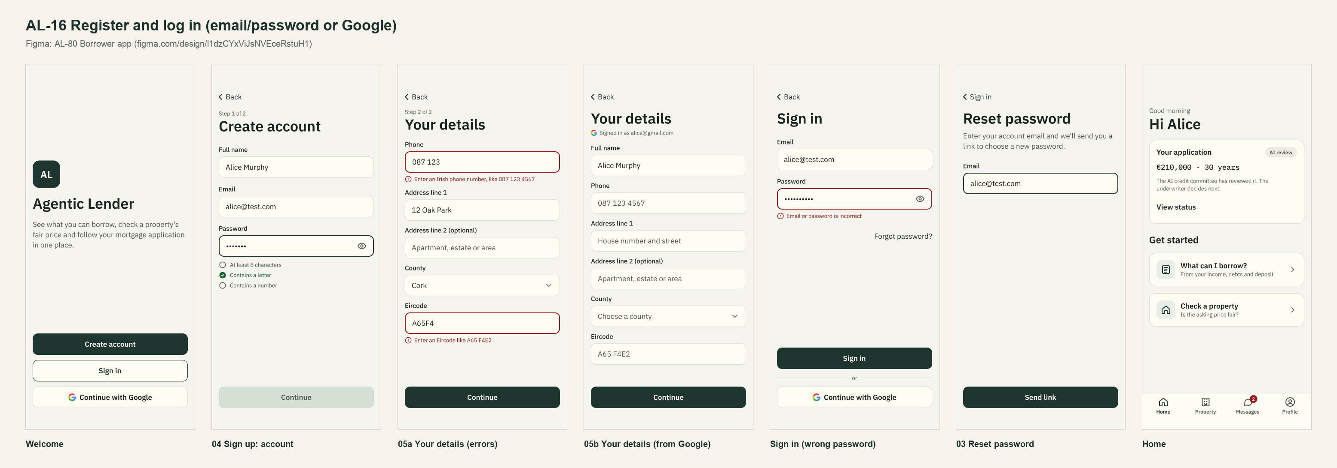
The wireframe is the design target. "Moved to Sprint 2 or not finished" below lists the parts that are not built or not merged yet.

Preconditions and test data
- Local Firebase emulators (Auth and Firestore) with the seed data from main, al-core and al-ai running behind the local Docker gateway, and the app on the iPhone 17 Simulator. The seeded accounts and the people in the test data are made up and exist only in the local emulator.
- Test data: Alice Murphy, a new email, a valid password, 087 123 4567, 12 Oak Park, Cork, a65f4e2. The seeded alice@test.com for sign-in.
- Unit tests: cd al-mobile, then xcodebuild test -project AgenticLender.xcodeproj -scheme AgenticLender -destination 'platform=iOS Simulator,name=iPhone 17'. They use fake services, so they need no emulator.
- Unit test results on 22 Oct 2026: 192 tests on main's sign-in code with #60, 221 on the stay-signed-in branch (PR #57, merged into main on 22 Oct), 0 failures.

Test cases
ID | Acceptance criterion | Steps | Expected result | How it was checked, and the result
TC-16-01 | Valid sign-up details create a Firebase Auth account and a borrower profile with role "borrower". | 1. Welcome > Create account. 2. Enter the test data above. 3. Continue, then Create account. | The account is created. The profile in the Emulator UI has role borrower, Eircode A65 F4E2 and phone +353871234567. | Automated: SignUpViewModelTests > testSubmitCreatesTheAccountWithANormalisedProfile; BorrowerProfileTests > testSendsTheEircodeInCapitalsWithASpace, testBodyLeavesOutAnEmptyAddressLine2AndNeverSendsARole; CoreProfileAPITests > testPostsTheProfileToCoreMeWithTheIDToken. Emulator (15 Oct): POST /core/me through the gateway created the profile (201) and the token gained the borrower role. Pass (on main).
TC-16-02 | A password under 8 characters, or without a letter and a number, can't be submitted, and the rule shows under the field. | On the password field type abcdefgh, then add a 1. | With abcdefgh, "Contains a number" stays unticked and Continue is disabled. After the 1, all three rules tick and Continue is enabled. | Automated: PasswordRuleTests (8 tests, including testSevenCharactersIsTooShort, testLettersOnlyHasNoNumber); SignUpViewModelTests > testContinueIsDisabledUntilThePasswordMeetsEveryRule, testRulesTickOffAsThePasswordIsTyped. Simulator screenshot of sign-up step 1. Pass (on main).
TC-16-03 | A wrong password shows "Email or password is incorrect" without saying which; Forgot password sends Firebase's reset email. | 1. Sign in as alice@test.com with a wrong password. 2. Sign in with an unknown email. 3. Forgot password? for alice@test.com. | Steps 1 and 2 both show "Email or password is incorrect". Step 3 shows "Check your email" and the reset email appears in the Auth emulator. | Automated: SignInViewModelTests > testIncorrectCredentialsShowOneMessageThatDoesNotSayWhichIsWrong, testEveryCredentialErrorReadsAsIncorrect, testSendsTheResetEmailAndShowsCheckYourEmail, testUnknownEmailStillShowsCheckYourEmail. Emulator: both wrong attempts showed the same message and alice's reset email appeared in the Auth emulator. Pass (on main).
TC-16-04 | Continue with Google signs a borrower in; a first-time Google user completes the profile (no password) before home. | 1. Welcome > Continue with Google as a new user. 2. Fill in Your details. 3. Sign out, then Continue with Google again. | Step 1 opens Your details with the Google name and email and no password field. Step 2 reaches home. Step 3 goes straight to home. | Automated: GoogleSignInViewModelTests > testFirstTimeGoogleUserGoesToTheProfileScreen, testReturningGoogleUserGoesStraightToHome; GoogleProfileViewModelTests > testSavesTheProfileWithTheGoogleEmailAndNoPassword, testTheEmailCannotBeChangedFromTheGoogleOne. Simulator walkthrough on the emulators (15 and 19 Oct). Pass (on main).
TC-16-05 | A signed-in borrower stays signed in after closing and reopening the app; signing out returns to Welcome. | 1. Sign in. 2. Close the app and open it again. 3. Sign out. | Step 2 opens on home. Step 3 shows Welcome, with none of the signed-in screens left behind. A failed sign-out stays on home and says so. | Automated: AppSessionTests > testOpensOnHomeWhenALoginIsSaved, testSignOutGoesBackToWelcomeAndStartsTheScreensAfresh, testAfterSigningOutTheNextLaunchOpensOnWelcome, testAFailedSignOutStaysPutAndSaysSo. Simulator: reopening the app went to home. Pass (on main, PR #57 merged 22 Oct).
TC-16-06 | Beyond the criteria: a dropped connection while saving the profile doesn't leave a login with no profile. | Make the first POST /core/me fail with no connection, then succeed. | Sign-up retries once and finishes. If both tries fail, the new login is removed and the borrower is told why. | Automated: ProfileSaveStepTests (9 tests, including testADroppedConnectionThenASuccessFinishesSignUp, testTwoDroppedConnectionsRemoveTheLoginAndShowTheNetworkMessage). Pass (on main, AL-239).
TC-16-07 | Beyond the criteria: sign-up fields stay within al-core's limits. | Type a full name of 101 characters and an address line of 201 characters. | "Use 100 characters or fewer" (or 200) shows under the field and no profile is sent. | Automated: SignUpLengthLimitTests (8 tests, including testAFormOverALimitMakesNoProfile). Pass (on main, AL-240).

Moved to Sprint 2 or not finished
- Sign out from Your details (AL-256): not started; now its own story in Sprint 2, so AL-16 closed for Sprint 1.
- Bug AL-249: Continue with Google with the same email as an unverified password account removes the password. Found in review, waiting for triage.

Notes
- Pull requests: #45 (sign-up), #52 (password rules), #54 (email sign-in), #55 (Google), #56 (home), #57 (stay signed in, with the broker picker), #89 (length limits) and #90 (profile save retry) are merged, and so is #85 (Your details for a user with no email, 22 Oct).
- Figma link for the whole story: https://www.figma.com/design/l1dzCYxViJsNVEceRstuH1?node-id=4-325

