Use case: AL-194 Home equity line of credit (HELOC)
Epic. A homeowner borrows against the value of a home they already own.
Item | Detail
Epic | AL-194 Home equity line of credit (HELOC)
Feature (from the brief) | The platform covers "mortgage or HELOC", and the loan note represents "mortgages/HELOCs".
Owner | Ibrahima Toure (iOS, AL-195). The underwriter review is Nikoloz's (AL-196); the HELOC calculations are Nic's (AL-198) and the HELOC fields Dumi's (AL-197).
Sprint | Sprint 1 (8 to 25 Oct 2026) built the wireframes and the mortgage-or-HELOC choice. The check, application and underwriter review follow in Sprint 2.
Wireframes | Figma "AL-80 Borrower app", section HELOC (AL-205): https://www.figma.com/design/l1dzCYxViJsNVEceRstuH1?node-id=393-1604

Goal
As a homeowner, I want to apply for a credit line against the value of my home, so that I can borrow against the equity I've built up.

Actors
- Homeowner (borrower): signed in to the iOS app, with a broker chosen.
- al-ai: estimates the home's value with the valuation model and works out the maximum line.
- al-core: saves and submits the HELOC application with loanType heloc.
- Underwriter: reviews the HELOC in the portal with its combined LTV and collateral value (AL-196).
- AI credit committee: the same four agents as for a mortgage, with HELOC rules.

Preconditions
- The borrower is signed in, has a borrower profile and a broker, and owns the home.
- al-ai has the valuation model and the HELOC affordability endpoint; al-core has the HELOC fields.

Trigger
The borrower taps "What can I borrow?" on home and chooses Borrow against my home.

Main flow
- The borrower chooses Borrow against my home (HELOC).
- They enter the five house details (county, size, bedrooms, property type, BER), the balance left on their mortgage, gross income, monthly debts and a repayment term. No deposit and no asking price.
- The app sends them to al-ai, which estimates the home's value and works out the maximum line.
- The app shows the maximum credit line, what limited it, the repayment if the line is fully drawn and at +2 points, and the estimated value, labelled indicative.
- The borrower taps Start application. The HELOC application opens filled in, with no deposit field.
- They add the credit line they want, take-home pay, living costs, employment and years in the job, and save it as a Draft.
- They review and submit. al-core saves it with loanType heloc and status Applied, and the app shows a reference.
- The AI committee and the underwriter review it like a mortgage, with the HELOC rules below.

Alternative flows
- A. No equity. At step 4, if the balance is 80% or more of the estimated value, the line is €0 and the app says there is no equity to borrow against yet.
- B. Mortgage instead. At step 1 the borrower picks Buy a home; the mortgage flow (AL-5) is unchanged.

Exceptions
- Invalid inputs, such as an empty mortgage balance: an error under the field ("Enter what's left on your mortgage, or 0 if it's paid off") and nothing is sent.
- No connection, a server error or an expired sign-in: the same handling as the mortgage check.
- The borrower already has an application in progress: al-core refuses a new one.

Postconditions
- Success: one application with loanType heloc and status Applied.
- A mortgage application behaves exactly as before.

Business rules
- Combined LTV is (existing balance + requested line) / estimated value, capped at 80%. The brief gives no number, so 80% is our prototype assumption.
- The maximum line is the lower of 80% of the value minus the balance, and the debt cap (stressed repayment plus debts at 40% of gross income). Never below zero, and no income multiple.
- The stress test assumes the line is fully drawn and repaid over the term at the benchmark rate plus 2 points.
- The valuation model's estimate is the collateral value. It is indicative (trained on 2024 asking prices), so the screens say "estimated value", never "asking price", and a surveyor valuation condition is always added.
- The choice of mortgage or HELOC is made once, at the start of the check, and carried into the application.

Flow diagrams
The check uses the same call as the mortgage check, from docs/diagrams/02-flow-affordability-valuation.png:
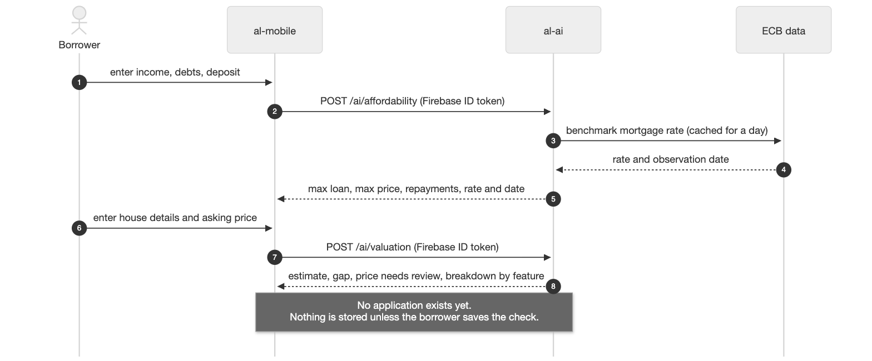

Stories in this epic
Story | What | Owner | Sprint | Status on 22 Oct
AL-195 | As a homeowner, I apply for a HELOC against my property's value | Ibrahima | Sprint 1 to 2 | In Progress: wireframes done and choice merged (PR #62) in Sprint 1; story moved to Sprint 2 for the check and application
AL-196 | As an underwriter, I review a HELOC application with its combined LTV and collateral value | Nikoloz | Sprint 2 | To Do

Notes
- Scope decision recorded in docs/infrastructure.md and agreed with Seamus: a lighter HELOC flow on the same pipeline as mortgages.
- Backend subtasks: AL-197 HELOC fields (Dumi, To Do) and AL-198 HELOC calculations (Nic, Done).
- Test case: AL-195/test-case.docx in this folder.

