Use case: AL-5 Loan Application
Epic. A borrower sees what they can borrow, applies for a mortgage and follows the application.
Item | Detail
Epic | AL-5 Loan Application
Feature (from the brief) | Mobile: Affordability & Loan Application (household gross income, existing debts, deposit, requested term); AL-AI Interface & Status (current lifecycle state). Core: real-time application states.
Owner | Ibrahima Toure (iOS borrower app). The affordability endpoint is Nic's (al-ai) and the application endpoints are Dumi's (al-core).
Sprint | Sprint 1 (8 to 25 Oct 2026) built the affordability check and the application. Following the application's status (AL-21) is Sprint 2.
Wireframes | Figma "AL-80 Borrower app", sections AL-107 (affordability) and AL-109 (application and status): https://www.figma.com/design/l1dzCYxViJsNVEceRstuH1

Goal
As a borrower, I want to see what I can borrow, apply, and follow my application, so that I know where I stand at every step.

Actors
- Borrower: signed in to the iOS app, with a broker chosen.
- al-ai (the AI API): works out what the borrower can borrow, using the latest ECB benchmark rate for Irish new mortgages.
- al-core (the core API): saves, edits and submits applications in Firestore, and checks who may change them.
- Broker: the broker the borrower chose; sees the borrower's application in the portal.
- AI credit committee: starts by itself when an application is submitted (Sprint 2).

Preconditions
- The borrower is signed in (Firebase Auth) and has a borrower profile and a broker.
- al-ai and al-core are running behind the gateway; every request carries the borrower's Firebase ID token.

Trigger
The borrower taps "What can I borrow?" on home.

Main flow
- The borrower chooses Buy a home (mortgage).
- They enter single or joint, gross yearly income (one per applicant), monthly debts, deposit, a term of 5 to 35 years and whether they are a first-time buyer. Calculate stays off until the form is valid.
- The app sends the answers to al-ai (POST /ai/affordability). A joint application's incomes are sent as one household total.
- al-ai returns the maximum loan, maximum price, monthly repayment, repayment if rates rise 2 points, which limit applied and the rate with its month.
- The app shows the result, labelled indicative, not an offer.
- The borrower taps Start application. The form opens filled in from the check.
- They add the loan amount, take-home pay, living costs, employment, years in the job and the home (address, Eircode, county, asking price, type, size, bedrooms, BER), and tap Save draft.
- al-core saves it with status Draft (POST /core/applications) and the app keeps its id on the phone.
- The borrower taps Review. Check your application shows every field with an Edit link.
- The borrower taps Submit and confirms. al-core checks the required fields and sets the status to Applied (POST /core/applications/{id}/submit).
- The app shows "Application submitted" and a short reference.
- From Sprint 2, the AI committee starts on its own, and the borrower follows the status live (AL-21).

Alternative flows
- A. Joint application. At step 2 the borrower picks Joint and enters both incomes.
- B. Loan above the maximum. At step 7 a loan above the calculated maximum shows a warning; the borrower can still continue.
- C. Come back later. The borrower leaves after step 8. Later, the form reopens with the saved draft (GET /core/applications/{id}), and changes save to the same draft (PATCH).
- D. Cancel the confirmation. At step 10 the borrower cancels; the application stays a Draft.

Exceptions
- Invalid inputs (an empty amount, a negative amount, more than €10,000,000, a term outside 5 to 35 years, a bad Eircode): an error under the field and nothing is sent.
- No connection, or a server error: "Couldn't calculate" or a save error with Try again. A second tap while a request is running is ignored.
- Signed out or token expired: the borrower is asked to sign in again.
- The borrower already has an application in progress: al-core refuses a new one (409) and the app says so.
- Editing after submitting: the application opens read-only, and al-core refuses a change (409).
- A required field is missing on submit: al-core names it, and the app says what to add.

Postconditions
- Success: one application exists for the borrower with status Applied and a submittedAt time, and its broker can see it.
- Stopped early: the application stays a Draft and can be changed later. A check on its own stores nothing.

Business rules
- Maximum loan is the lowest of: 4x income for first-time buyers or 3.5x otherwise, 90% loan-to-value, and the loan where the repayment at the rate plus 2 points plus existing debts reaches 40% of gross monthly income. The first two are the Central Bank of Ireland's mortgage measures; the 40% cap is our prototype policy.
- The calculation runs in al-ai, never in the app, so the app and the underwriter portal agree.
- The rate is the latest ECB benchmark for Irish new mortgages, shown with its month and labelled indicative.
- One active application per borrower. Editable while Draft, read-only from Applied, because the AI review starts on submit.
- The app writes through al-core's API, never straight to Firestore.
- Lifecycle states: Draft, Applied, AI Deliberated, Underwriter Approved or Declined, Funded, Closed.
- Out of scope: document uploads such as payslips.

Flow diagrams
The affordability check, from docs/diagrams/02-flow-affordability-valuation.png (the valuation part is Sprint 2):
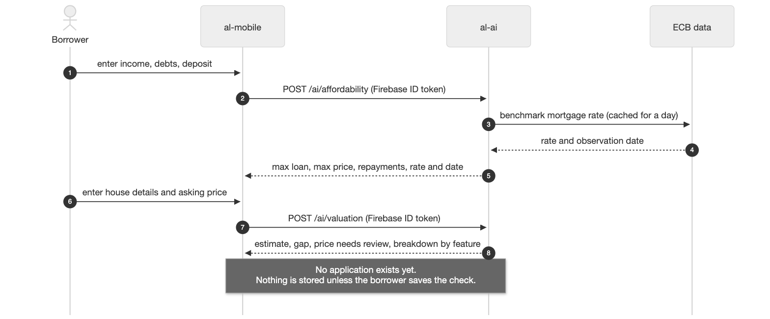
Submitting, and the AI review that follows in Sprint 2, from docs/diagrams/03-flow-submit-ai-review.png:
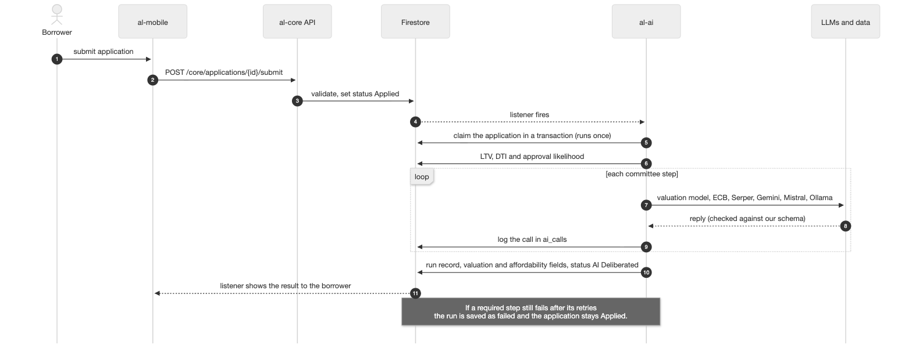

Stories in this epic
Story | What | Owner | Sprint | Status on 22 Oct
AL-19 | See how much I can borrow from my income, debts and deposit | Ibrahima | Sprint 1 | Done: form, endpoint call, result screen and Start application merged; what Check a property opens is Sprint 2 (AL-22)
AL-20 | Submit a loan application with my requested term and target property | Ibrahima | Sprint 1 | Done: form and draft (PR #61), edit a draft (PR #79) and review and submit (PR #98) merged
AL-21 | See the current status of my application | Ibrahima | Sprint 2 | To Do

Notes
- Backend subtasks: AL-57 affordability endpoint (Nic); AL-58, AL-244, AL-245 and AL-251 application endpoints (Dumi). All Done.
- Test cases: AL-19/test-case.docx and AL-20/test-case.docx in this folder.

