Test case: AL-17
As a broker or underwriter, I log in to the web portal and see only the views for my role
Item | Detail
Story | AL-17: As a broker or underwriter, I log in to the web portal and see only the views for my role
Epic | AL-4 Accounts & Roles
Owner | Nikoloz Chilachava (web portal, al-web)
Sprint | Sprint 1 (8 to 25 Oct 2026)
Wireframe | wireframe.png in this folder, exported from Figma (https://www.figma.com/design/F6lldwqy172ox5SeALdDEU?node-id=539-1619). The Figma page is "AL-Web - V2 - Pine & Oat".
Code | al-web/ on branch main, repository CS3-Agentic-Lender/agentic-lender

What this tests
A broker or an underwriter signs in with email and password and lands on a portal that shows only the pages their role allows. The role comes from the signed-in user's token claim, never from anything the browser can edit. A borrower account and a user with no role are refused. A signed-out visitor is sent to the sign-in page.

Wireframe
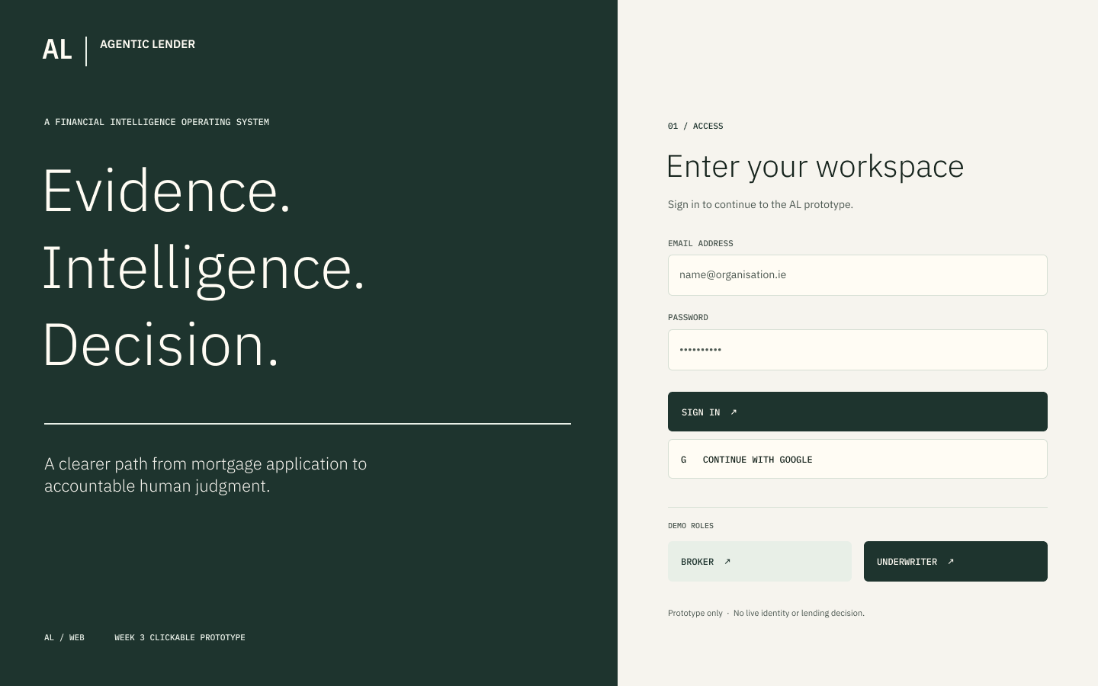
The wireframe is the design target. Section "Moved to Sprint 2" below lists the parts of it that are not built yet.

Preconditions and test data
- Local Firebase emulators (Auth and Firestore) started with the seed data from main: three seeded accounts for the roles under test (an underwriter, a broker and a second broker) with the seed script's test password. These are fixtures that exist only in the local emulator.
- al-web running locally (npm run dev in al-web/), or the Vitest suite (npm test in al-web/).
- The automated tests use a fake auth service, so they need no emulator. The browser checks were made on the emulators on 20 and 21 Oct 2026.

Test cases
ID | Acceptance criterion | Steps | Expected result | How it was checked, and the result
TC-17-01 | Broker signs in with email and password and lands on their own dashboard. | 1. Open /login. 2. Enter the seeded broker's email and password. 3. Press Sign in. | The page moves to /broker (Broker portal). No role is asked for. | Automated: login > submits email and password without asking the user to choose a role; authenticated routing > allows a broker to open the broker route after trusted claims resolve. Browser: broker signed in and landed on /broker. Pass.
TC-17-02 | Underwriter signs in and lands on their own dashboard. | As TC-17-01 with the seeded underwriter. | The page moves to /underwriter (Underwriter portal). | Automated: authenticated routing > allows an underwriter to open the underwriter route. Browser: underwriter signed in and landed on /underwriter. Pass.
TC-17-03 | The role comes from the token's role claim, not from the browser. | 1. Sign in as a broker. 2. Try to change the role in local storage or the URL. 3. Reload. | Access is unchanged: the portal still decides from the verified claim. | Automated: authenticated routing > ignores local and URL role spoofing. Pass.
TC-17-04 | A borrower account is refused with a clear message. | Sign in with an account whose role is borrower. | The portal says "This portal is for brokers and bank staff" and offers Sign out. | Automated: authenticated routing > refuses borrower accounts with the required portal message; lets a refused borrower sign out and removes the denied session. Pass.
TC-17-05 | A broker who opens an underwriter-only address sees a "Not allowed" page, not the content. | 1. Sign in as a broker. 2. Open /underwriter/pipeline directly. | The page shows Not allowed with a link back to the broker portal, and none of the underwriter content. | Automated: denies a broker who navigates directly to the underwriter route; offers a denied broker a link back to the broker portal. Browser: broker opened the underwriter pipeline and got Not allowed. Pass.
TC-17-06 | Signing out returns to the sign-in page, and a refresh keeps a signed-in user signed in. | 1. Sign in. 2. Reload a protected page. 3. Press Sign out. | After the reload the user is still signed in. After Sign out the page is /login and protected pages redirect to it. | Automated: restores a valid session on a protected deep link; removes protected access immediately after sign-out; resets exactly once to login after successful explicit sign-out; redirects an anonymous direct navigation to sign in. Browser: sign out returned to /login. Pass.
TC-17-07 | A failed login shows a safe error beside the form. | Enter a wrong password and press Sign in. | One neutral error message appears beside the form. It does not say whether the email or the password was wrong. | Automated: login > shows a safe invalid-credentials error beside the form. Pass.
TC-17-08 | Protected content is hidden while the session and role resolve, and a role change on a token refresh is applied. | 1. Sign in as a broker. 2. Change the user's role claim and let the token refresh. | While the new role resolves the protected content is hidden. A downgrade removes access and the page resets once at its current address. | Automated: hides protected content while Firebase restores the session and role claim; session boundaries > blocks a same-user downgrade while resolving and resets once at the current location; ignores a slow older refresh after a newer role resolution. Pass.
TC-17-09 | If the portal cannot verify the session (offline, expired token, emulator stopped) it says so and offers a retry, not "Not allowed". | Make the token lookup fail for a signed-in user and open /broker, /login or /forbidden. | The page says "We could not verify your session, reload to try again" with a Retry button that reloads. A missing or invalid role still shows Not allowed. | Automated: authenticated routing > offers a session retry when token lookup fails on /broker, /login and /forbidden. Not tried against a real stopped emulator in a browser. Pass (automated only).

Moved to Sprint 2
- The split sign-in layout in the wireframe (brand panel on the left), Continue with Google and the demo role buttons are not built; the sign-in page is a single form. Agreed by the team on 13 Oct and again on 19 Oct 2026.
- Showing a 401 (expired token) differently from a 403 (not allowed) on API calls: the portal makes no API calls yet, so this waits for its first call.

Notes
- Test results on main on 22 Oct 2026: 280 tests in the web suite pass, and the build passes.
- Pull requests: PR 28 (login and role guard), PR 76 and PR 96 (session handling).

