Test case: AL-32
As an underwriter, I see all applications in a queue grouped by LTV, risk tier and status
Item | Detail
Story | AL-32: As an underwriter, I see all applications in a queue grouped by LTV, risk tier and status
Epic | AL-8 Origination Pipeline
Owner | Nikoloz Chilachava (web portal, al-web)
Sprint | Sprint 1 (8 to 25 Oct 2026)
Wireframe | wireframe.png in this folder, exported from Figma (https://www.figma.com/design/F6lldwqy172ox5SeALdDEU?node-id=539-4730). The Figma page is "AL-Web - V2 - Pine & Oat".
Code | al-web/ on branch main, repository CS3-Agentic-Lender/agentic-lender

What this tests
An underwriter opens the pipeline queue and sees every application with its borrower name, requested amount, LTV, risk tier, status and date. The queue can be grouped by LTV band, risk tier or status, filtered by status, and updates live when an application changes.

Wireframe
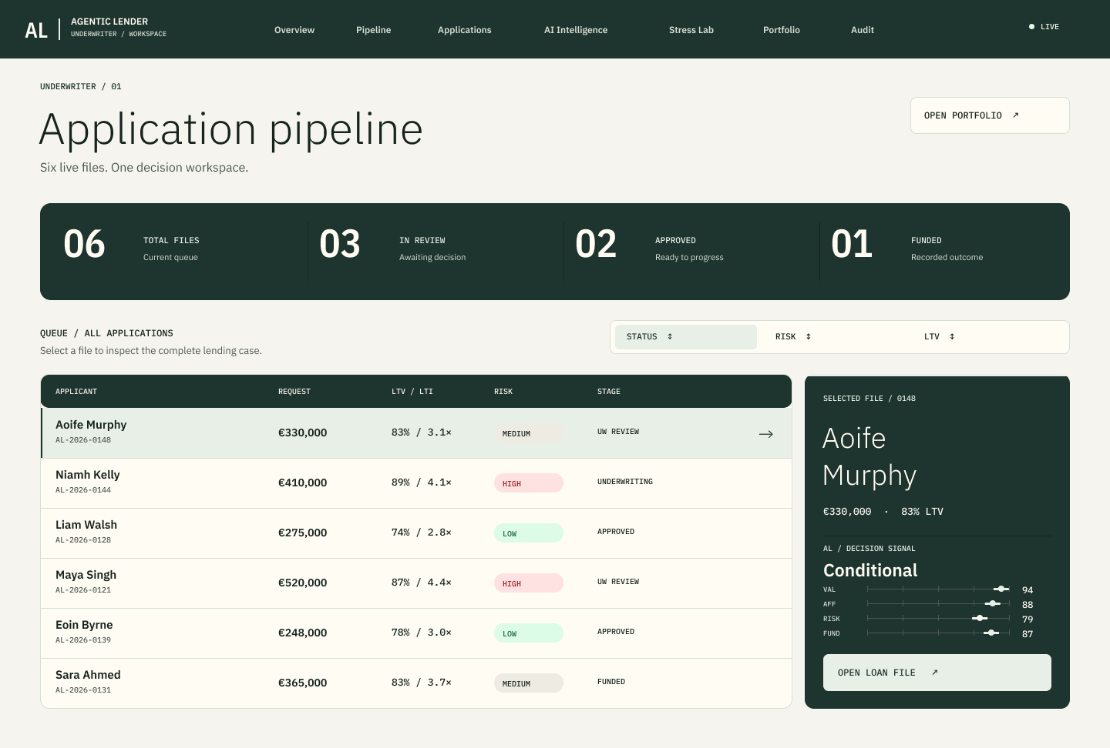
The wireframe is the design target. Section "Moved to Sprint 2" below lists the parts of it that are not built yet.

Preconditions and test data
- Local Firebase emulators (Auth and Firestore) started with the seed data from main: three seeded accounts for the roles under test (an underwriter, a broker and a second broker) with the seed script's test password. These are fixtures that exist only in the local emulator.
- al-web running locally (npm run dev in al-web/), or the Vitest suite (npm test in al-web/).
- The seed has seven applications across all lifecycle statuses (Draft, Applied, AI Deliberated, Underwriter Approved, Declined, Funded, Closed), each with a borrower name.
- Two further wireframes show the same queue grouped by LTV, risk and status: frames "35 / Underwriter / Queue by LTV", "36 / Underwriter / Queue by Risk" and "37 / Underwriter / Queue by Status" in the same Figma page.

Test cases
ID | Acceptance criterion | Steps | Expected result | How it was checked, and the result
TC-32-01 | The queue lists every application with borrower name, loan amount, LTV band, risk tier, status and date. | 1. Sign in as the underwriter. 2. Open Pipeline. | All seven seeded applications are listed with the six fields. A missing borrower name shows a dash, never a made-up name. | Automated: shows an underwriter every application with its figures, tier and status; shows the borrower name on each row and a dash when the application has none. Browser on the emulators with the seed from main: seven applications with their borrower names. Pass.
TC-32-02 | The queue can be grouped by LTV band, by risk tier and by status. | Choose each of LTV band, Risk tier and Status under Group by. | Rows regroup. LTV bands are 80% or less, over 80% to 90%, and over 90%. Tiers are A to D. Each group shows its count. | Automated: groups by status first, with a count on each group; switches the grouping to LTV band and to risk tier; groups all stored bands and tiers and falls back for each missing field independently; uses the stored asking-price band while labelling the 85% figure as valuation LTV. Browser: grouped by tier gave A (2), B (1), C (1) and so on. Pass.
TC-32-03 | The queue can be filtered by status. | Choose a status in the Status filter. | Only that status is listed. The page says the group counts are of the filtered applications. The filter offers exactly the agreed lifecycle statuses. | Automated: filters by status and says the counts are of the filtered applications; offers exactly the agreed lifecycle statuses in the filter. Pass.
TC-32-04 | Status uses the agreed list and the shared badge colours. | Look at the status badges for each status. | Draft, Applied, AI Deliberated, Underwriter Approved, Declined, Funded and Closed appear with the shared status colours. | The colour mapping is recorded in docs/infrastructure.md (PR 67) and shared with the borrower app. Checked by eye in the browser; the status list is covered by the filter test in TC-32-03. Pass.
TC-32-05 | A new or changed application appears without refreshing. | With the queue open, change an application's status in Firestore. | The row moves to its new group and the group counts change without a reload. | Automated: changes a group count without a reload when an application moves on; moves rows and group counts when stored fields arrive without reloading. Pass.
TC-32-06 | Missing data and failures are shown honestly. | Open the queue with no applications, with slow data, and with risk tiers that cannot be read. | A loading state first, a clear message when there are no applications, and "Unavailable" for tiers that cannot be read. Nothing is guessed. | Automated: shows a loading state before the first answer and no table; says so when there are no applications; says tiers are unavailable instead of showing any when they cannot be read; shows invalid stored fields without valuation or review fallback. Pass.
TC-32-07 | Only underwriters can read the queue. | 1. Sign in as a broker and open /underwriter/pipeline. 2. On the emulator, try to list all applications as a broker. | The broker is refused and the page never subscribes to the data. The database also refuses the broker's read. | Automated: refuses a broker and never subscribes for them; stops listening when the underwriter signs out; stops listening when the page is left. Emulator smoke test on 18 Oct 2026: a broker listing all applications is refused with PERMISSION_DENIED. Pass.

Moved to Sprint 2
- Criterion 4: clicking a row opens its loan file, and a broker gets the same view limited to their own clients. It goes with the loan file page (AL-158). Agreed by the team on 19 Oct 2026.
- From the V2 wireframe: the dark metric strip, the sort tabs and the selected-file side card.

Notes
- Test results on main on 22 Oct 2026: 280 tests in the web suite pass, and the build passes.
- Pull requests: PR 69 (the queue), PR 77 (stored LTV band and risk tier), PR 97 (borrower name), PR 67 (status colours).
- The wireframe shows sample risk labels (Low, Medium, High). The built queue uses tiers A to D, as agreed with the backend.

