**Indian Institute of Technology Mandi**

**CS-303(Software Engineering)**

**Group No:** 02

**Assignment:** Smart Parking System

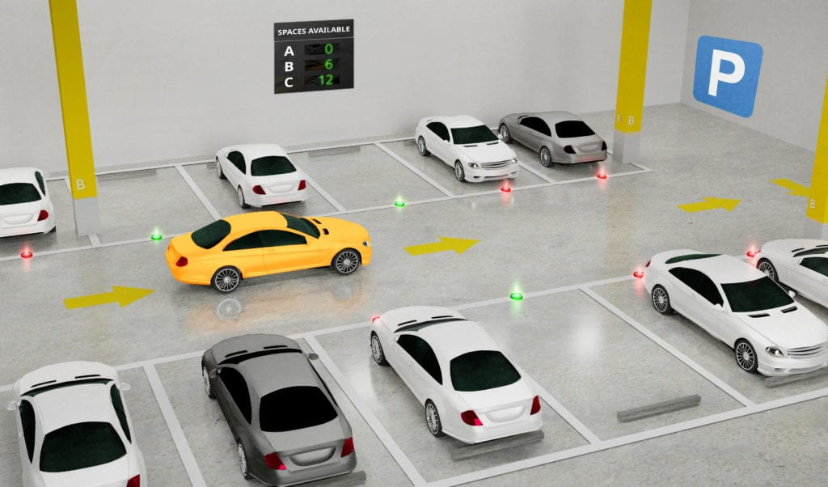

**Group Details:**

Luv Sharma (B22115)

Sameer Gupta(B22127)

Krish Mittal (B22214)

Bilal Muhammad Khan(B22293)

Ch Sunil Patra (B22294)

**Contents:**

**Topics** **Page No**

1. **Project Overview ------------------------------------------------------------ 01**
2. **Technical Implementations: ----------------------------------------------- 02-04**
   1. Technology Stack
   2. System Architecture
   3. Database Design
3. **Features & Functionalities ------------------------------------------------- 04-05**
4. **ER Diagram -------------------------------------------------------------------- 05-06**
5. **User Flow ----------------------------------------------------------------------- 06-07**
6. **Competitive Benchmarking ----------------------------------------------- 07-08**
7. **Future Scope ------------------------------------------------------------------ 08**
8. **Conclusions -------------------------------------------------------------------- 09-10**

# **Project Overview**

* **Smart and Convenient Parking:** It is a web-based parking management system that helps users find and book parking slots easily.
* **Real-Time Slot Booking & Monitoring:** Users can see available parking spots in real-time and reserve them instantly.
* **Multi-Level Parking Management:** The system supports parking across multiple basement levels, making it efficient for large facilities.
* **User Authentication & Booking History:** Every user needs to sign up and log in to book a slot. They can also view their past and current bookings for better trac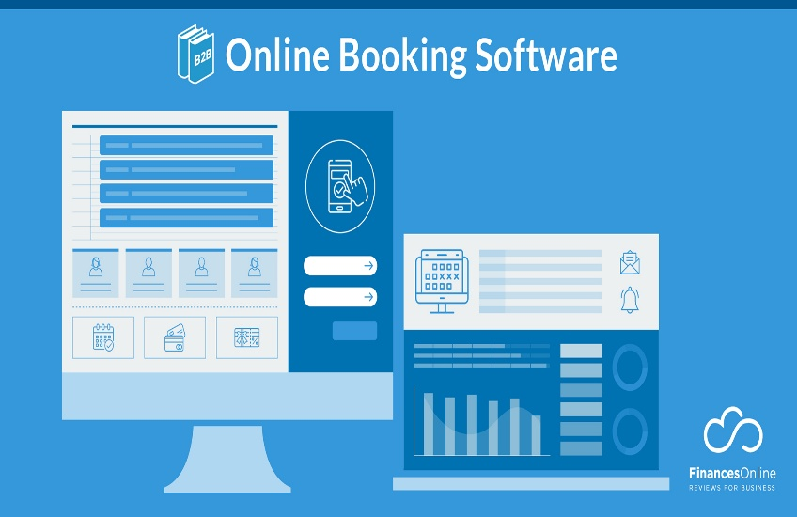 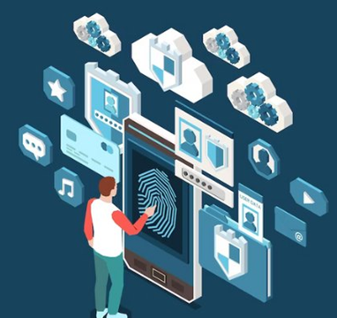



# **Technical Implementations:**

1. **Technology Stacks:**
   * + - **Frontend (User Interface & Experience):**
         * **React.js with Vite –** A fast and lightweight framework to build a responsive and interactive web interface**.**
         * **Material-UI Components –** Pre-designed UI components that enhance the look and feel of the application.
         * **JWT (JSON Web Token) for Authentication –** Ensures secure user login and session management.
         * **Axios for API Calls –** Handles communication between the frontend and backend efficiently.
       - **Backend (Server & Database Management):**
         * **Flask (Python) –** A lightweight and powerful web framework that handles server-side logic.
         * **SQLite Database –** A simple yet effective database to store user and booking data.
         * **Flask-JWT-Extended –** Manages secure authentication and user sessions**.**
         * **Flask-CORS –** Allows seamless interaction between the frontend and backend, even when hosted separately.
       - **System Requirements: Python 3.8+, Node.js 14+, npm /yarn, Visual Studio Code, Git .**
2. **System Architecture:**

Our Smart Parking System follows a structured architecture where different components communicate efficiently to provide a seamless experience.

**A [Client/Frontend] --> B [Flask Server/Backend]**

**B --> C [SQLite Database]**

**A --> D [Authentication Service]**

**D --> B**

Details:

1. **Client/Frontend (A → B)**
   * The user interacts with the React.js frontend, which sends requests (like booking a slot or logging in) to the Flask backend.
2. **Flask Server/Backend (B → C)**
   * The Flask server processes user requests and communicates with the SQLite database to store and retrieve data, such as user details and parking slot information.
3. **Authentication Service (A → D → B)**
   * When a user logs in, the JWT authentication service verifies their credentials before allowing access to the system.
   * Once verified, the backend grants access to features like booking slots and viewing past reservations.
4. **Database Design**

|  |
| --- |
| **Users** |
| **Username** |
| **Email** |
| **User_id** |
| **Password** |
| **Contact** |

|  |
| --- |
| **Parking** |
| **Slot_id** |
| **Level** |
| **User_id** |
| **Slot_No** |
| **Status** |

|  |
| --- |
| **Booking** |
| **Book_id** |
| **User_id** |
| **Slot_id** |

Feature and Functionalities

**1. User Management Features:**

User registration with unique credential, Secure login/authentication system, Profile management with email and phone verification and Session management using JWT tokens.

**2. Parking Management Features:**

Multi-level parking structure (3 levels), 100 parking slots per level, Real-time slot availability tracking, Interactive parking map visualization and Color-coded slot status indication ( White: Available, Red: Occupied).

**3. Booking System Features:**

Real-time slot booking, Slot selection from interactive map, Booking confirmation system, Multiple active bookings tracking, Booking history maintenance and Auto-calculation of parking charges.

**4. Security Features:**

Password encryption, JWT token-based authentication, Session timeout management, Input validation and sanitization and Secure API endpoints.

**5. Database Management:**

User data persistence, Booking records maintenance and Parking slot status tracking.

**6. Technical Features:**

Real-time data synchronization, Cross-platform compatibility, Error handling and logging and Database backup and recovery.

# ER Diagram:

**Representation of different elements**:

Relations

hip

Entity

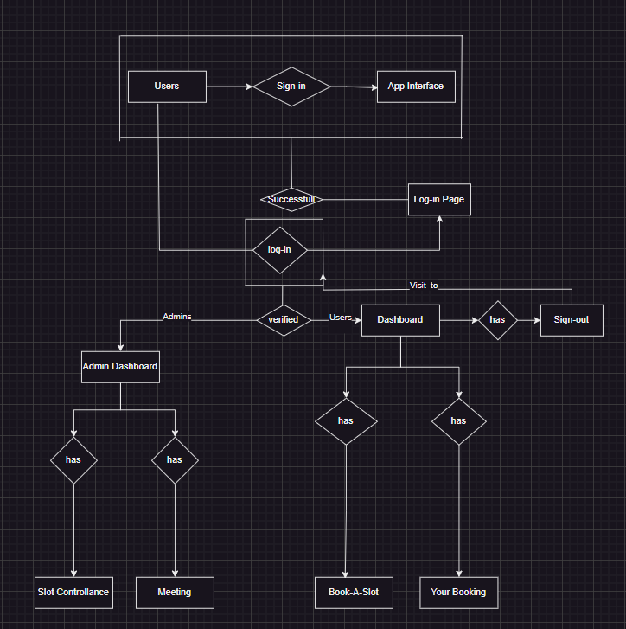

# User Flow:

A. User Authentication Flow:

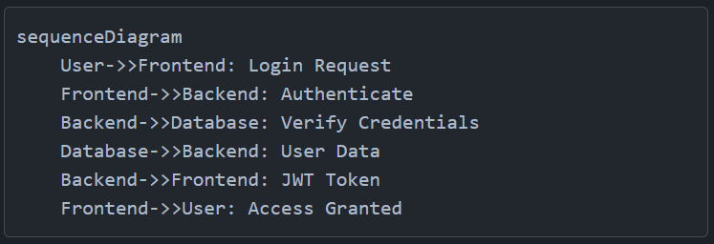

B. Booking Flow:

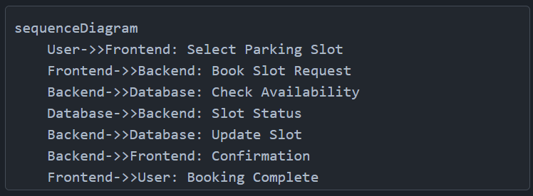

# Competitive Benchmarking:

1. Compared to traditional parking systems, our **Smart Parking System** offers:
   * **Real-time slot availability** to minimize manual errors.
   * **User-friendly dashboard** for easy slot booking and management.
   * **Secure authentication** to ensure user privacy.
   * **Digital slot allocation** to optimize space utilization.
2. Competes with existing solutions by offering a **cost-effective**, **efficient**, and **scalable** parking management system.

# Future Scope:

Our Smart Parking System has the potential to grow and improve significantly, making parking management even more convenient, automated, and user-friendly. By following ways:

1. Smart IoT Integration:

Sensor-based occupancy detection, Real-time monitoring systems, Automated barrier control and Environmental monitoring.

2. AI-Powered Slot Recommendations:

Predictive parking availability, Smart vehicle identification, Automated license plate recognition and Optimal slot recommendation.

3. Dedicated Mobile App:

Native Android/iOS apps, Real-time notifications, QR code-based access and Voice-guided navigation.

4. Digital Payment Integration:

Online payment gateway, Digital wallet integration, Subscription-based parking, Dynamic pricing model and Multi-Location Parking Support.

6. Enhanced Security Features:

Biometric authentication, Two-factor authentication, OAuth integration, SSO capabilities, Eco-Friendly Initiatives, CCTV integration, Security incident tracking and Automated alert system.

8. Data-Driven Insights & Reports:

Navigation apps integration, Weather service integration, Traffic management systems and Emergency services alerts.

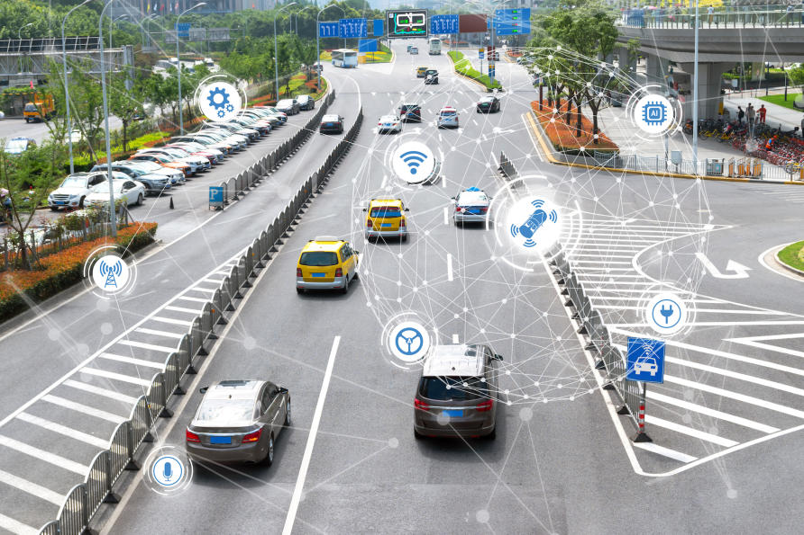

# Conclusion:

It is a simple and efficient way to manage parking spaces. It helps users find, book, and track parking slots easily through a digital platform. With features like real-time slot tracking, secure login, and a user-friendly interface, it makes parking hassle-free. This system saves time, reduces confusion, and ensures better space utilization. As it grows, it can be improved with more features like automated payments, smart sensors, and AI-based predictions, making parking even more convenient and efficient.

----------------------------------------------------------

# INTERFACE OF OUR WEBSITE:

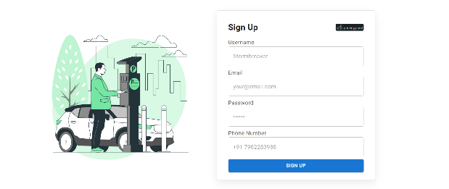 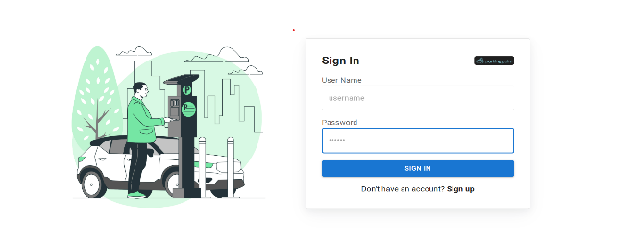

Signup Sign in

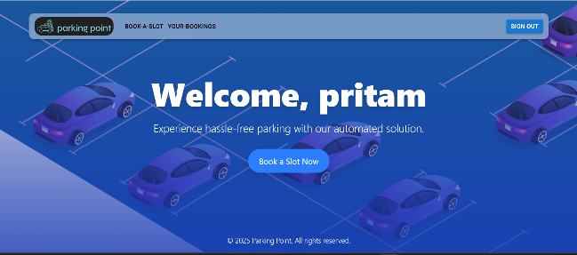 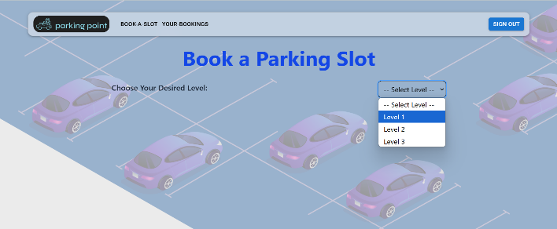

Dashboard Book Page

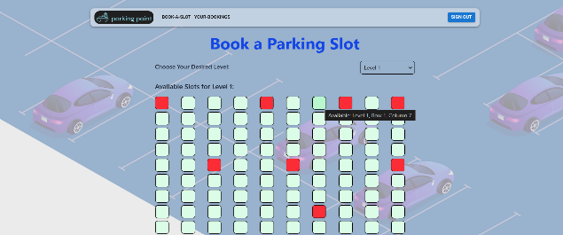 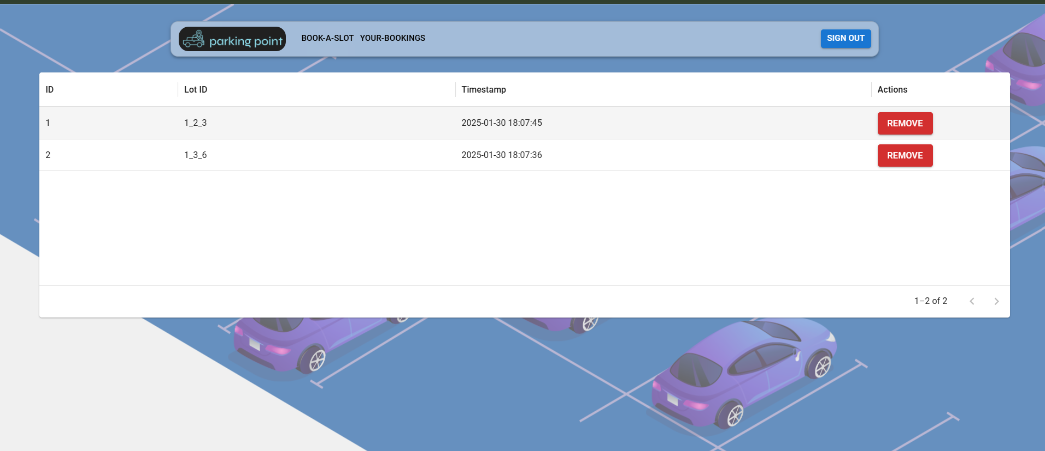

Slot View Your Bookings