Servos have a three pin connector on them that provides:

Vcc – usually red

Ground – usually black or brown

Signal – usually white, yellow or orange

Connect the servo to J3 pins 1 – 3 on the TIVA as shown.

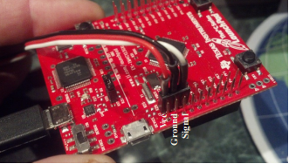

For multiple servos, connect Vcc of all servos to pin 1 and ground of all servos to pin 2 through breadboard. Connect the signal wires of each servo to the IO pins of board (PD0, PD1, PD2 and so on).

In our case :

Motor 1 – PD0

Motor 2 – PD1.