CS-308-2014 Final Report
POLLUTION DETECTOR
Team Members:
Ayush Deothia, 120050025
Arpit Singh, 120050037
Jayesh Bageriya, 120050022
Zubin Arya, 120050036
Avinash Malviya, 120050024

Table of Contents
1. Introduction 3
2. Problem Statement 3
3. Requirements 3
3.1 Functional Requirements 3
3.2 Non-Functional Requirements 3
3.3 Harwdare Requirements 3
3.4 Software Requirements 3
4. System Design 4
5. Working of the System and Test results 7
6. Discussion of System 11
7. Future Work 11
8. Conclusions 12
9. References
12

1. Introduction

Our project is ‘Pollution Detector’. The motivation behind this project is that in our country, the pollution is increasing at an alarming rate and one of the reasons for this is that the emissions are unregulated. So we thought of creating a pollution detector such that the readings are sent to the nearest service centre. This way the pollution level can be regulated.

For example, if this is installed in a car, then if the CO2 level increases above a certain range, the drivers can get the exhaust repaired/maintained and if they do not do it and the CO2 level increases even further, the people from service centre who receive the readings can come and get it repaired.

2. Problem Statement
We are trying to create a small carbon dioxide level detector which can be fit into vehicles, rooms or offices of factories which will alarm a buzzer if its level increases above a certain threshold. Plus, the readings are sent via wifi to a server (which can be there in the nearest service center). This way we can regulate the pollution level and try to decrease the pollution in the environment.

3. Requirements

3.1 Functional Requirements
We need to wait for a few seconds for the wifi connection to be established.

3.2 Non-Functional Requirements
It should not be kept inside water.

3.3 Harwdare Requirements
- Air quality sensors (MQ135)
- Wifi module (ESP8266)
- TIVA Board
- Buzzer
- Other accessories like breadboard and jumper wires

3.4 Software Requirements
- Code Composer Studio
- Netbeans
- XAMPP (for server)

4. System Design

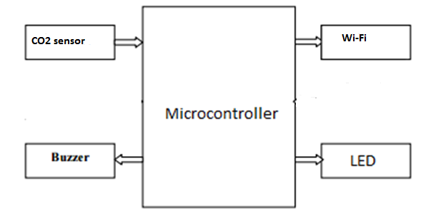

- The CO2 sensors detect the CO2 level which are then sent to the server via the wi-fi module.
- If their level goes beyond a certain threshold, the alarm buzzer starts ringing.
- The LED keeps changing its color depending on the state of the wi-fi module(if it is connected or not) and the CO2 level.

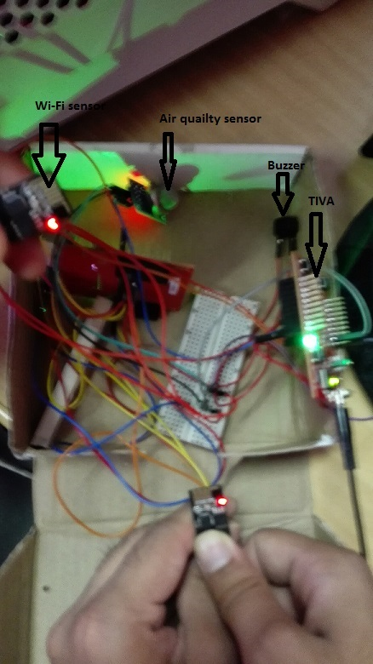
The above image shows the components of our embedded system.

FSM:
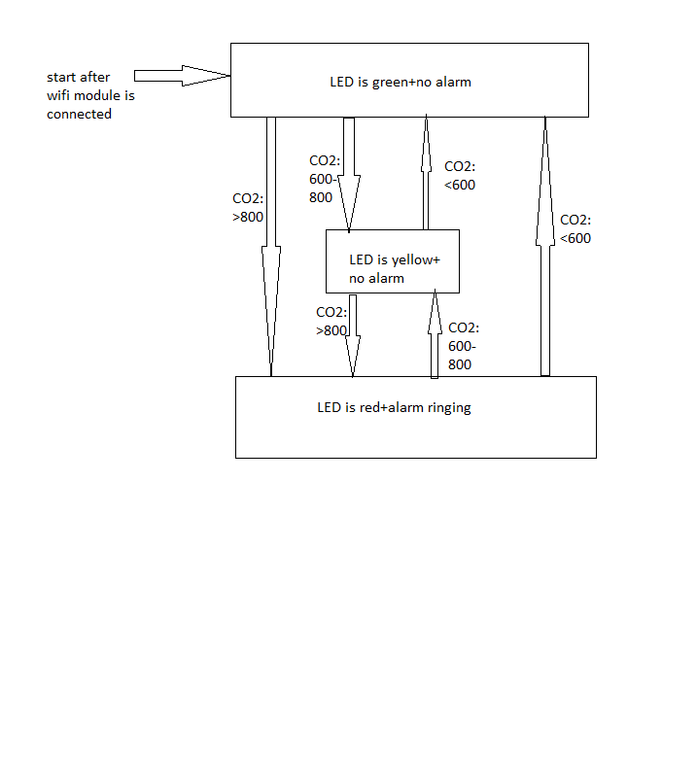

5. Working of the System and Test results

- The project had three parts: detecting CO2 level, sending readings via wifi-module to server and displaying those readings.
- The air quality sensors detect the CO2 level after which the readings are sent via wi-fi to the server and from there the readings are displayed on the webpage.
- When only the LED is red and alarm is not ringing, the wifi is not connected. After this when the wifi gets connected, the LED turns green. When the CO2 level goes above 600 ppm, the LED turns yellow and after that when the CO2 level goes above 800ppm, the LED turns red and the alarm starts ringing.
- For testing, we brought ENO, dissolved it in water and put it near the air quality sensors.
- We saw that there was the LED changed from green to yellow (as CO2 level started increasing) and it turned with the ringing of the alarm when the CO2 level reached above 800ppm.
- The readings could be seen on the webpage too which means the wifi module was also working properly.
- The whole test worked fine as expected.

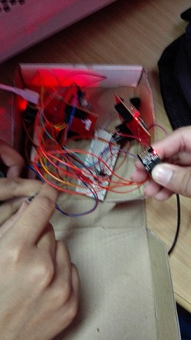
In the above image, the LED is red when the wifi is not connected.

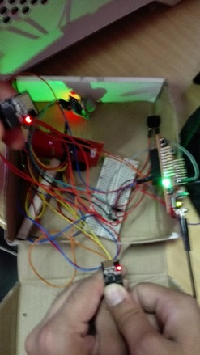

In the above image, the LED is green after the wifi is connected. There is no alarm buzzer ringing(the CO2 level is way below 600ppm).

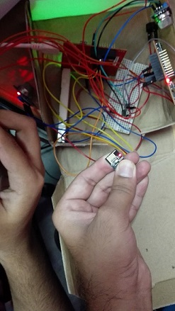
In the above image, the LED is red and the alarm buzzer is ringing (the CO2 level has gone above 800 ppm after exposing the air quality sensor to ENO dissolved in water).

Result:
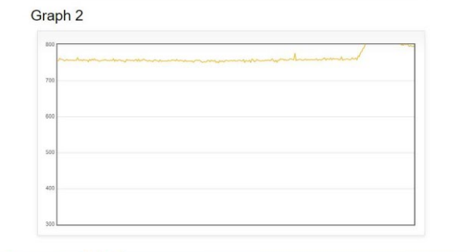
We see that the reading has gone up at the end when the ENO dissolved in water is exposed to air quality sensor.

6. Discussion of System

a) What all components of your project worked as per plan? All our components(air quality detection, wifi module and webpage display) worked as per the plan.

b) What we added more than discussed in SRS? We did not anything more than discussed in SRS.

c) Changes made in plan from SRS: We detected CO2 level instead of CO level because the air quality sensors were easily available (This was suggested by Prof. Kavi Arya himself).

7. Future Work
Possible extensions to our work:
- We can use better air quality sensors to get more accurate CO2 level.
- We can use even more number of air quality sensors for better reading.
- We can use better wifi module that connects even quicker than the current one.
- We can use other sensors like temperature sensors and humidity sensors.

Re-usable components: Both our code of detecting CO2 level and that of connecting wi-fi module are reusable. They are given in separate functions so anyone can use them again easily.

8. Conclusions

Our project can be generalised as ‘Sense+React’. We detect the CO2 level through air quality sensors. When it increases above 600 ppm, LED turns yellow but there is no alarm ringing. When it increases above 800 ppm, LED turns red and the alarm starts ringing. It can be installed in cars, rooms or offices of factories. It aims to regulate and hence decrease the pollution level from these places.

9. References
- Cheap CO2 meter using the MQ135 sensor with AVR ATmega(http://davidegironi.blogspot.in/2014/01/cheap-co2-meter-using-mq135-sensor-with.html#.VwAPaKR96Uk)
- Internet of Things (IoT) with ESP8266 WiFi Module (https://e2e.ti.com/group/launchyourdesign/m/tivaarmmicrocontrollerprojects/666222)

